Vital Monitoring Wrist Strap
V.M.W.S

Group 7
Victoria Balkissoon (Computer Engineering)
Sarmad Doulan (Electrical Engineering)
Kamal El Fagrich (Electrical Engineering)
David Lizzio (Electrical Engineering)

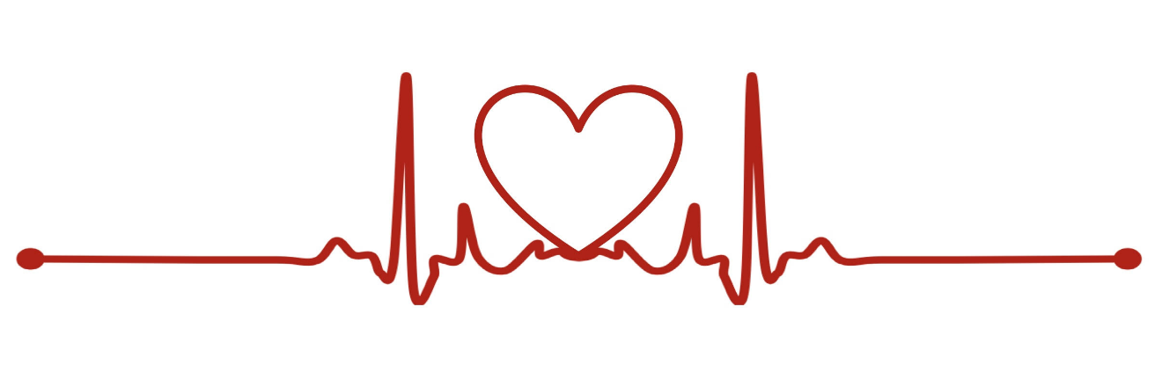

University of Central Florida
EEL4914
Summer 2019
Table of Contents
List of Figures 7
List of Tables 8
Acknowledgements 9
1.0 Executive Summary 10
2.0 Project Description 11
2.1 Motivation 11
2.2 Goals and Aims 11
2.3 Objectives 12
2.4 Engineering Requirements 13
2.5 Design Constraints 14
2.6 Standards 14
2.7 House of Quality 15
2.8 Block Diagram 15
2.9 Software Logic Flowchart 17
3.0 Project Research 18
3.1 Existing Vital monitoring systems 18
3.2 Sensor Research 20
3.2.1 Heart rate sensors 22
3.2.1.1 MAX30102 23
3.2.2 Oximeter sensors 24
3.2.2.1 MAX30100 25
3.2.3 Temperature sensors 26
3.2.3.1 MAX30205MTA+T 26
3.2.4 Blood pressure sensor 28
3.2.4.1 Components of blood pressure sensor system 28
3.2.4.2 Working of blood pressure sensor 28
3.2.4.3 Technical specifications of blood pressure sensor 28
3.2.4.4 Blood pressure calculation methodology 28
3.2.4.5 Blood pressure measurement procedure 29
3.2.4.6 ASDXL-DO Sensor 29
3.3 Microcontrollers 32
3.3.1 ESP8266 32
3.3.2 ATMEGA328P 34
3.3.3 Zigbee (MRF24J40MA) 36
3.4 Power management: 37
3.4.1 Power Management System Design Challenges: 40
3.4.1.1 Power Consumption: 40
3.4.1.2 Battery Leakage Current: 40
3.4.1.3 Switching and conduction losses 40
3.4.1.4 Harmonics and EMC 40
3.4.1.5 Limited battery size and capacity: 41
3.4.2 Design Solutions: 41
3.4.2.1 Power Management System Reference Design: 41
3.5 Battery 44
3.5.1 Rechargeable Battery 45
3.5.2 Li-ion Battery 46
3.5.2.1 Cost and Performance 47
3.5.2.2 Power and Capacity 47
3.5.3 NiCd Battery 47
3.5.3.1 Cost and Performance 47
3.5.3.2 Power and Capacity 48
3.5.4 Rechargeability and Batteries: 48
3.5.4.1 Lead Acid Battery 49
3.5.4.2 Pros and Cons of Lead Acid Battery 49
3.5.4.3 Application areas of lead acid batteries 50
3.5.4.4 Types of lead acid batteries 50
3.5.5 Lead Calcium batteries 51
3.5.5.1 Lead Antimony batteries 51
3.5.6 Absorbed Glass Matt (AGM) batteries 51
3.5.7 Starting, Lighting and Ignition (SLI) batteries 51
3.5.8 Rechargeable Alkaline Battery 51
3.5.8.1 Chemical composition 51
3.5.8.2 Capacity 52
3.5.8.3 Construction 52
3.5.8.4 Advantages of rechargeable alkaline batteries 52
3.5.8.5 Disadvantages of rechargeable alkaline batteries 52
3.5.8.6 Environmental impact 53
3.6 Recharge chip: 53
3.7 Charging Circuitry: 56
3.7.1 Charging circuitry features: 57
3.8 Power Management System 61
3.9 Battery charging module 61
3.10 Wireless charging module 62
3.11 Fuel gauging module 63
3.12 Battery protection module 63
3.13 Boost converter module 64
3.14 Micro USB interface 64
3.15 Design problems and challenges in PMS 65
3.16 Wireless Communications 66
3.16.1 Wi-Fi 66
3.16.2 Bluetooth 68
3.16.2 Zigbee 69
3.17 Indicators: 71
3.17.1 Battery power Indicators: 71
3.17.2 Buzzer 72
3.17.3 Piezo speaker 72
3.17.4 Piezoelectric vs. Electrodynamic Speakers 72
3.17.5 Audio Amplifier for Piezo Speakers /TPA2100P1 73
3.17.6 Motor design: 73
3.17.7 Power Consumption: 74
3.18 IDE/Setup 76
3.18.1 Arduino 76
3.18.2 Uploading Code 76
3.19 PCB Design 81
3.19.1 PCB Current Ratings 82
3.19.2 PCB Software (Altium Designer) 83
3.20 Data Logging Server 84
3.20.1 Amazon Web Services 85
3.20.2 Adafruit IO 87
3.21 Medical Overview 88
3.21.1 Heart Rate Ranges and Emergency Indicators 90
3.21.2 Temperature Indicators 92
3.21.3 Oxygen Saturation Level Indicators 93
3.22 Application Development Tools and Languages 94
3.22.1 Flutter 95
3.22.2 Ionic 96
3.22.3 Android Studio 96
4.0 Design Constraints and Standards 98
4.1 Constraints 98
4.1.1 Medical Knowledge Constraints 98
4.1.2 Health and Safety Constraints 99
4.1.3 Economic Constraints 99
4.1.4 Environmental Constraints 100
4.1.5 Social Constraints 100
4.1.6 Ethical Constraints 101
4.1.7 Manufacturability Constraints 101
4.1.8 Sustainability Constraints 102
4.1.9 Time Constraints 102
4.1.10 Testing Constraints 103
4.1.11 Presentation Constraints 104
4.2 Standards and Certificates 104
4.2.1 Wireless Communication Standards 105
4.2.2 Wireless Certificates 107
4.2.3 Hardware Standards/Protocols 108
4.2.4 Software Development Standards 110
5.0 Project Design 111
5.1 Hardware Design 111
5.2 Software Logic Diagram 114
5.3 Amazon Web Services 115
5.4 Software Design – Data Structures and Functions 116
5.5 Application Overview 118
6.0 Testing 122
6.1 Battery Monitoring for Wearable Devices 122
6.1.1 Battery management circuitry 123
6.2 Microcontroller and Sensor Testing 124
6.2.1 Amazon Web Services 126
6.3 Android Application Communication 127
7.0 Administrative Content 130
7.1 Budget and Cost 130
7.2 Project Timeline 131
8.0 Conclusion 132
References 133
APPENDIX 138

List of Figures
Figure 1 - House of Quality 15
Figure 2 - Block Diagram 16
Figure 3 - Software Logic diagram 17
Figure 4 - Relations within vital monitoring 18
Figure 5 - U.S Vital Signs monitoring devices market 20
Figure 6 - Physiological Parameters 21
Figure 7 - ECG 22
Figure 8 - Integrated Pulse Oximetry Heart Rate Sensor 23
Figure 9 - MAX30102 Pin Configuration 24
Figure 10 - MAX30100 Pin Configuration 25
Figure 11 - MAX30205 Pin Configuration 27
Figure 12 – ASDXL-DO Pin Configuration 30
Figure 13 - Zigbee Mesh Network 37
Figure 14 - Sleep Cycle 39
Figure 15 - Li-ion and Li-po 48
Figure 16 - Cycle life of a battery 50
Figure 17 - LDO dropout region efficiency 57
Figure 18 - Buck Converter Efficiency 57
Figure 19 - Circuit for Motor Design 73
Figure 20 - Power System Diagram 75
Figure 21 - Preferences in Arduino 76
Figure 22 - Additional Boards Manager Setting in Arduino 77
Figure 23 - Board Manager in Arduino 77
Figure 24 - Arduino ESP8266 Community Version Installation 78
Figure 25 - NODEMCU 1.0 (ESP-12E Module) 78
Figure 26 - Wire Up of ESP8266 79
Figure 27 - Settings Verification in Arduino 80
Figure 28 - PCB Trace Width Calculation 83
Figure 29 - SPI Interface 108
Figure 30 - SPI Bus 109
Figure 31 - I2C Interface 109
Figure 32 - Microcontroller Schematic 111
Figure 33 - Power Circuitry Schematic 112
Figure 34 - Software Logic Diagram 114
Figure 35 - Entity Relationship Diagram Representing Database Structure 116
Figure 36 -Array data structure to store vitals 116
Figure 37 - Proposed Constants and Variables for Mobile Application Code 117
Figure 38 - Proposed Functions for the Mobile Application 117
Figure 39 - Login and Register Screens of Mobile Applications 118
Figure 40 - Patient Information Page of Mobile Application 119
Figure 41 - Screens with Display the Vitals on the Mobile Application 120
Figure 42 - Emergency Indicator 121
Figure 43 - Use Case Diagram for V.W.M.S 122
Figure 44 - Serial Output of MAX30102 Sensor 124
Figure 45 - Sensor Placement on Radial Pulse Area 125
Figure 46 - Fossil Smartwatch Pulse Reading 126

List of Tables
Table 1 – Engineering Requirements………………………..……………………………………13
Table 2 – Design Constraints……………………………………………………………………...14
Table 3 – Standards……………………………………………………………………………….14
Table 4 – Vitals Sensing Devices………………………………………………………………….21
Table 5 – Pin Functions for MAX30102………………………………………………………….24
Table 6 – Pin Functions for MAX30100…………………………………………………………..26
Table 7 – Pin Functions for MAX30205…………………………………………………………..27
Table 8 – Pin Description from Sensors Tecnics Website…………………………………………30
Table 9 – Current Consumption Modes in ESP8266………………………………………34
Table 10 – Current Consumption of ATMEGA328P……………………………………..34
Table 11 – Current consumption of MRF24J40MA……………………………………….36
Table 12 – Overview of Rechargeable Battery Types…………………………………….45
Table 13 – Specification comparison between different battery materials………………..46
Table 14 – Summary on Li-Po batteries…………………………………………………..49
Table 15 – MCP73833 Features…………………………………………………………...53
Table 16 – Configurations of 802.11 Standard……………………………………………67
Table 17 – Bluetooth Chipsets…………………………………………………………….69
Table 18 – Advantages and Disadvantages of ZigBee……………………………………70
Table 19 – LED Indicators Scenario………………………………………………………71
Table 20 – Power draw of components……………………………………………………75
Table 21 – ESP8266 Pins………………………………………………………………….79
Table 22 – Altium Features……………………………………………………………………….84
Table 23 – Heart Rate Indicators…………………………………………………………..91
Table 24 – Target Heart Rate Zones based on Age……………………………………….92
Table 25 – 802.11b……………………………………………………………………….106
Table 26 – 802.11a……………………………………………………………………….106
Table 27 – 802.11g……………………………………………………………………….106
Table 28 –802.11n……………………………………………………………………….107
Table 29 – TELEC Certification Submission Basic Guidelines….……………………....107
Table 30 – SRRC Certification Basic Guidelines………………………………………...108
Table 31 – Project Costs…………………………………….…………………………………...130
Table 32 – Senior Design I – Timeline………………..………………………………….131
Table 33 – Senior Design II – Timeline……………….…………………………………131

Acknowledgements

We will like to thank Health Sciences student, Steven Arrieta, for initially proposing the idea which evolved into our current project design.

1.0 Executive Summary
The world of medicine is currently evolving with the new implementation of technology. Now, it has been easier and more accessible than ever to gain your own health information such as heart rate, blood pressure, etc. on a constant basis without the need for visiting the doctor’s office. This has been made possible through new smart watch and fitness band technologies that are taking over the global market. Despite these efforts by companies to increase health awareness, current products on the market are individualized meaning that they are made for the user’s personal awareness of their health and fitness levels. In times of emergencies, individual awareness may not be the most beneficial.
For much older patients and very young patients who cannot utilize health technology to its fullest extent like the health bands currently on the market which focus on providing health statistics to the individual through applications on their own devices, they are at a disadvantage. Typically, they are the patients that need the most watching over as high-risk health situations are more likely to occur in those age groups. Our group sought to provide a new form of health tracking which would focus on the caregiver-patient relationship through allowing the caregiver monitoring capabilities over the patient’s vitals.
The Vital Wrist Monitoring Strap (V.W.M.S) system consists of a physical health monitoring device much like those that currently exist on the market. The strap will contain multiple sensors that will allow for the conduction of several vital readings such as that for heart rate, temperature, and oxygen saturation levels. The Vital Wrist Monitoring Strap system strives to allow for constant viewing of patient’s vitals to ensure that they are in a stable condition. Vitals will be read and transferred to a mobile application for continuous and timely viewing of the patient’s health status. The proposed system will also include the implementation of emergency notifications. When a patient’s vitals go far out of range of typical defined ranges for their condition, an emergency notification will be sent to the caregiver’s device warning of the potential need for medical attention for the patient. This system seeks to increase the quality care of patients and eliminate the disastrous outcomes due to lack of care during emergency situations when patients are alone.
This document provides a detailed outlook into both the hardware and software research and design for the Vital Wrist Monitoring Strap. Furthermore, it explains the limitations and standards that will be followed and implemented during the development of both components of the project and the testing that will be conducted to safeguard the validity and functionality of the finalized product.
Through the development of the Vital Wrist Monitoring Strap, we aspire to increase patient safety and create a long lasting and reliable product that can be utilized by all age groups especially for patients with particular conditions which are conveyed through the vitals being displayed through the product. Moreover, we hope to assist medical professionals with providing enhanced care to patients and contribute to the merging of the medical field with the field of technology

2.0 Project Description
The Vital Wrist Monitoring Strap (V.W.M.S) system consists of a physical health monitoring device much like those that currently exist on the market. The strap will contain multiple sensors that will allow for the conduction of several vital readings such as that for heart rate, temperature, and oxygen saturation levels. The Vital Wrist Monitoring Strap system strives to allow for constant viewing of patient’s vitals to ensure that they are in a stable condition. Vitals will be read and transferred to a mobile application for continuous and timely viewing of the patient’s health status. The proposed system will also include the implementation of emergency notifications. When a patient’s vitals go far out of range of typical defined ranges for their condition, an emergency notification will be sent to the caregiver’s device warning of the potential need for medical attention for the patient. This system seeks to increase the quality care of patients and eliminate the disastrous outcomes due to lack of care during emergency situations when patients are alone.
Through the development of the Vital Wrist Monitoring Strap, we aspire to increase patient safety and create a long lasting and reliable product that can be utilized by all age groups especially for patients with particular conditions which are conveyed through the vitals being displayed through the product. Moreover, we hope to assist medical professionals with providing enhanced care to patients and contribute to the merging of the medical field with the field of technology

2.1 Motivation
For many caregivers and family members, having loved-ones including children with heart issues, other medical issues or ones who live alone, it can be difficult to monitor those individuals constantly to ensure that they are alive and are not facing any medical emergencies. One of our group members, Victoria, has seen this firsthand with her grandmother who suffers from several medical issues. Victoria’s mom is constantly in a panic when her mother is not reachable throughout the day and fears that something could have possibly happen to her. Creating a device that would provide constant information about the health status of the individual, through heart rate, temperature, oxygen level would assist people like Victoria’s mom with keeping a watchful eye on their loved-ones, allowing their safety and health to be ensured. We want to create a wearable device that would allow individuals to be monitored by their caregivers and family members from remote locations at all times to ensure their safety. Through this project, we hope to alleviate the anxiety that comes with being a caregiver. Additionally, we hope to maximize the health of patients through providing emergency notifications when their vitals, particularly heart rate, exceeds certain standards so care can be provided as quickly as possible. Moreover, with the evolving world of medicine, we have the desire to contribute to the development of new medical technology.

2.2 Goals and Aims
The goal of V.M.W.S. is to provide accurate and real-time vital readings of patients wearing the device to individuals (typically their caregivers) at any location. The basis of the proposed device lies in heart rate monitoring alongside other possible vitals such as temperature and oxygen saturation. Alongside conducting the vital readings, the hope is to relay the information to individuals through an easy to use application where all information can be accessed and consolidated for analysis of the patient’s health over time. Additionally, to ensure for greater health benefits, one of the goals for the Vital Monitoring Wrist Strap development is an emergency notification system which would notify caregivers when vitals are out of range such as when the heart rate varies significantly from normal ranges and could possibly be indicating a myocardial infarction (heart attack). The V.M.W.S. should be easy-to-use and be useful for all ages.

The overall product aims of the V.M.W.S. can be summarized in the following list:
- Provide accurate and real-time vital readings such as heart rate and temperature.
- Relay patient vital information to users using an easy-to-use mobile application.
- Store vitals data for each patient so users can access health information overtime for comparison.
- Implement an emergency notification system for indication of out-of-range vital values to maximize the health benefits of the device and assist in ensuring patient safety.
- Create a small, comfortable, safe and easy-to-use daily device that can be worn at all times during most daily activities.
- Device should be durable for long time usage.
- While currently geared toward adults, the device should have the capability to be transferred to a smaller scale for children.

2.3 Objectives
Objectives are certain tasks or goals to acquire over the course of designing a project. This can contain certain characteristics of the project or even to acquire new skills as an engineer. List below are the objectives for the Vital Monitoring Wrist Strap.

- Shall produce 1 PCB along with an Android application
- Device will be worn on patient’s choice of wrist
- Device will contain a securing strap to secure wristband to wrist (Velcro)
- Device will have a means to communicate battery life to patient
- Software will display sensor data to care taker
- Software will alert caretaker of anomalies
o Irregular heart beat
o Drastic temperature drops
o Irregular oximeter readings

Software Programs
- Microcontroller will be able to be programmed using Arduino via USB
- Amazon Web Services will be utilized to store data
- Android application will extract information from Amazon Web Services and display to user with a horizontal time scale
- Altium shall be used to design PCB

2.4 Engineering Requirements
When designing engineering requirements, it is essentially a written agreement for how the final product will be fulfilled to the customer. The engineering team is responsible for each requirement to deliver a successful product. List in Table 1 below, are the engineering requirements for the Vital Monitoring Wrist Strap.

Table 1 - Engineering Requirements
Engineering Requirements
Requirement Number | Requirement Description
Requirement #1 | Shall produce a product of size 4 x 3 in or less
Requirement #2 | Shall produce a product less than ½ in thickness
Requirement #3 | Shall operate on a rechargeable battery
Requirement #4 | Battery shall be able to be recharged via a 5V external DC power source
Requirement #5 | Sensors shall utilize I2C communication
Requirement #6 | Shall be able to be programmable via USB protocol
Requirement #7 | Device shall contain a 3D printed housing
Requirement #8 | Sensors shall be isolated from patient’s skin
Requirement #9 | Device shall utilize WIFI connection for data relaying
Requirement #10 | Device shall contain a heart rate sensor
Requirement #11 | Device shall contain an oximeter
Requirement #12 | Device shall contain a temperature sensor
Requirement #13 | Microcontroller shall be able to be programmed using Arduino via USB

2.5 Design Constraints
Design constraints are an important aspect in the design process of a project. Essentially, a constraint refers to a limitation on the operation or requirements stated previously. The engineering team will utilize their tools and research to minimize the impact the constraints have on the project. The constraints for the Vital Monitoring Wrist Strap are listed in Table 2 below.

Table 2: Design Constraints
Design Constraints
Constraint #1 | Battery life may not be sufficient to power MCU for prolonged hours
Constraint #2 | WIFI connection may be intermittent at times (losing packets)
Constraint #3 | HIPAA Security Rule
Constraint #4 | Making the housing small enough to be wearable
Constraint #5 | Sensors may not be totally accurate for vital readings
Constraint #6 | The amount of data that can be logged in the database
Constraint #7 | Placement of sensors
Constraint #8 | Data logging time latency

2.6 Standards
Throughout the project development, there are several constraints to take into consideration when designing the vital monitoring watch. Many of these constraints were highlighted by the Accreditation Board for Engineering and Technology (ABET). Others of these constraints were due to the timeline of the project as restricted by the semester schedules that were provided. As engineers, it is extremely important to consider the constraints of a project in order to create a product that is functional, and safe for the user and the environment. Listed in Table 3 below, are the standards that the engineering team will utilize.

Table 3: Standards
Standards
Wireless Certificates | SRRC, FCC, CE (RED), IC, NCC, KCC, TELEC (MIC)
Green Certificates | RoHS, REACH
Wireless Communication Standard | 802.11 b/g/n standard
Hardware Communication Standard | USB standard
PCB Standard | IPC-A-610

2.7 House of Quality
The House of Quality depicted below in Figure 1 shows the team’s product development plan in unison with the customer requirements. The engineering requirements set a basis for which the team must design a product to fit the customer's desires in an appropriate manner. The left side of the chart, depicted in blue, show the requirements that the customer deems necessary for a product. The green sections of the chart depict engineering requirements for which the team must measure and execute upon for the final product. The ‘roof’ of the chart shows the correlations between different engineering requirements, which is necessary to see how changing one requirement can affect the rest of the project. For example, if the customer desires more Vital Sensors, then the efficiency of the product will decrease instead of staying at the ‘target’ sensor quantity that engineering and the customer had originally agreed upon (3 sensors). Not only does efficiency decrease, but the battery life and installation time per device also gets negatively impacted.

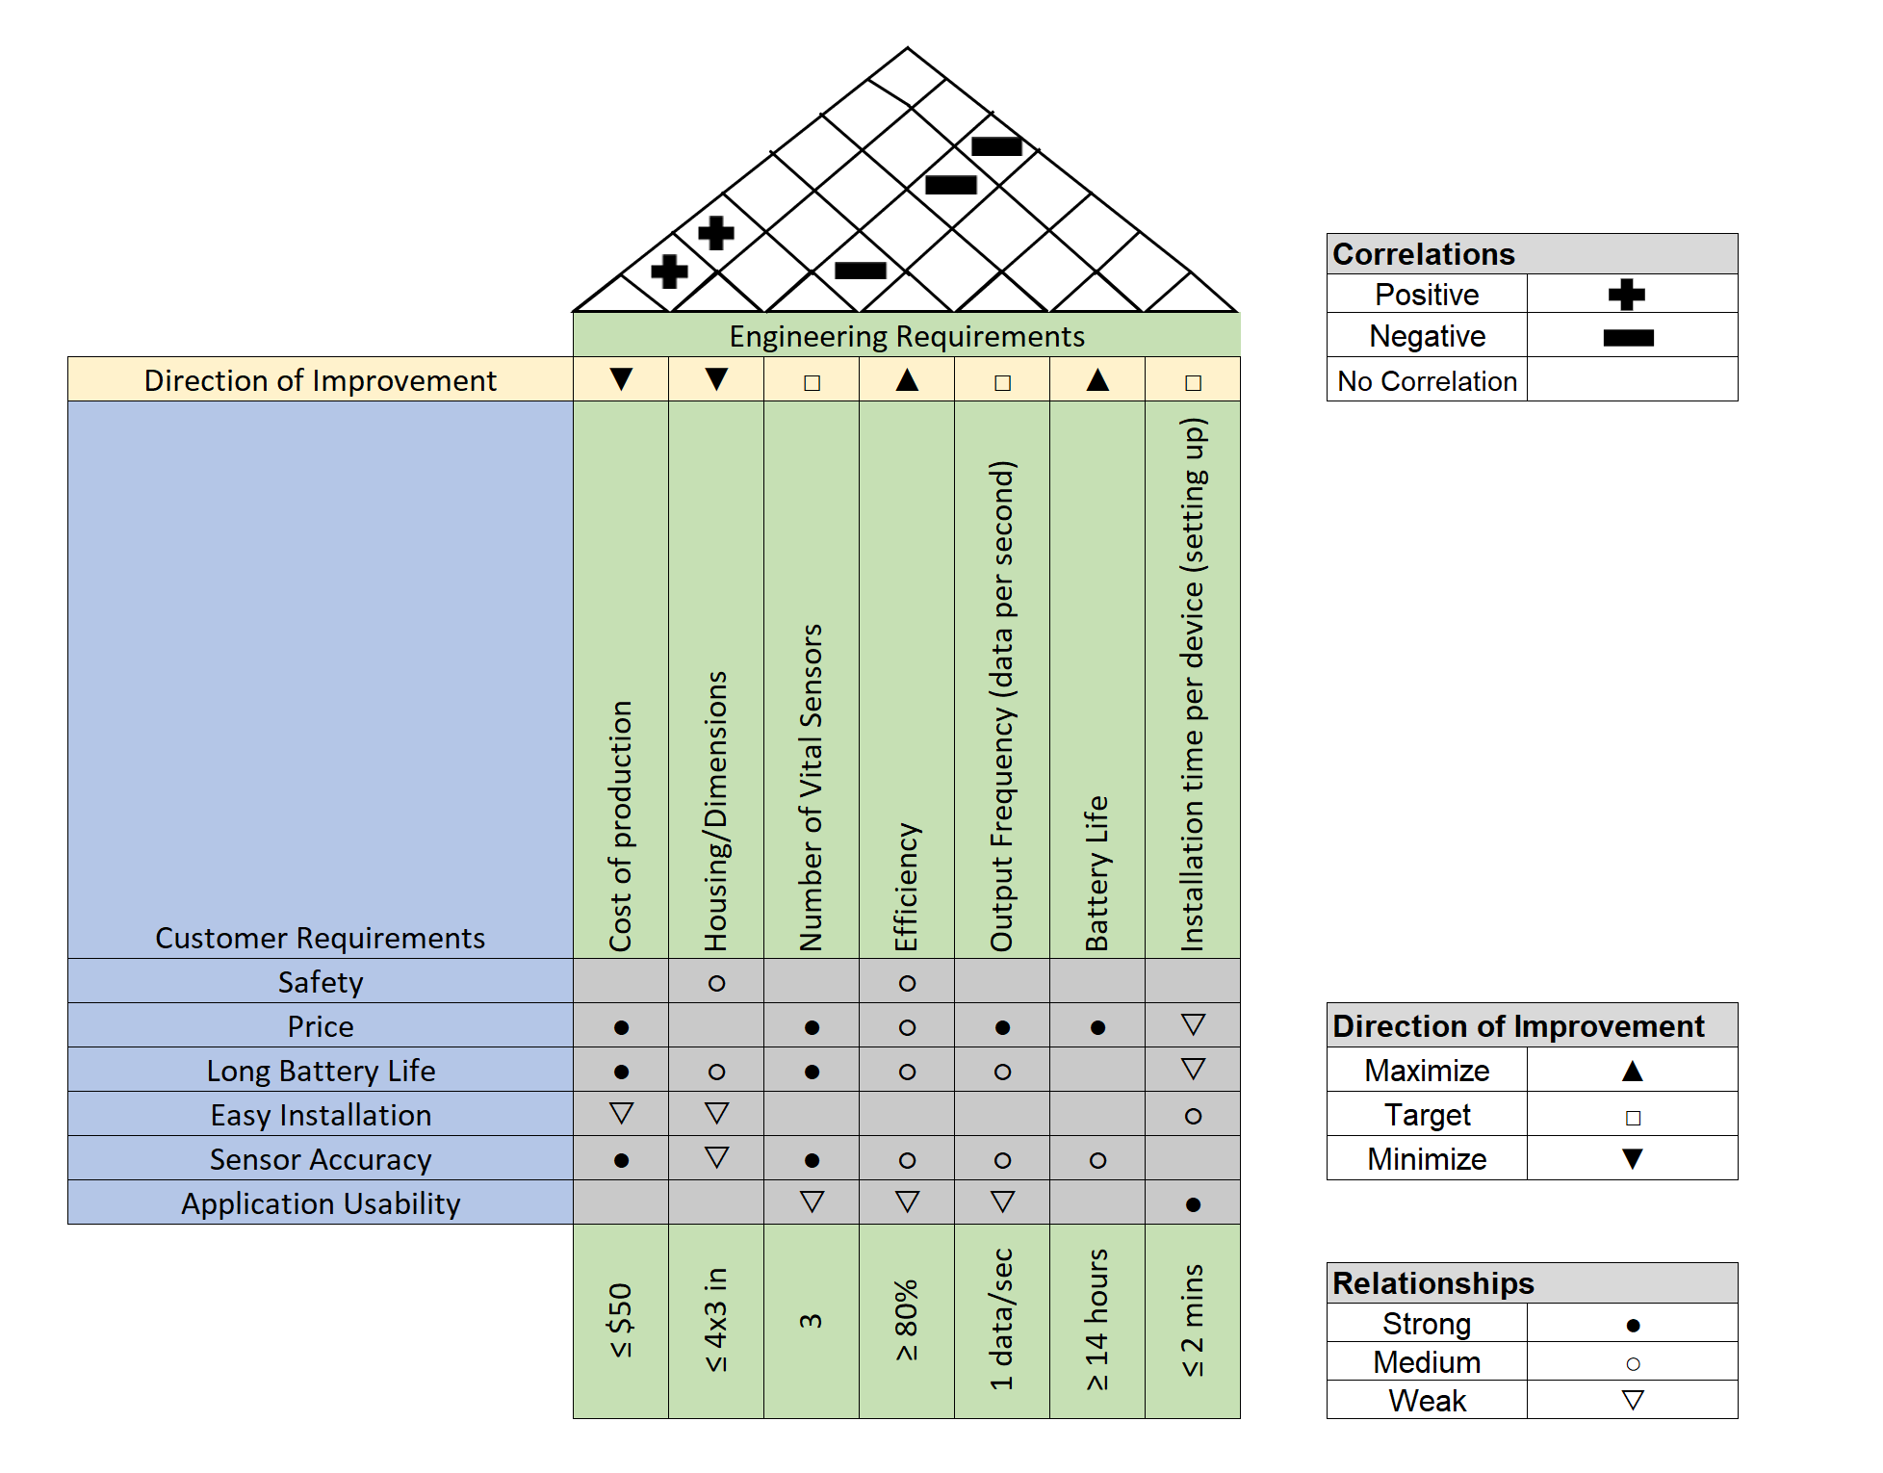
Figure 1 - House of Quality

2.8 Block Diagram

As it shows in the block diagram, depicted in Figure 2 we will use three sensors in our Vital Monitoring Wrist Strap. The sensors connected to a Microcontroller which is powered by a battery that is connected to a voltage regulator to regulate the voltage level. The first sensor is the Oximeter, which will be used to measure the oxygen level (Saturation) of the blood. So, it should tell how well oxygen is being sent to body parts. The sensor will send a light then compare how much red light and infrared is absorbed by the blood.

The second sensor we will use is a Heart Rate sensor to measure the heart rate. It works by measuring the electrical pulse by shining light into the skin then measuring the light that scattered by blood flow. So, the amount of light absorbed depends on the blood volume in the tissue. The sensor output will be in a form of an electrical signal and it’s proportional to the rate of heart beat.

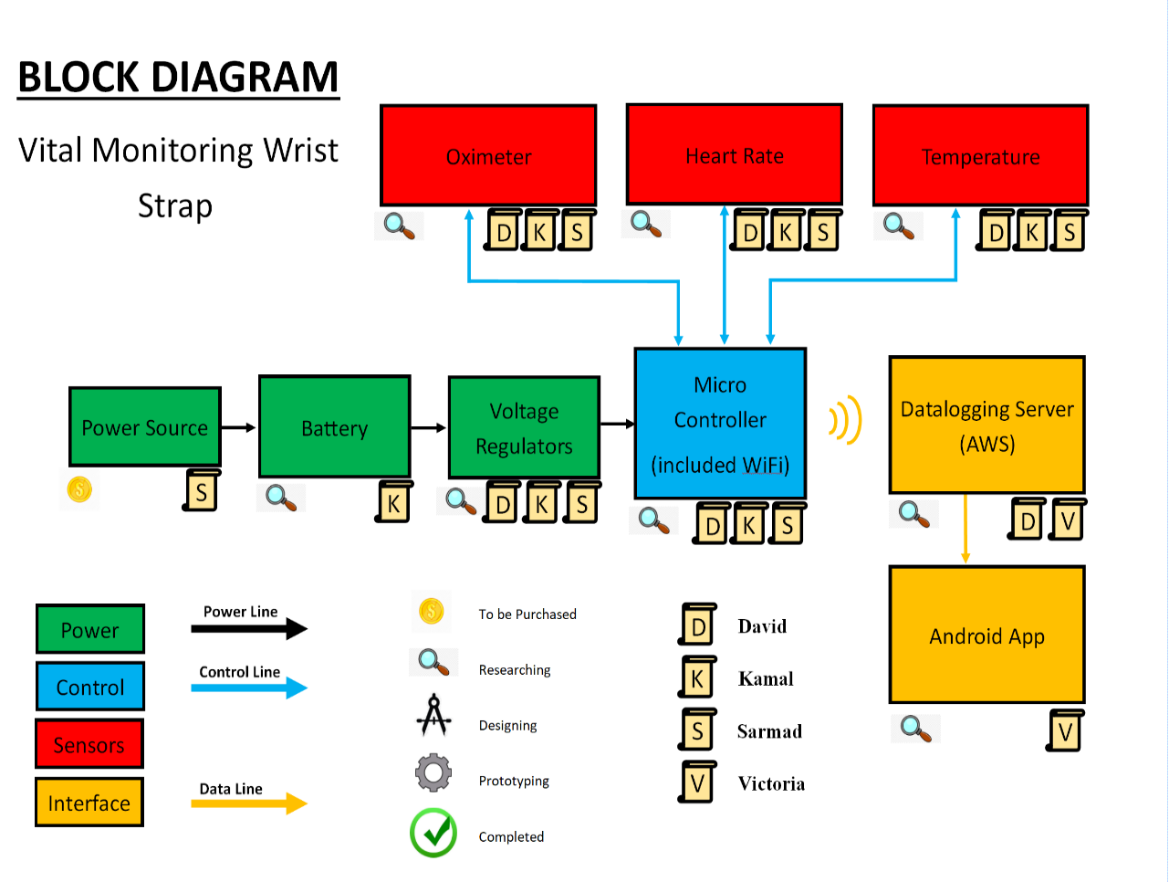
The last sensor that our Vital Monitoring Wrist Strap will include is a temperature sensor. It will measure the temperature on the skins surface by converting thermal energy into electrical signal. The microcontroller will send these three different features to the data logging server which will be Amazon Web Services through the WiFi. David will be the lead for the user interface design due to his prior experience in the area. David, Kamal and Sarmad will work to find what will be the best sensors and microcontroller that will fit into our project. Victoria will work on application’s backend algorithm. Also, Victoria will help in the integration process between software and hardware to communicate and synchronize with the Android application.
Figure 2 - Block Diagram

2.9 Software Logic Flowchart
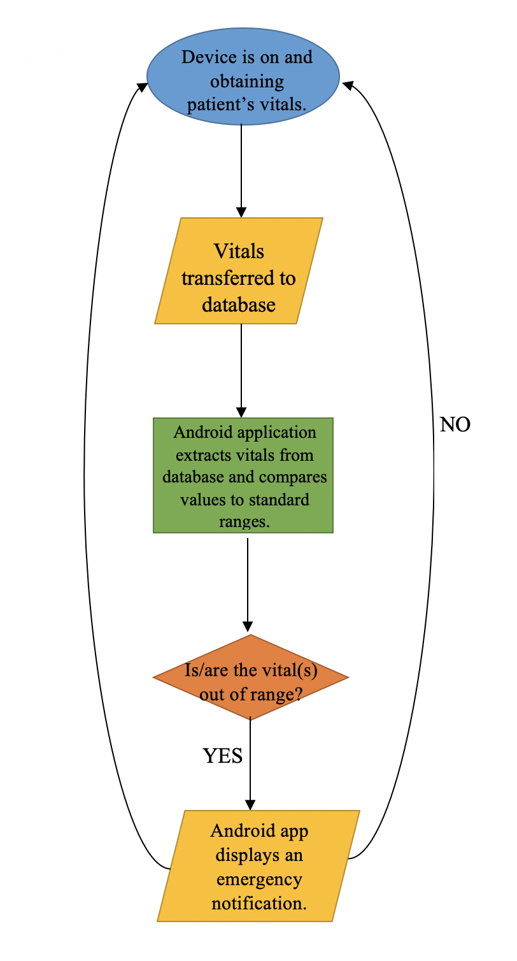
The flowchart depicted in Figure 3, displays the basis behind the logic involved in the software for this project. Each shape in the flowchart represents a different concept behind the logic. The oval represents the start of the processing of information. In this case, it is when the patient is wearing the wrist strap and it is on and functioning. This would allow for information to be gathered by the sensors that will be further processed by actual software. The rhombus shape signifies input and output into the system. The first rhombus after the oval illustrates input into our system as the vitals will be transmitted from the wrist strap to a database. The second rhombus at the bottom of the figure represents output which in this case is the emergency notification that will be outputted by the mobile application if the vitals recorded are out of range. The data is processed by the application as indicated by the green rectangle and compared to standard values that will be coded into the application. The decision of whether an emergency notification needs to be outputted is the final step of processing before it goes back to the top and repeats the process again. The diamond represents making a decision in the flowchart.
Figure 3 - Software Logic diagram

3.0 Project Research

3.1 Existing Vital monitoring systems
Wearable Health Devices help people for monitoring their body status at activity and fitness. It also uses in the medical field to help patients to monitor their body’s parts by collecting the data from their body to give an accurate information about brain work, heart beats, and body temperature and much more features. Especially, with tone of the busy life today that make it not an easy to stop by medical facilities every day to check their health status. Nowadays, the revolution in technology also effected the medical side in a positive aspect. It contributed in make it possible to design portable, small and reliable devices that can diagnose the body parts and give an early sign about abnormal activities like high or low heart rate or body temperature.

In our group research papers, we will review some important aspects of the wearable health devices area. Then we will list some existing vital monitoring systems. Also, we will go over about some specification. On the end, we will focus on how to build a vital monitoring system from scratch which is our Senior Design project. The most common monitoring devices that are being used are body temperature, electro cardiogram, heart rate, blood pressure, motion evaluation respiration rate and blood oxygen saturation. In addition, there are monitoring devices for blood glucose, capnography and skin perspiration.

All of these sensors designed to monitor the human vital signs during their daily life at work and home and even when they practice sport activities. Another major using for vital monitoring systems is on the medical fields. One of the main reasons for using them is to minimize the interface with daily human activities. In Figure 4 below, it shows the relation between the vital monitoring devices that used in a different aspect of daily life.
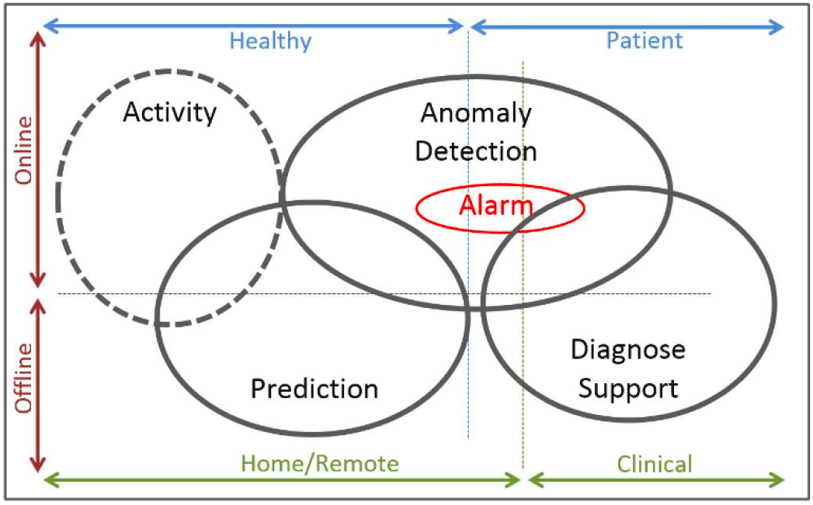
Figure 4 - Relations within vital monitoring

There are many different physiological signs can be measure in the human body. An example for these physiological signs is Biochemical and Electrical signs. So, by measuring these signs, we can get more understanding about the body reaction and status for different factors. Figure 5 below explains how nowadays wearable devices classified. These three classifications are type of monitoring, type of users, and the scenario of use. An example for type of use is sick or healthy. And for Scenario of use is clinical or home. In addition, the example of type of monitoring is offline or online. Most of the wearable sensors people are wearing nowadays it either for not medical monitoring or for medical use. By using Vital monitoring systems, it makes it easy and accurate to get guidance and feedback from the human body.

That feedback will lead generate warning based on the body physiological signs.
In our project we will focus on the medical aspect of using the Vital Monitoring Systems. One of the most important things that should be considered when designing devices is by making it comfortable. In this case, more people will wear it because it will be like a smartwatch. One of the most popular wearable health devices called AMON that presented at the beginning of 2002. This wearable device was able to monitor Oxygen saturation, heart rate, and the skin temperature.

All Vital Monitoring Systems work idea is the contact of skin with the sensor. Then, the hardware device will determine the signal quality during a specific movement influencing the accuracy level in the extracted signal. The new generations of wearable vital monitoring systems have a great feature such wireless data communication that has the ability to emerge with mobile communication, so that will give it the ability of providing twenty-four hours of vital monitoring. Also, some of new generation have new features like monitor calories and sleep monitoring.

The first smart wearable vital system used to track sleeping habits called Moov. Another type of wearable monitoring system is Google eye lens. Also, there are ear wearable devices that can monitor different parameters such as OSL (Saturating Oxygen Level). During my research for our group project, I found my articles talking about using monitoring devices on the ear gives more accurate data because the signals on the air is hundred times clearer than the signal on wrest.

These types of devices may will be the new generation of wearable monitoring devices. The main types of wearable monitoring devices are three. Chest straps, adhesive patches, and t-shirts. Each one of them has cons and pros. The issue on the Chest straps and adhesive patches that they are not that much confirmable comparing to the t-shirt. Globally, the Vital Monitoring Systems for health aspect using is increasing year after year. The Vital Monitoring Systems’ market developed during a short time. Especially, the compounded devices which have the features to monitor temperature, blood pressure, and heart rate. One of the main reasons behind growing this market up is increasing of chronic disorders because of the lifestyle change in the population. According to the Health Observation Data, 45% of the deaths at 2015 were due to cardiovascular diseases (CVD).
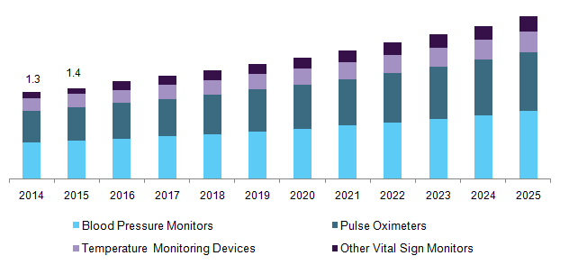
Figure 5 - u.s vital signs monitoring devices market

3.2 Sensor Research
The sensors we will use in our project are medical sensors. Each sensor will have a specific function that make it to be able to measure a different task such as temperature, heart rate and oxygen level. These sensors will dedicate to monitor health care applications. These sensors will give who wear them the flexibility of free moving. It will measure both external and internal function like heart rate and skin temperature. It is comfortable specially for long term of monitoring. It’s using to alert the medical staff or the end user about any life threating change for the person who is wearing them. The three majors of using these sensors are Vital Signs such as heart rate, blood pressure, respiration treatment rate, skin temperature, and blood oxygen saturation level. The second major is for diseases. An example for the types is using in Diseases part are sleep apnea, chronic obstructive pulmonary disease, diabetes mellitus, cardiovascular diseases, brain diseases, mosquito born diseases, renal failure, sketale system diseases, and for hearing loss. The other major is varying from sun prevention, vein finding, and to detect of stress and depression levels. The blood pressure, heart rate, and skin temperature are the most common parameters they are in use nowadays. Heart rate sensor sensors can be placed on ear, chest, fingers and wrest. The wearable blood Oxygen saturation level is the measures of circulation of the blood in vessels and breathing. The normal reading should be 75 to 100 mm Hg. So, if the level is less than 75, it means the body need more Oxygen. It can be measured from ear or fingertip. When it comes to the body temperature, it is better to place the sensor inside the body because the skin does not reflect the accurate temperature. A good place to measure the body temperature is the mouth or under the arm. While the heart rate should be measured continuously, the body temperature is not. It is better to measure it during intervals time of period. Depicted in Figure 6 below, are physiological parameters.

Figure 6 - physiological parameters

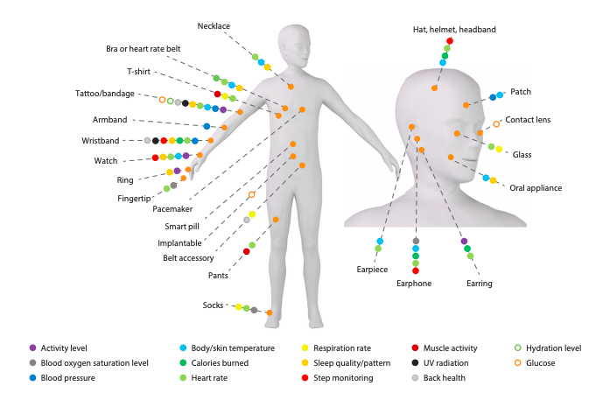

Table 4: Vitals Sensing Devices
Vital Sign | Sensor | Wearable Device
Heart Rate | Pulse Oximeter | Watch (Samsung Gear)
Heart Rate | Pulse Oximeter | Shirt (Polotech)
Body and/or skin temperature | Temperature | Earphone
Body and/or skin temperature | Temperature | Watch
Respiration rate | Accelerometer | Belt
Respiration rate | Piezo-resistive Sensor | Smart Textile electrocardiogram sensor
Blood Pressure | Two photoplethysmography | Patch
Blood Pressure | Potential Difference | Wristband
Blood Oxygen Saturation Level | Pulse Oximeter | Fingertip (Go2 Fingertip Pulse Oximeter)

3.2.1 Heart rate sensors
Heart rate sensor is used to measure the heart rate measurement in fitness activity and healthcare. It measures the heart rate by measuring the change in the heart cycle. Heart beats are inarguably the most important vital parameter in our heart which can reveal many aspects about the person's health. As it is a pillar in the medical field allowing the professionals to diagnostic a wide range of health situations from chest pain to heart muscle strength. By adding this sensor to our design, we reinforce the vitality of our project, which also comes with challenges and tradeoffs knowing the boundary set by the health and medical standard and norms.

Heart beats are inarguably the most important vital parameter in our heart which can reveal many aspects about the person's health. As it is a pillar in the medical field allowing the professionals to diagnostic a wide range of health situations from chest pain to heart muscle strength. The intent as elaborated early in this papers in to mimic the heart reading accuracy provided at Hospital rooms, although we will be tracking the heart rate optically verses electrical techniques used in ECG(Electrocardiography) where a few electrodes, usually four are to be attached the the patient chest and the pattern of heart beats is recorded in form of a graph. This is still the core concept of the heart rate sensor. Included in Figure 7 below, is an ECG.

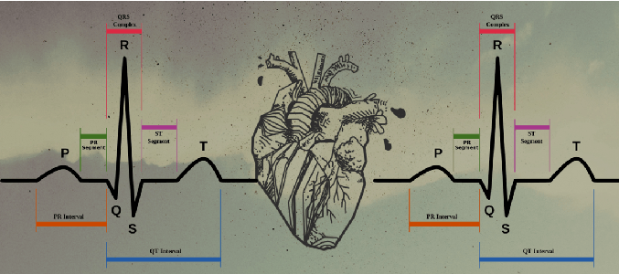
Figure 7 - ecg

This type of measure illustrated above are electrical signal generated due to contraction and relaxation of the heart ventricle muscle where a peak in the signal indicates a heart beats and the number of peaks occurring in a minute are counted to generate the bpm number. The technique we will be using is known as PPG, which will get us to our goal with less trade off maintaining a range of accuracy accepted for a caregiver to interpret according to case by case basis in the light off the set of standards called for by the health professionals. This method works by projecting a beam of light onto the blood flow under the wrist’s skin and measuring the difference between scattering light, which change between heart beats this change is processed by well-developed algorithm and digital signal processing to yield a bpm number.

3.2.1.1 MAX30102
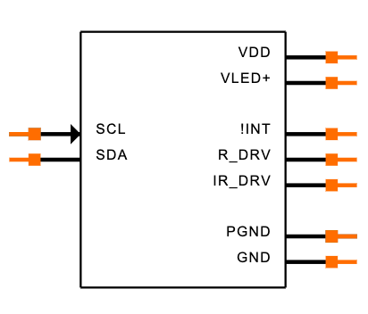
The MAX30102 sensor is an integrated pulse oximetry heart rate sensor. It’s high sensitivity pulse oximeter and heart rate sensor which use for wearable health devices. This type had LED photodetector and another optical material. It also includes low noise electronics. It designed with completed system to make it easier to design wearable devices. The company make this sensor is This sensor is Maxim Integrated. AX30102EFD work on 1.8- and 3.3-Volt separate power supply to make the internal communication. The good thing about this module that we can shut it down with zero current through the software that will be designed by Victoria. In the same time, by allowing the power rails in order to remain it powered at all times. Included in Figure 8 below is the MAX30102 sensor.
Figure 8 - integrated pulse oximetry heart rate sensor
This sensor is also used with some fitness devices, smartphones, and tablets. There are many advantages for choosing this sensor such it uses LED reflective solution. Another prose for using this sensor is the weight and dimensions. It’s 5.6 mm * 3.3 mm*1.55 mm. Because of its tiny size, it will be fit in our vital monitoring wrist strap. Another good thing about it regarding to the power consumption. This sensor can be operating with less than one milli Watt. One more feature for this sensor is the fast data output capability which leads to a high sample rate. Last thing to mention is when it comes to the temperature. I work with a temperature between -104 to 158 Fahrenheit which is mean it works with large rate scale of temperature.

The MAX30102EFD is a complete pulse oximetry and heart rate sensor’s features make it met all requirements for our project. It maintains a small solution size without scarifying our vital monitoring wrist strap performance. And by general, tiny hardware components are required to integrate into wearable devices. The manufacture data manual for this sensor integrates IR LED drives to modulate LED pulses and heart rate measurements. This LED’s current can be calibrated by Victoria from 0-50mA with proper supply voltage. The LED pulse width can be calibrated from 69-411Micro second in order to allow the algorithm to optimize the heart rate accuracy and power consumption

Pin Configuration and Description
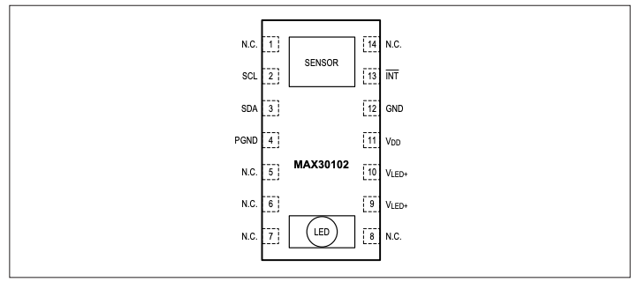
Figure 9 - max30102 pin configuration

Table 5: Pin Functions for MAX30102
(Pin Number) Name | Function
(1, 5, 6, 7, 8, 14) N.C. | No Connection. Connect to PCB pad for stability
(2) SCL | I2C Clock Input
(3) SDA | 2C Data, Open-Drain
(4) PGND | Power Ground
(9) VLED+ | LED Power Supply (anode connection)
(10) VLED+ | LED Power Supply (anode connection)
(11) VDD | Analog Power Supply Input
(12) GND | Analog Ground
(13) INT | Active-Low Interrupt (Open-Drain)

3.2.2 Oximeter sensors

This is a feature that impose its vitality at different levels especially in our V.M.W.S where the constraints of the medical field standards set the priorities of our design as we lay out in our strategy and implementation. We will incorporate an Oximeter to our V.M.W.S to track the oxygen saturation. Again, where aiming a very tedious task that will surely bring the convenience of use and the accuracy called for by the state of the art. Oxygen saturation levels measure the degree to which the Hemoglobin contained in the red blood cell (Erythrocytes) has bonded with oxygen molecules. As of today, technology offers two main methods to assess oxygen saturation in the blood are Arterial blood gases ABG and Pulsatile oxygen.
Normally, more than 89 percent of the blood should be carrying oxygen in order to keep the cells healthy and the body fully functioning. When a person’s blood oxygen saturation level drops below normal, this could lead to serious complications. The continuous monitoring of this vital parameter will be achievable in our V.M.W.S by the use of a Pulse oximeter that has optical ability to emet red and infrared through a relatively transparent portion of skin, the principal of this technology is that oxygenated hemoglobin can absorb more infrared light allowing more red light to pass through while the deoxygenated absorbs more red light this way we could compute the ratio leading to a level of the oxygen saturation in the blood.

3.2.2.1 MAX30100
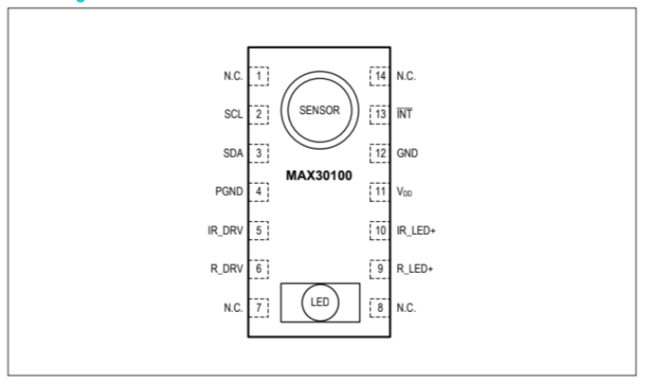
MAX30100 is an integrated pulse oximetry and also heart rate sensor. This sensor combines photodetector, optimized optics, and low noise analog signal processing in order to detect both pulse oximetry and heart rate beats’ signals. It needs 1.8 V and 3.3 V separate power source to be operated. We can shut it down through a software. This type of sensor can be used for many wearable devices for fitness and medical monitoring devices. This pulse oximeter and hear rate sensor has many benefits such high performance and a small size so we can use it in the Vital Monitoring Wrist Strap that we are designing. Its dimension is 5.6mm*2.8mm*1.2mm with 14 pin. Also, because the very low power consumption, it will make the batteries we are using run for longer time. It just needs 0.7 Micro Ampere in order to shut it down.
Figure 10 - max30100 pin configuration

Table 6: Pin Functions for MAX30100
(Pin Number) Name | Function
(1, 7, 8, 14) N.C. | No Connection.
(2) SCL | (I^2)C Clock Input
(3) SDA | (I^2)C Clock Data
(4) PGND | Power Ground of the LED Driver blocks
(5) I R_DRV | IR cathode & LED driver connection point
(6) R_DRV | Red cathode & LED driver connection point
(9) R_LED+ | Power Supply (anode connection) for Red LED
(10) IR_LED+ | Power Supply (anode connection) for IR LED
(11) VDD | Analog Power Supply Input
(12) GND | Analog Ground
(13) INT | Active-Low Interrupt (Open-Drain)

3.2.3 Temperature sensors
Although the incorporation of this type of sensor did not resonate well in the market, due to the accuracy challenges but we choose to take challenge knowing that is a plus, to bring extra assurance to type of caregiver we aim. We hope that we will successful to relay the body temperature taking in consideration that measuring the skin temperature which is a few degrees Celsius less that the body temperature also it will oscillate due to environment temperature. Our V.M.W.S design consist essentially of an improved version that will compensate for the ambient temperature otherwise we will only use it as reference only and not for alarming medical or the caregiver. There are more than one brand but we will pick the one that most fit with our wearable vital monitoring system (W.V.M.S).

3.2.3.1 MAX30205MTA+T
MAX30205 is a temperature sensor I found it on Maxim Integrated company website. This sensor converts the temperature to digital form by using analog to digital. The communication with the PCB well be through an I^2 C where this I^2 C serial interface accept the standard write byte, send and receive byte commands in order to read the data. MAX3020 use 2.7V-3.3V voltage rang supply, so that make it perfect for wearable devices in general and especially for our wear that wearable vital monitoring system that we are designing. This device has 8 pin and can read the temperature between 0 C -50 C. The data sheet shows it has 0.1 accuracy for temperature between 37C-39C.

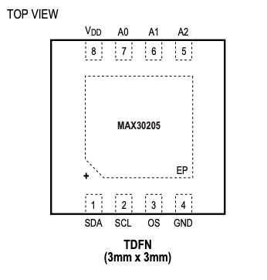
Figure 11 - max30205 pin configuration

Table 7: Pin Functions for MAX30205
(Pin Number) Name | Function
- SDA | Serial-Data Input/Output Line. Open-drain.High impedance for supply voltages from 0 to 3.3V.
- SCL | Serial-Data Clock Input. Open-drain.
- OS | Overtemperature Shutdown Output
- GND | Ground
- A2 | I2C Slave Address Input. Connect A2 to GND or VDD to set the desired I2C bus address
- A1 | I2C Slave Address Input. Connect A1 to GND, VDD, SDA, or SCL to set the desired I2C bus address.
- A0 | I2C Slave Address Input. Connect A1 to GND, VDD, SDA, or SCL to set the desired I2C bus address.
- Vdd | Positive 3.3V Supply Voltage Input. Bypass to GND with a 0.1µF bypass capacitor.
(-) Vdd | Connect EP to GND

3.2.4 Blood pressure sensor
A blood pressure sensor is a non-invasive transducer which is designed for the purpose of measuring human blood pressure. The sensor is capable of measuring systolic diastolic and mean-arterial pressures using the oscillometric technique. In addition, the blood pressure, heart rate can also be measured by the transducer.

3.2.4.1 Components of blood pressure sensor system
The non-invasive type blood pressure sensors are always used in conjunction with an adjustable cuff, a bulb pump and a compatible digital interface. Since, these are digital type sensors therefore a proper display device with appropriate software is required to view the sensor data. The software is either provided by the sensor manufacturer for PC, Android or iOS platforms, or it can be custom-built using an embedded controller and an LCD display. In our project, we will display the result through the application that will be created b Victoria. In general, the primary task of the software is to log the digital data values received from the sensor and display them in a graphical or textual format. [54]

3.2.4.2 Working of blood pressure sensor
The output voltage of the blood pressure sensor varies with the cuff pressure. The greater the cuff pressure, greater is the output voltage of the transducer. The output voltage increases linearly with respect to the pressure. The sensor circuitry also includes temperature compensation circuit because temperature can negatively affect the accuracy of the measured blood pressure. In addition to temperature compensation, the sensor also includes signal conditioning and filtering circuitry in order to remove ambient noise, harmonics and other undesired signals which can distort the original signal waveform. The associated software gets digital values from the sensor and interprets this data to calculate the blood pressure parameters. [54]

3.2.4.3 Technical specifications of blood pressure sensor
The non-invasive digital blood pressure sensors are far more accurate, efficient and convenient as compared to the analog ones. A typical digital blood pressure sensor has an average response time of 1ms, typical pressure range of 0-260 mmHg, typical accuracy of +1 mmHg, and a temperature compensation range of -20º to 85º C. Since it is a medical and safety critical device, therefore good accuracy, efficiency and precision of the sensor are of utmost importance. [54]

3.2.4.4 Blood pressure calculation methodology
The blood pressure measurement method used by digital non-invasive sensors is known as Oscillometric technique. When the cuff is first inflated to a high pressure and then deflated, an oscillatory arterial pressure pulse is generated. This pulse passes through the arteries in the arm and is also picked up by the pressure cuff. The peak-to-peak amplitude of the oscillatory waveform creates a bell-shaped envelope. Within this envelope, the waveform amplitude increases through systolic pressure and continue increasing until mean arterial pressure is reached (MAP). [54]
The pressure changes in the cuff are detected by the pressure transducer and a corresponding linear voltage is produced at the output. This voltage signal is then digitized using an analog to digital converter and passed on to the software. The software processes the digital signal and provided systolic, diastolic and mean arterial pressures in graphical or textual format.

3.2.4.5 Blood pressure measurement procedure
The operational steps for getting a blood pressure reading of a patient are given as following [54]:

- The blood pressure sensor is connected to the software interface and the communication is established between the two.

- The cuff is wrapped tightly around the arm of the patient, roughly 2cm above the elbow. The two rubber hoses attached with the cuff are positioned over the brachial artery (bicep muscle). The patient’s arm must remain stationary during the reading in order to obtain an accurate measurement.

- The bulb is squeezed rapidly and repeatedly in order to inflate the cuff wrapped around the patient’s arm. The cuff pressure is continuously monitored on the display screen during this process. The cuff is inflated until a pressure of 150 to 170 mmHg is achieved. After the achievement of required pressure, the bulb is kept aside and the cuff is allowed to deflate by means of a built-in pressure release valve.

- The systolic and diastolic pressure values are observed on the LCD display in graphical or textual list format.

3.2.4.6 ASDXL-DO Sensor
The ASDXL-DO is a series of Low Pressure Plastic Silicon Pressure digital sensors. These sensors can be interfaced with digital controllers and devices using I²C or SPI (Serial Peripheral Interface) protocols. The ASDXL-DO sensors incorporate on-board ASIC (Application Specific Integrated Circuit) which provides calibration as well as temperature compensation. Issues of offset, sensitivity, non-linearity and temperature effects are dealt with using the on-board calibration and temperature compensation capabilities.

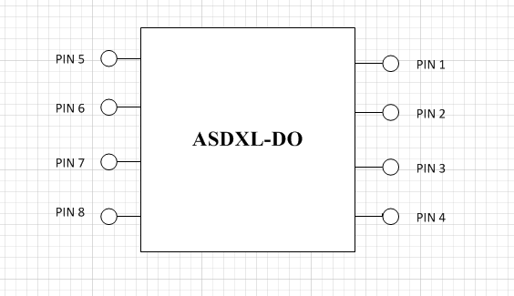
Figure 12 – asdxl-do pin configuration

Table 8: PIN Description from Sensors Tecnics website

Pin | Description | Type | Definition
1 | Serial bidirectional data; data is clocked in or out on clock edge of SCL | digital I/O | SDA
2 | Serial clock input; used to clock data on SDA | digital input | SCL
3 | power supply ground | supply | GND
4 | Do not connect in the application | not used | N/C
5 | Interrupt signal (conversion complete output) | digital output | SS
6 | power supply source | supply | VDD
7 | Do not connect in the application | not used | N/C
8 | Do not connect in the application | not used | N/C

The ASDXL-DO sensors operate at a frequency of 1kHz and are capable of operating from a single battery of either 3.3Vdc or 5Vdc. These sensors can be effectively used for the measurement of differential and gauge pressures. In the differential pressure versions, the pressure can be applied to either side of the sensing diaphragm. The gauge versions take atmospheric pressure as the reference value. The output of these sensors is in direct proportion to the variations in atmospheric pressure levels. These sensors are designed to be used with non-corrosive and non-ionic fluids such as a air and dry gases. These products are in compliance with the ISO-9001 standards. [55]

3.2.4.6.1 Features and specifications
The features and technical specifications of ASDXL-DO sensors are as following[55]:

- 14-bit digital output compatible with I²C and SPI communication interfaces
- ASIC based calibration and temperature compensation
- Temperature compensation over the range of 0º to 85º C
- Availability of differential and gauge versions
- Standard calibration units available in: mBar, kPa, cm-H₂O and in-H₂O
- Total error band of +2.0% of full scale deflection
- Operable with single battery of 3.3Vdc or 5Vdc
- High operating frequency of 1kHz

3.2.4.6.2 Application areas
There are numerous applications and sectors in which ASDXL-DO sensors can be employed for pressure measurement. Some of them are listed as following [55]:

- Wearable devices
- Pressure measurement in HVAC systems
- Gas flow instrumentation in Oil & Gas industry
- Gas pressure measurement in medical systems
- Pressure measurement in pneumatic systems

3.2.4.6.3 Environmental specifications
The life-span and longevity of any outdoor equipment depends on its ability to tolerate humidity, shock, vibration, temperature and other weather conditions. The ruggedness of sensors is of extreme importance in outdoor safety critical systems. Following are presented the environmental specifications of ASDXL-DO sensors. [55]

- Humidity: 0% - 95% RH non-condensing
- 10G at 20-2000Hz
- 100G for a period of 11ms
- Minimum 1 million cycles

3.2.4.6.4 Precautions for safe operation
Like all electrical devices, ASDXL-DO sensors also demand some precautions to be taken into consideration for safe operation. Overlooking those precautions might result in to device failure, system failure or injuries. Following are some points which should be considered for the operation of these sensors. [55]

- Providing supply voltage greater than 5Vdc may result into device failure.
- A bypass capacitor must be connected across the supply voltage pins of the sensor to ensure reliable operation.
- The sensor is not protected against reverse voltage polarity. Application of voltage to the ground pin or vice versa can result into device failure.
- Application of pressure greater than “proof pressure” might result into calibration damage.
- Application of pressure greater than “burst pressure” might result into sensor damage.
- The maximum allowed sensor current is 5mA.
- Vibration levels above 10G might result in sensor damage.
- Shock levels above 100G for 11ms might result in sensor damage.
- Application of liquids or humid gases might result into corrosion and device failure.

3.3 Microcontrollers
The microcontroller is the most critical piece of hardware included in the Vital Monitoring Wrist Strap. It will be responsible for communicating to each of the sensors via I²C, SPI, or UART where applicable. Not only is it responsible for communicating to the sensors, it must have a means to properly relay that information onto the internet. For many projects that require a microcontroller, there are factors that must be taken into consideration when choosing an appropriate microcontroller. Some factors include power consumption, telecommunication features, number of general-purpose input/output pins, I²C capability, SPI capability, UART capability, form factor, ease of use, well-documented, clock frequency, ADC, internal registers, and memory.

In the following sections, common microcontrollers have been selected for research to be adapted into the Vital Monitoring Wrist Strap. Included in the paragraph above was characteristics and features of the microcontroller selection. Another category that was not listed is the price of the microcontroller. Typically, microcontrollers are used to only communicate and control certain sensors and peripheral devices. Peripheral devices can include a Bluetooth module, WI-FI module or a means of mesh networking to communicate effectively but at a certain price.

Another constraint worth mentioning in the selection process of the microcontroller is the area that the components will use. As mentioned in the requirements specification, the product will fit in a set size of no more than 4 x 3 inches or less. With microcontrollers that don’t include onboard wireless communication, extra peripherals will need to be added to include that functionality. With extra peripheral hardware added, it increases the area needed to fit all components on the PCB.

3.3.1 ESP8266
The ESP8266 is a unique microcontroller that is developed by Expressif Systems, that provides the key feature of a built-in 2.4 GHz radio module. Within that frequency band of 2.4 GHz, the ESP8266 can appropriately communicate on the standard 802.11 b/g/n protocol for WI-FI communication. The package size of the ESP8266 is a standard 32 QFN with a size of 5x5mm which fits within the requirements specification stated in the Executive Summary section. The nominal operating voltage of the ESP8266 is 3.3V with a low range of 3.0V and a high range of 3.6V. The average operating current of the ESP8266 is 80mA and with a simple Ohm’s Law calculation, the average power of this chip computes to 0.264W. With the power computation in mind, a 3.3V regulator must be chosen to adequately stabilize the voltage and current values which will be explained in a later section. The communication peripherals of the ESP8266 include: UART/SDIO/SPI/I²C/I²S/GPIO/PWM, which successfully satisfy the communication requirements between sensors and microcontroller. [28]

The software parameters of the ESP8266 include the standard WPA/WPA2 for WI-FI data with encryption techniques via WEP/TKIP/AES. A main software feature that the ESP8266 boasts is its Ultra Low Power Technology which consists of 3 modes: active mode, sleep mode, and deep sleep mode. When the ESP8266 is in active mode it will consume the approximate 80mA as mentioned before. When in sleep mode, only the real-time clock and watchdog timers remain powered on. When in deep sleep mode, the device consumes a miniscule value of 60µA with the RTC clock still running, less than 1.0mA (DTIM=3) or less than 0.5mA (DTIM=10) to stay connected to the access point. Along with those benefits, many other features can be shutdown via coding such as the ADC, SPI, or any other unused feature to save more power. A better depiction of all the power consumption modes is provided in Table 9. By referencing Table 9, some conclusions shall have to be decided on when choosing the best power saving mode. In the case of our project requirements, the device shall be sending data every 1 minute to the internet. This means that the Deep Sleep functionality cannot be used since in the Deep Sleep mode, the WI-FI antenna and its counterparts are turned off, violating the requirements specification. Light Sleep mode will have to be tested to see if it will satisfy the requirements specification as the CPU is suspended for WI-FI switching but in DTIM3, the chip can maintain a 300ms-wake 3ms to receive AP’s beacon packages while only consuming 0.9mA. Modem Sleep mode will have to be researched to see if it satisfies the requirements specifications, as the WI-FI modem is turned off but still connected to the access point. The current draw of the Modem Sleep mode is 15mA. [28]

The cost of the ESP8266 is approximately $3.00 for the IC itself depending on how much internal memory is selected. Prototype boards are also available for approximately $8.00 that include regulators and a breakout board for easy breadboarding. Note that minor peripheral components are necessary such as resistors, capacitors, 3.3V regulator, crystal oscillator and a UART communication method to successfully flash code onto the microcontroller.

As of now, the engineering team has decided to select the ESP8266 to satisfy the engineering requirements. The main feature that swayed the decision is the fact that the ESP8266 has built-in WI-FI communication, along with having an adequate amount of power saving techniques and ease of use. The documentation provided in the datasheet provides great insight of the internal workings of the chip. Along with documentation, comes a great community and support with the Arduino IDE software.
Table 9: Current Consumption Modes in ESP8266
Parameters | Current Draw
Tx802.11b, CCK 11Mbps, P OUT=+17dBm | 170 mA
Tx 802.11g, OFDM 54Mbps, P OUT =+15dBm | 140 mA
Tx 802.11n, MCS7, P OUT =+13dBm | 120 mA
Rx 802.11b, 1024 bytes packet length, -80dBm | 50 mA
Rx 802.11g, 1024 bytes packet length, -70dBm | 56 mA
Rx 802.11n, 1024 bytes packet length, -65dBm | 56 mA
Modem-Sleep | 20 mA
Light-Sleep | 2 mA
Deep-Sleep | 20 uA
Power Off | 0.5 uA

3.3.2 ATMEGA328P
The ATMEGA328P microcontroller is a very popular choice within the embedded systems community. Notably, it is the microcontroller that is included for every Arduino Uno microcontroller board. With that said, it makes sense that there is a plentiful amount of resources and libraries that help beginners and even advanced users when designing projects. The package size of the ATMEGA328P is a standard 32-pin TQFP with a size of 5x5mm which fits within the requirements specification stated in the Executive Summary section. The nominal operating voltage of the ATMEGA328P is 5V with a low range of 2.7V and a high range of 5.5V. The average operating current of the ATMEGA328P can vary depending on the operating voltage that the user selects along with the clock frequency that is necessary for the project in mind. With the power computation in mind, a 5V regulator must be chosen to adequately stabilize the voltage and current values which will be explained in a later section. However, the ATMEGA328P can also be run at 3.0V with a lower clock frequency of 4MHz. At this setting, the ATMEGA328P consumes approximately, 0.0045W. The communication parameters of the ATMEGA include: UART/SPI/I²C/GPIO/PWM, which successfully satisfy the communication requirements between sensors and microcontroller. Listed in Table 10 is the power consumption of the ATMEGA328P with its different selection of clock frequency and operating voltage. [29]
Table 10: Current Consumption of ATMEGA328P [29]

Parameters | Current Draw
3.3V, 8MHz | 12.3 mA
3.3V, 16MHz | 21.8 mA
5V, 8MHz | 63.4 mA
5V, 16MHz | 81.8 mA

The cost of the ATMEGA328P is approximately $1.38 in its TQFP package size. Prototype boards are also available such as the Arduino UNO which include a detailed guide and huge community support with forums and libraries. However, a wireless module is required to send the data online such as a Bluetooth module or WI-FI module of some sort.

In most cases of Bluetooth communication, there is a Master and a Slave device. A Master device can control slave devices and slave devices have no say in any administrative actions. For example, a smartphone is considered a master device considering it can connect to multiple devices and control the functionalities of the slave devices. A slave device is typically your earbuds, smartwatch, stereos, and all other small device applications on the market. For device discovery, typically there is usually a button or switch of some sort to set a slave device, such as wireless earbuds, into pairing mode. In pairing mode, the slave device sends out its radio signatures within the 2.4GHz range and the master device will receive that radio signature and decide whether to connect to the slave device, otherwise known as inquiry scanning. The ATMEGA328P would be able to communicate with a Bluetooth module to set it up in a slave mode, however you would then need a master Bluetooth module to properly send the data to. Even after the master device receives the sensor data, it has no way of sending it to the internet unless the master slave was a smartphone or a computer of some sort which has built-in internet connection.
The main issue of using the ATMEGA328P is that additional hardware must be purchased to attain the same functionality of the ESP8266. This not only increases the cost of the overall project, but also increases the PCB dimension size for the project. The critical piece that is missing, is the communication method of sending data to the internet. To successfully communicate the sensor data online, the design must include one of the following: Bluetooth, WI-FI, or an ethernet connection. For the Bluetooth route, you have two prominent options which are either creating an application on a smart device to send the vital data online or sending the data to a Bluetooth receiver and then sending it online by means of hardware options available. For the WI-FI route, you could technically connect an ESP8266 to the ATMEGA328 but that defeats the whole purpose of utilizing the ATMEGA328P in the first place. However, one could purchase a WI-FI antenna and go through the painstaking task of making it send the correct number of packets. The last option is ethernet which seems relatively out of scope for our project, considering that the engineering requirements clearly state that this device shall communicate wirelessly. The added component of a wire connected to the patient’s wrist adds more complications then is worth explaining.

Not only is the wireless communication a relatively large issue, but the ATMEGA328P is a bit overkill for the simplicity of the sensors that we are using. For example, the ATMEGA328P contains 8 general purpose working registers and many different timers that are simply not necessary for the Vital Monitoring Wrist Strap. As many engineers and businessmen know, the more features included in any product always comes at a cost and in this project the engineering team has decided that the ATMEGA328P will not be an adequate choice for the microcontroller of the Vital Monitoring Wrist Strap.

3.3.3 Zigbee (MRF24J40MA)
Zigbee is based upon IEEE’s 802.15.4 standard. Essentially Zigbee acts as an alternative wireless communication standard like WI-FI and Bluetooth. The IEEE 802.15.4 standard intends to offer lower network layers of a wireless personal area network. Compared to WI-FI, Zigbee offers lower bandwidth and less power consumption for use in small sensor data communication. In instances where projects require simple data communication, like temperature sensors, humidity sensors, or basic home automation projects, Zigbee offers a great way to communicate efficiently. In the case of the MRF24J40MA chip, it includes a certified 2.4GHz IEEE 802.15.4 radio transceiver module. It has an integrated PCB antenna similar to the ESP8266 with a 4-wire SPI interface for connecting to PIC microcontrollers. The nominal operating voltage of the MRF24J40MA is 3.3V with a low range of 2.4V and a high range of 3.6V. Listed in Table 11 is the current consumption of the MRF24J40MA with its different states. [30]
Table 11: Current consumption of MRF24J40MA [30]
Parameters | Current Draw
TX - Transmitting (maximum output power) | 23 mA
RX – Receiving | 19 mA
Sleep (Clock disabled) | 2 µA

By referencing Table 11, the current consumption is very impressive especially when transmitting data. When compared to the ESP8266 in the Rx 802.11b mode, it consumes 50mA which is approximately 217% more current draw than the MRF24J40MA’s 23mA. With that said, Zigbee seems nice in theory, but there is much more to Zigbee that goes into creating a successful datalink.

As mentioned, this is an alternative to WI-FI and Bluetooth not a replacement. Even though the MRF24J40MA communicates on a 2.4GHz band, it can coincide with WI-FI signals within that 2.4 GHz band and not cause interference. The MRF24J40MA can communicate between different 802.15.4 standard transceivers, but still does not have any means of communicating directly to a WI-FI router without a peripheral Zigbee router. Zigbee merely acts as a mesh network to communicate between sensors with a low power consumption and low bandwidth. Typically, there are 3 different types of devices defined by Zigbee: Zigbee coordinator, Zigbee Router, and Zigbee End Device. The Zigbee coordinator is basically the module that gives commands to other slave devices within the Zigbee network while also providing a means to connect to the internet. The Zigbee router is responsible for moving data within the network if necessary. The Zigbee End Device is the physical device/sensor that is being controlled. The end device has no say within the network for administrative control. These three main features make the Zigbee an even more secure network than standard WI-FI that is available in today’s world. Zigbee can also be programmed via Arduino or another IDE software. Depicted in Figure 13, it shows how mesh networking works in theory. [30]

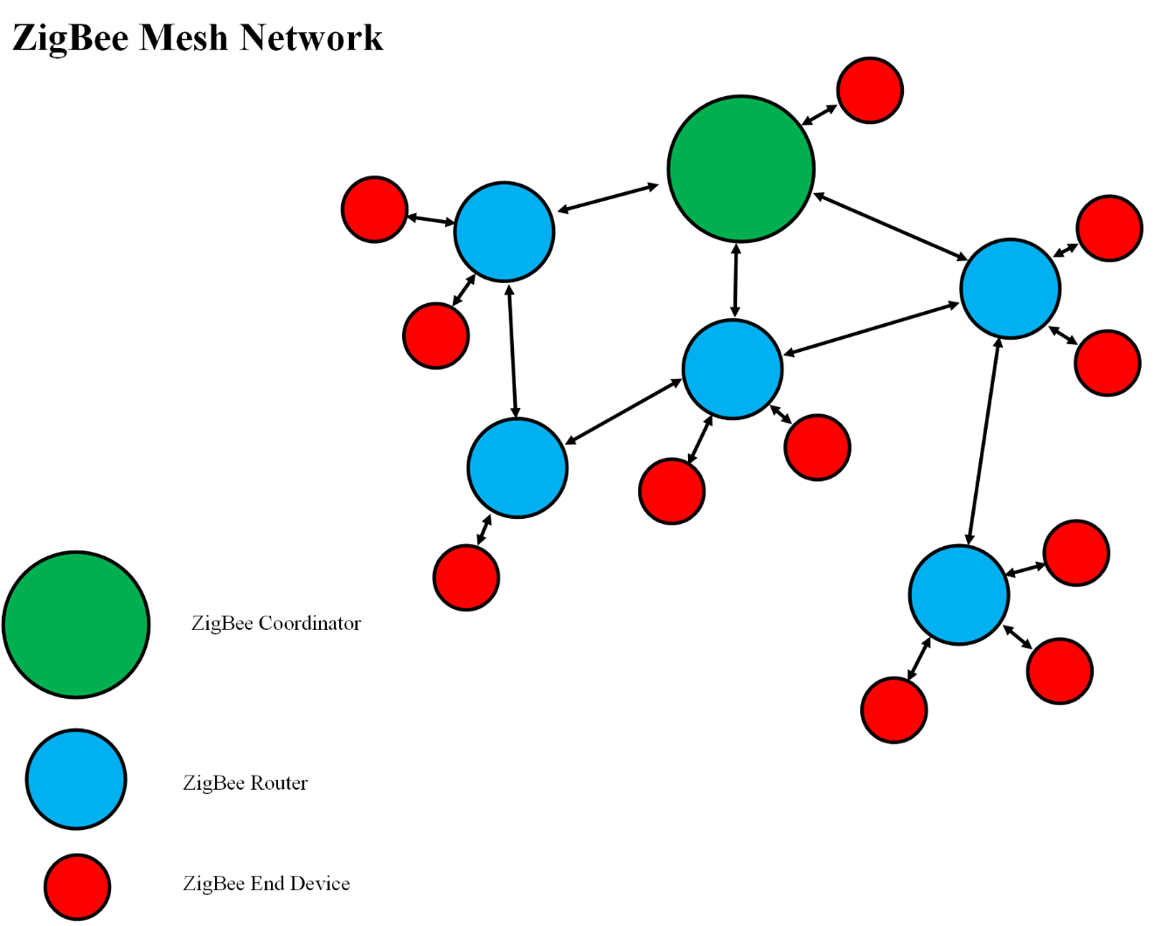
Figure 13 - zigbee mesh network
The drawbacks of incorporating Zigbee into our project is the detrimental fact that 2 separate transceivers are necessary for successfully linking data to the internet. Would the Vital Monitoring Wrist strap last longer on Zigbee hardware? Absolutely. However, the price for a Zigbee transceiver for WI-FI can cost around $20.00 which is a 666% increase in cost versus the ESP8266 for $3.00. That price also doesn’t include the price of the MRF24J40MA chip itself that would be mounted on the PCB for the Vital Monitoring Wrist Strap. The difficulty of setting up and prototyping Zigbee is not an easy task to go through with compared to the setup of the ESP8266. From the research gathered, Zigbee seems to be geared towards industrial and large-scale interconnected devices that require the better efficiency and lower bandwidth to cut costs on power draw. As for the Vital Monitoring Wrist Strap, Zigbee will not be selected as the choice of microcontroller, due to the high cost of peripheral devices needed as well as the complexity of setting up the network.

3.4 Power management:
With the rapid advancements in electronics and computing technologies, latest devices and gadgets are being introduced in the market on a regular basis. These new smart devices exhibit advanced features, reduced power consumption and very compact form factors. Almost all of these smart devices are capable of connecting to the internet and therefore, they can be considered as IOT (Internet of Things) devices. These smart IOT devices are causing major disruptions in the areas of consumer electronics, enterprise business models, healthcare, and logistics.
One of the very popular and widely used sub-categories of IOT based smart devices is wearable devices. Due to the minimal power consumption and compact sizes of electronic components, it is now possible to develop very lightweight electronic devices and gadgets which can actually be worn by people. Some examples of these wearable devices include smart watches, smart jewelry, fitness trackers, smart glasses, and head mounted displays. Apart from their technical features and capabilities, these gadgets have also started to gain the status of fashion statement and lifestyle product.
One smart device which has grabbed the attention of masses is the smart watch combined with the features of a fitness tracker. Many such watches manufactured by iconic brands are available in the market. The latest versions of these smart watches include features such as touch screen display, mobile apps, operating system, WiFi connectivity, social media, and media player. Apart from the generic smart-phone like features, these devices also incorporate fitness and health related features such as heart rate monitoring, calorie tracking, step counter, activity tracking and sleep monitoring. Due to these extra fitness features, these devices have become a must-have for fitness geeks, runners, athletes, and gym rats.
The shiny and elegant looks, as well as the flabbergasting smart features of a smart watch are undoubtedly very impressive however, the real magic happens at the circuit level which remains hidden from the eyes of consumers. Despite of its simplistic looks and minimalist design philosophy, a smart watch is quite a complex electronic system which is a tight integration of multiple sub-systems. Examples of some of these sub-systems include microprocessor system, sensor system, power management system, internet & communication system, GPS tracking system, mechanical assembly, and software system.
The point of our interest and focus in this section of our report will be the power management system. The power system is the most important and crucial part in any type of electronic or electrical system. From huge-sized industrial machines to tiny microchips, electric power is an essential requirement without which these systems are good for nothing. The rapid growth of smart gadgets industry and the consumer requirements are constantly pushing the manufacturers to come up with more and more compact, feature-rich, and power efficient smart devices. These requirements have opened new arenas of research and development for the creation of novel solutions for power management and power conservation in IOT based smart devices.
Once we established that the power management is of great importance it may be even critical especially in the case of battery- powered applications. The slight differences of microamperes can result in months or even years of operating life. Most microcontrollers in the market today aim to achieve this management through various methods such as sleep mode, idle mode, and external peripherals optimal clock frequency.
- Sleep mode: also called standby mode and it is the simplest mode for a designer to deal with the objective is to keep the power consumption low by enabling the system with a quick return to active mode usually via an interrupt.
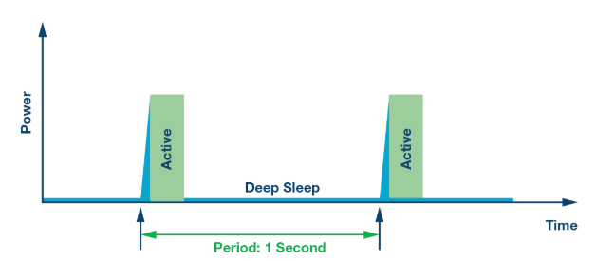
Figure 14 - sleep cycle
- Idle mode: this method turns off the microcontroller since it is the component that consumes most of the power while keeping the peripheral units such as serial port, timers and interrupt system continue operating normally.
- External peripherals optimal clock frequency: in this technique, we manipulate the frequency by slowing d
- own the clock decreases the immediate power consumption. This type of management mode is part of a progressive level of power reduction since it is based on external activity and performance needed.
In our project architecture especially at the level of the PMIC, we are going to follow the state of the art where the PMIC may include a charger, various buck converter, and low drop out regulators. At this level of the research our Vital Monitoring Wrist Strap design challenges are essentially power dissipation and battery sizing.
In the following sections, common power management devices have been selected for research to be adapted into the Vital Monitoring Wrist Strap. Included in the paragraph above was characteristics and features that we aim in our selection. Another category that was not listed is the price and the cost of these PMICs which is a constraint that we will discuss later in this report. Another constraint worth mentioning in the selection process of PMIC is the area that the components will use. As mentioned in the requirements specification, the product will fit in a set size of no more than 4 x 3 inches or less. With the right power management integrated chip, we could avoid any extra peripherals simply by optimizing the I²C commands. At this level of our research, we choose to set a minimum of constraint that will be the criterion to pick a PMIC and they as follow:
- The PMIC must be configurable through an I²C interface.
- The PMIC architecture must allow power switching and sequencing.
- The PMIC must offer a way to have activate safety features including but not limited to overcurrent protection and thermal protection.

3.4.1 Power Management System Design Challenges:
The design of power management system for a smart wearable device is not a straightforward task and presents several challenges to the engineers and designers. Some of these challenges are covered in detail in the following sub-sections.

3.4.1.1 Power Consumption:
The first and the most obvious challenge in the design of power management system for a smart wearable device is that of power consumption. The market trends and competition are forcing the chip manufacturers and device integrators to provide the end user with most power-efficient solutions. This competitive environment has resulted in the creation of semiconductor chips and power electronic devices with super-low power consumption characteristics. Despite of huge advancements in this arena, there is still a lot of room left for improvements. Employment of new solid-state materials, wide band gap semiconductors, latest power converter topologies, and modern fabrication processes promise power electronic converters with ultra-low power consumption in the near future.

3.4.1.2 Battery Leakage Current:
The second great challenge faced by the circuit designers of smart devices is that of battery leakage current. The device should be able to retain enough of its charge so that it provides roughly a battery time of 10-15 hours to the customer on the first-time power up. Due to the very small battery size, the charge retention is a great challenge for the manufacturers. Very high quality and specialized batteries need to be used in such high-performance circuits in order to avoid the charge leakage.

3.4.1.3 Switching and conduction losses
The third design challenge is offered by the switching and conduction losses of the power electronic converters. The conventional Silicon based power electronic switches and diodes waste a significant amount of energy in switching and conduction losses. Due to these losses, the overall power conversion efficiency of the converters is quite low. To overcome the problem of switching and conduction losses, specialized wide band gap materials such as Silicon Carbide are used for the construction of power electronic switches and diodes. These latest power electronic devices offer very less switching and conduction losses as compared to the conventional solid-state materials.

3.4.1.4 Harmonics and EMC
The fourth major challenge is related to the switching frequency of the power electronic devices and converters. In the recent past, switch-mode power converters have come up as a great alternative to the linear power converters. Due to high switching frequencies in switch-mode converters, the size of magnetic and passive elements such as transformers, coils and capacitors, can be greatly reduced. Due to this fact, the size and weight of switch-mode converters is far less as compared to the linear converters. This is a very desirable feature for compact and lightweight devices such as wearable electronics. However, this benefit comes at a price. The high switching frequency generates harmonics and noise in the system. These undesired signals can distort the current and voltage waveforms in the circuit and degrade the system performance.
The higher switching frequency also causes emission of electromagnetic radiation which can cause issues of electromagnetic interference (EMI) and electromagnetic compatibility (EMC) in other electronic devices in the vicinity. Non-compliance with EMC regulations can ban a product from being sold in a market/country. Hence for a device to be marketable in the global market, EMC compliance is a very important requirement and needs to be taken seriously by the product manufacturers. To reduce the frequency harmonics, noise and EMI, the designers need to introduce filter circuits, filter ICs, and grounding/shielding techniques in the circuit board. These additional measures increase the design complexity as well as the unit cost of the product. However, this is a necessary trade-off which must be made in order to keep the device compact and lightweight.

3.4.1.5 Limited battery size and capacity:
Although, the smart phones and the smart watches have the similar software design philosophy and system features, their power management systems are completely different from each other. This is due to the form factor of the smart watch. The typical battery capacity of a smart phone is around 2200 mAh which is enough for a single day’s use. However, the smart watch needs to provide the same features with a battery capacity of mere 40 mAh. This is a drastic difference which makes the design of power management system of a smart watch even more strict and difficult. The extraction of functionality from a smart device with such a limited battery capacity requires very energy-efficient components as well as a tight circuit design.

3.4.2 Design Solutions:
Most of the power in wearable devices is consumed by the microcontroller, LCD display, medical sensors, haptic vibration, and Bluetooth connectivity. However, the power management system of the smart watch does not cope with these requirements by increasing the battery size or increasing the number of energy storage elements. The power system architecture of the smart watch revolves around the concept of SIMO (Single Inductor Multiple Outputs). This helps in keep the design simple and the circuit size minimal.
The challenges associated with the design of power management system for smart wearable devices are countered using the following design techniques and methods.
- Use of wide band gap solid state materials for the construction of power electronic switches and diodes.
- Use of high frequency switching in the converter design to reduce the size of transformers, coils and capacitors.
- Use of harmonic filters, common-mode filters, and differential filters for EMC compliance and EMI rejection.
- Use of latest design topologies which ensure minimum losses and maximum efficiency.
- Use of special purpose batteries to avoid leakage currents and to ensure maximum power output.
- Use of ultra-low Iq regulators to reduce the standby power of sensors which are always on.

3.4.2.1 Power Management System Reference Design:
There are many integrated power management solutions available in the market for the smart wearable applications. In this section we will discuss the reference design of one such power management system developed by Texas Instruments. This PMS solution is purpose-built for devices like smart watches, field transmitters, portable instruments, IOT devices and wearable electronics. In the Vital Monitoring Wrist Strap, and after researching deferent PMICs, we narrowed our choices considering effectiveness and constraints compliances.
- MAX20303:
The MAX20303 is a highly integrated and programmable power management solution designed for ultra -low-power wearable applications, which make it a very strong choice for our Vital Monitoring Wrist Strap.MAX20303 includes a complete battery management solution with battery seal, charger, and power path with a built-in thermal management and input protection. This device is configurable through an I2C interface. Also, the MAX20303 is optimized for efficiency and size which will enhance the value of the Vital Monitoring Wrist Strap by extending its battery life while staying bounded by the size constraints, this PMIC from Maxim Integrated is available in a 0.5mm pitch 3.71mm × 4.21mm and operating interval between -40°C and +85°C. As for its ability of optimal power management is engineered by a flexible set of voltage regulators suited for 1µA (typ) configured to 3.3V or 5V at low quiescent current and low drop-out yielding a safe- output when there is a valid voltage present at CHGIN state. There is another regulator incorporated to this chip that will act as an operation maintainer in a fixed current mode for low current applications.
The technical specification of MAX20303 could be categorized according to the feature it serves, the first category it is oriented to extend the battery use time between charges and for that purpose Maxim Integrated dedicated two micro-IQ Buck Regulators with a maximum 1µA IQ(typ) each, and 220 mA output current with a slight difference between the two regulators when it comes to the voltage range between 0.8V and 3.95V, this device also uses two Micro-IQ LDO one with a voltage input from 1.16V to 2.0V the other LDO has a wider input voltage interval yielding approximatively 100mA in output current. The second category aim the Easy-to-Implement Li+ battery charging offering the capability to fast charge current range from 5mA to 500mA with high voltage input tolerance between –5.5V and 28V. As for the third category Maxim Integrated minimizes the solution footprint through safe output LDO with 15mA when charging is active, Haptic Driver, and optimize system control.[2]
- TPS65720:
TPS65720 from Texas Instrument is one of the smallest PMIC’s oriented to wearable devices, favored over other competitors by its 0.4mm pitch and body size of 2.11mm × 2.11mm it does also contain a Li-Po or Lithium-Ion battery charger, a step-down converter and many other supporting functions. It is also a I2C interface-controlled device. TPS65720 has fulfilled the minimum criterion set earlier to be considered as one of our Vital Monitoring Wrist Strap PMIC choices. It has an operating interval between -40°C and +85°C. As for its ability of optimal power management is engineered by a flexible set of voltage regulators suited for 1µA (typ) with very good margin for the input voltage that between 2.3V and 5.6V at low quiescent current.
The TPS65720 offers a set of features suitable for our Vital Monitoring Wrist Strap especially the 28 Volt rated power path, up to 500mA input current, and 300mA charge current. This features along with a flexible Vin range for DC to DC converter from 2.3V to 5.6 V, a 2.25-MHz fixed frequency operation, an output voltage accuracy in power management mode of ±2%, and I²C compatible interface that we will use to optimize the 100% duty cycle for lowest dropout and saving power mode at light load current. Finally, the space factor that is well engineered that complies with the space constraints set by the Vital Monitoring Wrist Strap design.[3]
- DA9070:
In this PMIC the manufacturer (Dialog SEMICONDUCTOR) did include dynamic power path management that balances current delivered between the system and the battery, which make this PMIC very effective in wearable devices design. This power management IC comes in 2.97mm×2.66mm compacted package, I²C configurable, analog battery monitor, and wide voltage tolerance. This PMIC could bring to our Vital Monitoring Wrist Strap an ultralow quiescent current of 900 nA using the buck regulator, and even lower Iq of 800 nA at load switches.
The DA9070 offers a set of features suitable for our Vital Monitoring Wrist Strap especially the 22 Volt rated power path, up to 500mA input current, and 300mA charge current. This features along with a flexible Vin range for DC to DC converter from 2.3V to 5.6 V, a 2.25-MHz fixed frequency operation, an output voltage accuracy in power management mode of ±3%, and I²C compatible interface that we will use to optimize the 100% duty cycle for lowest dropout and saving power mode at light load current. Finally, the space factor that is well engineered that complies with the space constraints set by the Vital Monitoring Wrist Strap design.[4]
- MAX14676/MAX14676A:
The MAX1476/A is a highly integrated and programmable power management solution designed for ultra -low-power wearable applications, which make it a very strong choice for our Vital Monitoring Wrist Strap. MAX1476/A includes a complete battery management solution with battery seal, charger, and power path with a built-in thermal management and input protection. This device is configurable through an I2C interface. Also, the MAX1476/A is optimized for efficiency and size which will enhance the value of the Vital Monitoring Wrist Strap by extending its battery life while staying bounded by the size constraints, this PMIC from Maxim Integrated is available in a 0.5mm pitch 3.497mm × 3.118mm and operating interval between -40°C and +85°C. As for its ability of optimal power management is engineered by a flexible set of voltage regulators suited for 900nA (typ) and 74% efficiency with 10µA output configured to 1.8V at low quiescent current and low drop-out yielding a safe- output when there is a valid voltage present at CHGIN state. There is another regulator incorporated to this chip that will act as an operation maintainer in a fixed current mode for low current applications.
MAX1476/A could be categorized according to the feature it serves, the first category it is oriented to extend the battery use time between charges and for that purpose Maxim Integrated dedicated two micro-IQ Buck Regulators with a maximum 0.9µA IQ(typ) each, and 200 mA output current with a slight difference between the two regulators when it comes to the voltage range between 0.8V and 3.95V, this device also uses two Micro-IQ LDO one with a voltage input from 1.16V to 2.0V the other LDO has a wider input voltage interval yielding approximatively 100mA in output current. The second category aim the Easy-to-Implement Li+ battery charging offering the capability to fast charge current range from 5mA to 500mA with high voltage input tolerance between up to 28V. As for the third category Maxim Integrated minimizes the solution footprint through safe output LDO with 15mA when charging is active, Haptic Driver, and optimize system control.[2]

3.5 Battery
As we know, the battery convert the chemical energy to electric energy. Some batteries are rechargeable, and some are not. The rechargeable batteries mean we can charge them again and again in every time they drained out. So, that will save us time and money. But the regular batteries or disposable, we will through them out after they drained out. Based on our project, we will may to use the rechargeable batteries. Many button cell batteries and coin cell batteries have what it called low self discharge. Low self discharge means that these batteries can hold the charge for long time comparing to the other types of batteries. This feature will give long shelf life. These batteries will be great to be used in the wearable devices because of their consisting and reliability. So, for example, when they use them for some artificial body parts like the artificial hearts, it can stay for more than six years without replacing them.

Both Button cell batteries and Coin batteries got their names for their shapes. The Coin battery is thinner than the Button one. Their size range is between 1 to 6 millimeter in height and 5 to 25 millimeter in diameter. Usually, Cell batteries are disposable while Button batteries are rechargeable. Also, most of these two types of batteries are used in computer devices in order to save the date when we power the devices off. When it comes to the standard naming of batteries, it’s not easy to find the battery that we are looking for based on their names. The easier wan to find a specific battery based on our needs is by learning the formats of batteries names. These standards names based on either International Electrotechnical Commission or American Standard National Institute. [1]

For the Primary batteries (non rechargeable), it became a popular too. The reason is sometimes it’s not an easy to use the rechargeable batteries such as during the military missions. Batteries can be classified based on their chemistry. The most popular are Lithium, Nicklel based systems, and Lead. Based onBatteryUniversity website, The Lithium-ion is take 37% as the battery choice for portable devices . Then Lead acid , started battery share 20%. Alkaline takes 15% from the total then 8% for the Lead acid, stationary. Zink-carbon, Lead acid, deep-cycle, and Nickel-metal-hybrid will take 6%,5% and 3% sequentially. And after that, 3% for Lithium, primary and 2% for Nickel-cadmium [2].

A great advantage for primary batteries like Alkaline is the storage life. It can be stored for 10 years. It also, had a unique safety history and that’s why it could be carried on airplanes without being subjected to transport regulation. Some disadvantage needs to be mentioned are lights load and low current load and that why it used for flashlights and to power the remote controls. So, when the user looking for higher capacity, he or she should focus on Lithium metal batteries. All in all, the primary batteries are used in devices that need occasional power, but the dark side is they will be expensive if continuous use needed. The US army batteries conference a general said that 50% of the batteries that discarded still have 50% power left. The Table 13 below is the Performance Characteristics [3].

3.5.1 Rechargeable Battery
Each cell in the battery store the electrical energy as a chemical energy in two electrodes. One of them is called Anode, and the other one called Cathode. These electrodes are separated by an electrolyte material that transfer the components during the chemical reaction. The chemical reaction of a rechargeable battery must be reversible on the application of a charging I and V. Critical parameters of a rechargeable battery are safety, density of energy that can be stored at a specific power input and retrieved at a specific power output, cycle and shelf life, storage efficiency, and cost of fabrication [8].

A great feature about the rechargeable batteries that it’s can be reused many times depending on the performance of the battery. So, that can save both time and money. It’s also a better for the environment. Rechargeable batteries can be made in different compositions including Nickel Cadmium NiCd, Lithium Ion Li-ion, Lead Acid, or Ion Polymer Li-ion Polymer. Each battery has different performance characteristics that as summarized in the Table 12. Another advantage of rechargeable batteries is they are convenient. They can easily and conveniently recharge with a battery charger. These battery chargers come with different designs and become more reliable and durable. Most of the battery charger cane charge different types of rechargeable batteries. Also, nowadays the rechargeable batteries can be charged through wall outlet or wirelessly.

Another advantage for rechargeable batteries is the better performance. By using the rechargeable battery, the use will get same peak performance all the time whenever if the battery has full charge or not, while using the non-rechargeable battery the peak performance will be weak when the battery is close to drain. In addition, when it comes to the wearable devices, using the rechargeable batteries will save the user time especially in wearable health devices.

Table 12: Overview of Rechargeable Battery Types
 | NiCd | NiMH | Li-Ion
Energy Density | Average | Average | High
Memory Effect or Lazy Effect | Memory effect | Lazy effect | No
Costs | Cheap | Average | Expensive
Self-Discharge, % per Month | 25 | 25 | 8

Table 13: Specification comparison between different battery materials
Specification | Lead Acid | NiCd | NiMH | Li-ion
Specific Energy | 30-50 | 45-80 | 60-120 | 90-250
Internal Resistance | Very Low | Very Low | Low | Very low-Moderate
Cycle Life | 200-300 | 1000^3 | 300-500^3 | 500-2000
Charge time | 8-16h | 1-2h | 2-4h | 1-4h
Overcharge  tolerance | High | Moderate | Low | Low
Self -discharge  per month | 5% | 20% | 30% | <5%
Cell Voltage | 2V | 1.2V | 1.2V | 3.2-3.7V
Charge Cutoff  Voltage | 2.40 | Full charge detection by voltage signature | Full charge detection by voltage signature | 3.60-4.20
Discharge Cutoff  Voltage | 1.75V | 1V | 1V | 2.50-3V
Peak load  current | 0.2C | 1C | 0.5C | <1<10
Charge Temperature | -20 to 50C | 0-45C | 0-45C | 0-45C
Discharge  Temperature | -20 to 50C | -20-65C | -20-65C | -20 to 60C
Maintenance  requirement | 3-6 months | Full discharge evry 90 days | Full discharge evry 90 days | Maintenance Free
Safety requirements | Thermally Stable | Thermally Stable fuse protection | Thermally Stable fuse protection | Protection Circuit mandatory
Efficiency | 90% | 70% -90% depend on slow or fast charge | 70% -90% depend on slow or fast charge | 99%
Cost | $25 | $50 | $60 | $100

3.5.2 Li-ion Battery
These types of batteries have a great feature and that’s why they are too popular nowadays. Most of wearable devices use LiPolymer even Cells or LiCoin rechargeable batteries. Li-ion battery have a small size and that make it a great for most of small devices. The first Li-ion battery became available at 1970s [38]. After almost 10 years, the rechargeable version announced. Based on weight and size, Li-ion is the best battery as a source of power. It can provide high energy densities.

3.5.2.1 Cost and Performance
In 1994, The Li-ion battery from manufacture was costing more than $10 for 18650 cylindrical. But, today, with more performance battery with over 3000mAh and 18650 energy-dense, the cost is reduced. Table 13 above shows a specific detail about the performance, power and capacity. Li-ion battery is a low maintenance battery and that considered as a great advantage comparing to the other types of batteries.

It also does not require a full discharge. Also, the self-discharge is almost than the Nickel-based system. The dark side for Li-ion battery is it needs a protection circuit. Also, the changing in chemical materials is affect the battery. It also could be subject to aging whether in use or not.

3.5.2.2 Power and Capacity
Li-ion batteries have a good range of capacity and that make them a fit for our project. While some types of Li-ion batteries have 500 mAh capacity, other types of these batteries have up to 1200 mAh. Also, the nominal voltage is about 3.7 V. Also, the cycle life will be >500 to >400.

3.5.3 NiCd Battery
Nickel–cadmium battery is a shortcut name for two chemical elements, Nickel and Cadmium. It is a secondary type which can be recharged. Typically the positive electrode is made of Nickel hydroxide (Ni (OH) 2) and the negative electrode is composed of Cadmium hydroxide (Cd (OH) 2), with the electrolyte itself being Potassium hydroxide (KOH)[7].Nickel–cadmium battery has low density for energy. It has high toxic metals and that make them not friendly for environment. This battery invented in 1899, but the sealed commercial version made in 1947[39]. This battery is usually use in two-way radios, medical equipment, and cameras. Nowadays, many airlines industries use this type of battery.

3.5.3.1 Cost and Performance
nickel–cadmium battery is the lowest in terms of cost per cycle. According to RWTH, Aachen, Germany (2018), the cost of nickel–cadmium battery is about $400 per kWh[6]. nickel–cadmium battery have many advantages such it’s Rugged with high cycle count with proper maintenance. Also, it’s the only battery the feature that can be ultra fast charged with little stress. In addition, it has a good performance in case of abusing.

It also can be stored for long time, but it just needs to be discharged before the storage. It also does not subject to the regularity control. nickel–cadmium battery recorded a good performance with a low temperature. Finally, it’s available in a many sizes and performance options.

Also, because of the wide range of temperature, nickel–cadmium battery became the main battery in aircraft. In the other hand, nickel–cadmium battery have some disadvantages. It’s provided a low energy density. It also it has high toxic and that make it unsafe comparing to other batteries. Another disadvantage is the high self-discharge. Finally, the cell of this battery has very low voltage, so more cells will be requiring getting the voltage that the user try to achieve. nickel–cadmium battery should be full discharged very three months as required for maintenance.

3.5.3.2 Power and Capacity
Nominal voltage for nickel–cadmium battery is 1.2V per cell. The Trickle charge is 0.1C with 45 to 80 Wh/kg. The charge rate for nickel–cadmium battery is above 1 C, while the discharge will have the same rate value (above 1 C). When it come to the cycle life, nickel–cadmium battery will have 1000 cycles.

3.5.4 Rechargeability and Batteries:
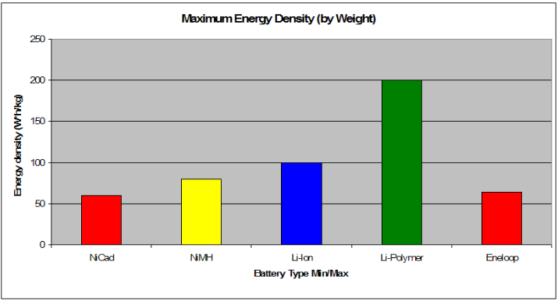
Enough power source will be used to power the Vital Monitoring Wrist Strap which will have its own rechargeable battery and charging circuitry. An intense research is needed to pick the right rechargeable battery which at this level of research yield three leading types of batteries, Lithium-ion, Lithium-polymer, and nickel cadmium batteries. After an initial comparison is established here, while further investigation is to come later in this report, we summarized it as illustrated below.
Figure 15 - li-ion and li-po

This comparison showed that the Li-Ion and Li-Po are more suitable for our project because of their superiority in energy density, size and weight, and lack of memory effect.[5]

Table 14: Summary on Li-Po batteries.
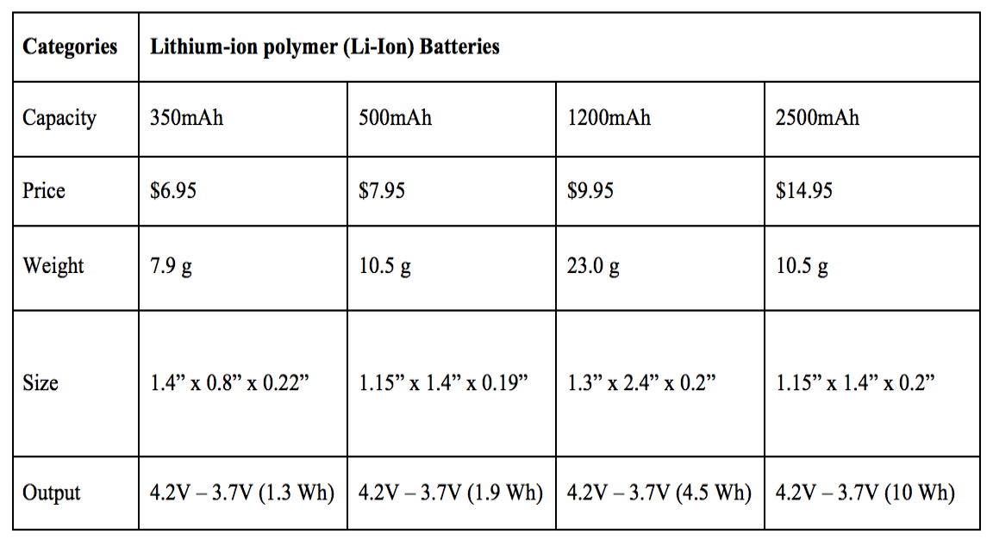

3.5.4.1 Lead Acid Battery
The lead acid battery was the first battery ever introduced for the commercial use around 150 years ago. Despite being a very old technology, it is still very widely used. The main reasons behind its popularity are its durability, high stable current output, and low cost-per-watt ratio. The lead acid batteries are very commonly used in cars, trucks, motorbikes, UPS systems, forklifts and energy storage applications.

3.5.4.2 Pros and Cons of Lead Acid Battery
The lead acid batteries, despite being a very old and dated technology, are still being widely used. The main reason behind this is the number of advantages that these batteries offer. Some of these advantages are listed as following: [56]
- Low energy cost per kWh
- Durable and rugged construction
- High tolerance for over-charging
- Lower internal impedance
- High and stable output current capacity
- Very long shelf life when stored without electrolyte
- Availability in wide range of capacities and sizes
- Easier recycling process
- Superior performance under sub-zero temperatures

Despite of their large-scale popularity and massive usage, lead acid batteries do have their own limitations and shortcomings. So of the problems with lead acid batteries are given as following: [56]
- Heavier and bulkier as compared to other batteries
- Typical charge efficiency is only around 70% which is quite low
- Hazard of overheating during charging process
- No option for fast-charging is available
- Moderate battery life of around 300-500 cycles
- Requires full-charged storage to avoid sulphation
- Requires regular topping up of water to due to gassing phenomena
- Toxic materials used in the battery construction and operation

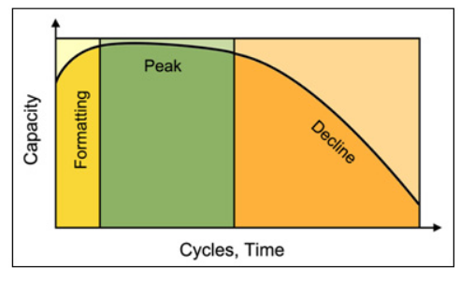
Figure 16 - cycle life of a battery

3.5.4.3 Application areas of lead acid batteries
There are a number of domestic, commercial and industrial applications in which lead acid batteries are widely employed. Some of the application areas of these batteries are given as following: [57]
- Automotive applications
- Standby and backup electrical power systems
- Solar and wind energy storage applications
- Submarines and marine applications
- Fire and security system backup power
- Starter batteries for on-line power generators

3.5.4.4 Types of lead acid batteries
One of the biggest advantages of lead acid batteries is that they are around for quite some time and therefore, are available in different varieties, sizes and capacities. Different types of batteries are available for different applications and market niches. Some of the types of lead acid batteries are described as following: [57]

3.5.5 Lead Calcium batteries
When Calcium is introduced to the battery electrodes, numerous benefits are obtained. The problems of corrosion, over-charging, gassing, water-usage and self-discharge are minimized. This significantly improves the battery life and efficiency. In addition to that, these batteries have a higher cold cranking current rating compared to other lead acid batteries. They also require lesser maintenance.

3.5.5.1 Lead Antimony batteries
When Antimony is added to the electrodes of a lead acid battery, many benefits can be reaped. The first benefit is that the mechanical strength of the battery is increased which is very important for EV applications. The second advantage is reduction of internal heat and water loss due to gassing. These batteries tend to have longer life spans as compared to Calcium based batteries. The self-discharge rate of these batteries is higher as compared to Calcium lead batteries.

3.5.6 Absorbed Glass Matt (AGM) batteries
In these types of batteries, Boron Silicate fiberglass is used as a separator between the electrodes and absorbs the extra electrolyte. These batteries offer the advantage of higher charge/discharge rate and deep cycling. These batteries have very low self-discharge rates.

3.5.7 Starting, Lighting and Ignition (SLI) batteries
These batteries are widely used in automotive applications for starting and ignition.

3.5.8 Rechargeable Alkaline Battery
Alkaline batteries are the batteries in which electrical energy is produced due to the chemical reaction between Zinc and Magnesium Dioxide. They are known as alkaline batteries because the electrolyte used in these batteries is potassium hydroxide, which is an Alkaline chemical. Alkaline batteries have a high-power density and longer storage life. These are the most commonly used battery type in the world and are used in low power portable applications such as media players, gaming consoles, digital cameras, toys, torch lights, remote controllers, clocks and radios.

The rechargeable versions of the alkaline batteries can be charged and reused again and again. The non-rechargeable versions of th alkaline batteries can only be used for a single time and are disposable.

3.5.8.1 Chemical composition
The positive electrode in an alkaline battery is made of Magnesium Oxide whereas the negative terminal is made of Zinc. The Potassium Hydroxide is used as an electrolyte in the reaction and does not get consumed. The potential difference is created due to the chemical reaction between the positive and negative terminals.

3.5.8.2 Capacity
The nominal voltage of a new alkaline battery is 1.5 Vdc. The battery drain current highly depends on the type of load. At a load current of 1 ampere, the battery capacity is typically 700 mAh. However, the current capacity of the battery depends heavily on the battery size. The capacity of alkaline batteries is higher than the Zinc Carbon batteries because of the higher power density of these batteries.

3.5.8.3 Construction
The outer shell or casing of the battery is made of a hollow steel drum or container. This steel shell keeps all the battery components together and also serves as the cathode of the battery. Inside the shell, there is a layer of cathode powder which is a mixture of coal dust and magnesium dioxide. This outer layer of cathode mixture is separated from the inner layer of zinc by means of a paper separator. Potassium hydroxide serves as the electrolyte between the zinc and cathode mixture layer. A metallic negative collector pin runs through the center of the assembly for the purpose of collection of negative charge. A plastic separator is present on the metallic end which separates the positive container from negative metallic pin.

3.5.8.4 Advantages of rechargeable alkaline batteries
Rechargeable alkaline batteries are the most consumed type of batteries in the world. Their popularity is due to the several advantages which these batteries offer. Following are some of the advantages of these batteries [58]:

- These batteries are rechargeable and can be used over and over again.
- Due to the reusability, these batteries are very cost effective.
- They have higher power density as compared to non-alkaline batteries.
- These batteries are safe to use and contain moderate levels of toxic ingredients.
- These batteries very lightweight and hence ideal for portable applications.
- Good performance in continuous as well as intermittent applications.
- Better dimensional and structural stability.

3.5.8.5 Disadvantages of rechargeable alkaline batteries
The rechargeable alkaline batteries do have their own set of disadvantages. Following are some of the disadvantages [58]:
- These batteries have relatively higher internal resistance which drops the output power.
- Due to higher internal resistance, the battery gets heated up quite easily.
- These batteries have a bulkier form factor as compared to the Lithium Ion batteries. This prevents their usage in the mobile and laptop devices.
- Due to their bulk production and toxic materials, their recycling is a significant challenge.
- Chemical leakage from the batteries can result into corrosion and explosion.

3.5.8.6 Environmental impact
The rechargeable alkaline batteries are designed for multiple recharges. Hence the adoption of rechargeable batteries results in the reduced number of disposable batteries being manufactured. Recycling of alkaline batteries is a challenge hence by reducing the number of disposable batteries being manufactured the rechargeable batteries are serving the cause of green revolution.

The older alkaline batteries contained mercury or cadmium, which are highly toxic materials. Due to the hazards of toxic leakages, the rechargeable batteries are designed without any toxic materials and therefore, they have a rather positive impact on environment.

3.6 Recharge chip:

3.6.1 MCP73833
The wearable devices rechargeability introduce an additional set of challenges to our project, these challenges are bounded by the design constraints especially effectiveness and space limitation. At this stage of the research we had compared a few chips that has both the ability of delivery and safety features. These conditions set for by the Vital Monitoring Wrist Strap constraints can be fulfilled using the MCP73833 a stand-alone linear Li-Ion/Li-Polymer charge management controller that offers 1A output current. Includes integrated pass transistor, integrated current sensing, and reverse discharge protection. The MCP73833 is available in 3mm × 3mm DFN package. We include below a set of features that will make the difference in our design:

Table 15: MCP73833 Features
MCP73833 Features
High accuracy preset output voltage regulation.
Regulated output voltage options.
User-programmable charge current up to 1A.
Preconditioning and end-of-charge ratio options.
Two open-drain Status outputs.
Under-voltage lockout.
Power Good output

3.6.2 BQ2510X
Another alternative to the MCP73833 is the bq2510x from Texas Instruments, although it is a single cell Li-Ion or Li-Pol battery charger it still offers 250mA at 1mA termination, in addition to a very minimal battery leakage estimated at 75-nA. As for its suitability to our Vital Monitoring Wrist Strap Texas Instruments has integrated in bq2510x series a multitude of features that we categorized to three major facades, charging, protection, and system. As for the charging bq2510x has the ability of 1% charge voltage accuracy,10% charge current accuracy, it will support any low charge current application of 10mA to 250mA, it will give us the ability to set the termination and the pre-charge threshold, and a high voltage support of 4.35V. At the protection level the bq2510x have an outstanding thermal regulation of 125°C and shutdown temperature of 150°C. Finally, the bq2510x system is packaged in 1.6mm × 0.9mm with automatic system termination.[7]

3.6.3 BQ2430/32
For a higher charge current that is beyond 250mA Texas Instruments offers other alternatives a like BQ2430/32 a fully-compliant USB charger that also monitor the output current. This device continuously monitors the input voltage, the input current, and the battery voltage.[8] Its active fault condition gives it the ability to turn off while the output is isolated from input source. The BQ2430/32 is a space saving with a body size of 2.0mm × 2.0mm. If the testing phase shows the need to elevate the overcurrent threshold can be increased using internal resistor. We think that BQ2430/32 is good candidate for our Vital Monitoring Wrist Strap but testing and cross examination of features will affect our choice decision.

3.6.4 BQ25120 battery charger module
BQ25120 is a family of battery charging power modules from Texas Instruments. This module can be used for charging the Li-ion battery as well as for powering the system. This module provides three modes of operation. The first mode is the pre-charging mode. In this mode, the module is used for recovering a fully discharged battery. The second mode is the fast-charging mode. The module provides constant current to the battery for fast-charging in this mode. The third mode is the voltage regulation mode in which the module provides constant voltage in order to safely charge the battery to its full capacity. The fast charge current and pre-charge current threshold is programmable which provides greater degree of flexibility to the circuit designer. The module can provide charging current in the range of 5mA to 300mA. The default charge current is 260mA and the default termination current is 8mA. However, these default values are programmable via I2C interface. In addition to the currents, the output voltage is also programmable within the range of 0.8V to 3.3V. The device features a built-in buck converter.

3.6.5 BQ51003 wireless charging module
The use of wireless charging in a smart wearable device is optional and depends on the manufacturer. However, the PMS from Texas Instruments provides the system designer the provision to include a wireless charging feature in his/her product. This feature is implemented in the product design using the BQ51003 IC module. The operating principle of wireless charging is based on magnetic induction. The primary side of the wireless system consists of a charging pad with a coil built-in. The secondary side of the wireless system also contains a coil which is magnetically coupled to the primary coil. The power flows from primary to secondary side by means of magnetic induction. A feedback control loop is in place from secondary to primary which is used to control the amount of power flow. The BQ51003 module houses an AC/DC converter with integrated digital control system. The digital control system uses back-scatter modulation and employs Qi communication protocol for wireless communication with the primary side circuitry. The AC signal received from the primary side is first rectified and regulated, and is then provided to the appropriate electronic sub-systems. The module boasts a low impedance full wave rectifier, low drop-out regulator, digital control system and precise voltage/current loops.

3.6.6 BQ2970 battery protector module
The BQ2970 serves as the primary battery protection module in the power management system of a smart wearable device. It is designed to be used with Lithium-ion batteries. This module protects the battery against over-charging as well as charge depletion. The module implements timer delays for the safe turning on/off of transistors. The module also has a feature of zero voltage charging. This feature allows the charging of depleted cells before the battery could be used for normal functions. The module includes several sub-systems such as current comparators, hysteresis comparators, counters, oscillators, and logic circuits for an efficient implementation of a battery protection system.

3.6.7 BQ27421 impedance tracking module
Fuel gauging and the awareness of battery condition is of utmost importance for the end consumer in order to operate the device effectively. The BQ27421 is a microcontroller based configurable IC which is used for fuel-gauging applications in the smart wearable applications. It is designed to work effortlessly with Lithium-ion batteries. The integrated circuit employs impedance tracking algorithm for providing the information about state-of-charge, remaining battery capacity, and battery voltage. The module can be communicated with using standard and extended commands. The commands can be given to the module using I2C interface. The module senses the voltage across a sense resistor and assesses the status of battery using impedance tracking algorithm. The module also contains a temperature sensor for the monitoring of battery cell temperature. The module is designed in such a way that it requires minimum configuration and firmware development on the designer’s part.

3.6.8 TPS61046 boost converter module
The TPS61046 is an integrated boost converter module from Texas Instruments. These boost converter modules are geared for applications which require high voltage and a compact form factor. The module assembly consists of a 30-V power switch, input/output isolation switch, and a power diode. The module can provide a maximum voltage of 28V with a Lithium-ion battery.
In conventional boost converters, there exists a conduction path between the input and the output, even when the switch is turned off. This conduction path results in leakage currents, excessive overload currents and higher inrush currents. The isolation switch present in the TPS61046 provides true isolation of input and output when the switch is turned off. This results into the increase of performance and efficiency.
The TPS61046 integrated module works at a high frequency of 1MHz. This high frequency operation allows for the significant reduction in the size of magnetic and passive components enabling a very compact form factor and reduced power consumption. The maximum rated current of this module is 900 mA. The module also houses the soft starting circuitry for limiting the inrush currents. The TPS61046 has built-in short circuit protection, thermal shutdown and over voltage protection.

3.6.8.1 Micro USB interface
The integrated power management system for smart wearable devices also includes a micro USB interface for providing input power to the system. The small size of the micro USB port helps the device in maintaining its compact form factor. The USB interface, although capable of providing power as well as data transmission capability, is only used for providing input power to the PMS. The system configuration and firmware development is performed using the I2C interface

3.6.8.2 EV2400 I2C interface
The EV2400 is an interface board and a firmware updater from Texas Instruments. It is designed to communicate with peripherals through SM-Bus and I2C communication protocols. The system is specifically designed for interfacing with fuel-gauging ICs in the power management system for wearable electronics. It connects to the peripherals and ICs via USB interface. This firmware updater module is compatible with PCs and requires the installation of appropriate drivers for its functioning.

3.7 Charging Circuitry:
Vital Monitoring Wrist Strap like any other typical wearable its architecture especially at the level of the PMIC. We are going to follow the state of the art where the PMIC may include a charger, various buck converter, and low drop out regulators. At this level of the research our Vital Monitoring Wrist Strap design challenges are essentially power dissipation and battery sizing. Our system will require a charger and various outputs regulated for circuits functions, at this level in our research we see that this part could be divided into two supply buses:

microcontroller and communication protocols which respectively will need 3.3V and 1.2V These characteristics will be achieved through a bidirectional I²C interface to configure and monitor device status. The PMIC circuitry also includes a controlling and supervisory parts.

In our circuitry we will be using multiple LDOs to provide a stable power supply voltage independent from the load impedance, input voltage variation temperature, and times. For our Vital Monitoring Wrist Strap, we will be using battery with the constraints of limiting the charge drop because we want to maintain 2.5V at the load for example, always, knowing that the battery lowest charge allowed is 2.7V. As for our LDO choices we are to consider the input voltage. Also, important to consider minimum drop out voltage, maximum load current, quiescent current and power dissipation. Below is a closer of the performance interval for most LDO in the market. Below is a closer of the performance interval for most LDO in the market.

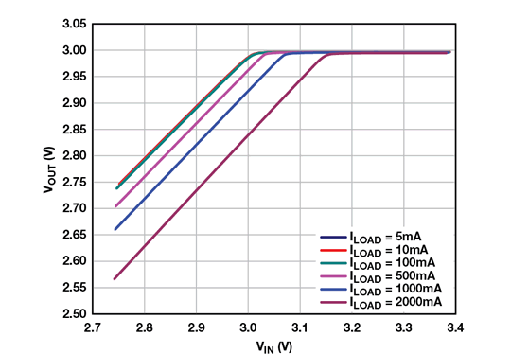
Figure 17 - ldo dropout region efficiency [9]

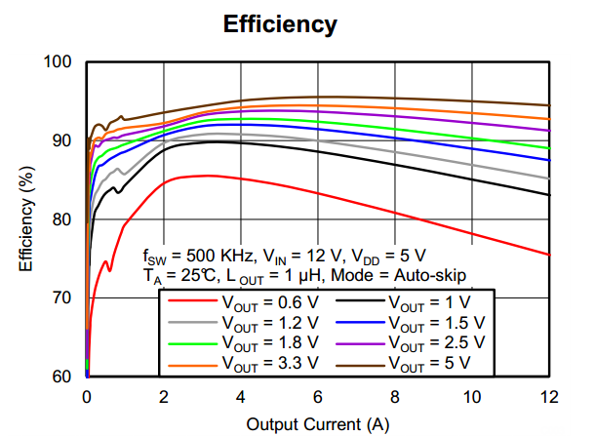
This will in the circuit part that conditions the DC power, we will a class of converter with a high switch mode efficiency. Especially, the Vital Monitoring Wrist Strap will require an optimized power use, Buck converter will give the ability to implement switching at optimized level leading to better management and system response. A typical response is illustrated in Figure 18 below:
Figure 18 - buck converter efficiency

3.7.1 Charging circuitry features:
There are several features and functions which a power management system, especially at the charging circuitry, level must be able to provide in order to be deemed suitable for use in wearable smart devices. Some of these features are listed as following and are discussed in detail in the subsequent sub-sections:
- Energy harvesting
- Qi compliant wireless charging
- Fuel gauging
- Iq regulation and minimization of losses
- Current, voltage and thermal protection
We already established in the previous sections that the battery capacity of a smart watch is very less. Providing longer battery times to the consumers is one of the major concerns of the smart watch manufacturers. To achieve longer battery times, many novel methods and techniques are being researched and presented. One of the ingenious and practical methods being proposed is that of energy harvesting. The idea of energy harvesting essentially revolves around the harvesting of energy from the immediate environment in which the watch is present, rather than from the battery. If successfully implemented, this energy harvester will act as a secondary power system and will reduce the burden on the main battery which will result in extended battery time.
Energy harvesting is not an entirely new idea. It has been successfully implemented in many portable devices in the past such as watches and calculators. However, the traditional energy harvesting designs have always been based on solar photovoltaic cells. These photovoltaic cells served their purpose well in those low power devices. The watches and calculators are simple devices with monochrome displays and low-power oscillator-based operation. However, the latest smart watches are not such simple systems. They require features such as MP3 players, touch-screen color displays, various sensors, Bluetooth connectivity, and call/SMS functions. Therefore, the solar photovoltaic cells are not capable of providing enough power demanded by a smart watch. The average power requirement of a smart watch ranges from 200 mAh to 450 mAh. 450 mAh is an adequate power capacity which can provide a battery time of around 36 hours. This much battery time is convenient for the consumer and does not force him/her to put the device on charging every 12 hours. Due to the higher energy requirement of wearable devices, new methods and technique of energy harvesting are being tried and tested by the manufacturers. The energy harvesting method being chosen must be practical, cost effective, and able to meet the energy requirements of the smart watches. Some of the proposed solutions for energy harvesting in wearable smart devices are presented as following:
Employment of transparent solar cells. These solar cells, due to their transparent nature, can be overlaid on top of the device screen. There are many advantages to this approach. The first benefit is that it allows for a large sized solar cell to be placed on top of the device screen. The solar cell can have roughly the same dimensions as the smart device screen. The solar cell does not require any dedicated space being allocated for its installation. This is a huge advantage in terms of maintaining the device form factor. The second advantage of this solar cell is that it does not obstruct the screen view and serves as an additional protective layer for the device’s touch screen. However, this technology is not perfected yet and is still in the development phase. These solar cells work only with some specific wavelengths of the non-visible ultraviolet and infrared light spectrum. Due to this reason, their current efficiency is only around 1%. However, efforts are being made to increase this number to a significant level so that this technology can be made available to the consumers.
Another potential source of energy harvesting could be the piezo-electric crystals. This is not a new technology and has been well tested in many previous applications as well. The pizeo-electric crystals are the devices which convert mechanical motion into electrical energy and electrical energy into mechanical vibration. This means that when a mechanical force is applied to a piezo-electric crystal, it develops voltage at its output and when a voltage is given to this crystal, mechanical vibration is produced. These crystals can effectively be used for converting the user’s motion energy into electrical energy. However, there are some serious problems with this technology as well. For the piezo-electric device to produce power, the user must be walking or moving. This constraint the amount of power being produced by these devices. Making the power generation process dependent on user’s motion is not a practical idea. This scheme might work well for athletes, runners, joggers, and sports lover, but it cannot gain widespread success with common consumers.
Another proposed method for energy harvesting is the utilization of radio frequency power. We are surrounded by radio frequencies and signals all the time. Our televisions, satellites, cell phones and other communication devices are constantly throwing out radio signals. These radio signals do carry power which can be harvested for use in wearable electronic devices. However, this technology is just in prototyping and research phase. Another great challenge with this technology is that it cannot produce any significant amount of energy and therefore, it might not be a suitable option for wearable devices.
The harvesting of ambient energy is not an easy task. Even if a viable and practical energy harvesting method is available, the integration of this secondary energy system with the battery is a very challenging task and requires special power electronic devices and materials.
Wireless charging is a feature that has been increasingly introduced in the latest smart gadgets and devices. The wireless charging allows the user to charge the device without any cables or wires in a safe manner.
The wireless charging technology is based on the Faraday’s law of electromagnetic induction and therefore, is sometimes also known as inductive charging. Both the charging pad and the device have coils built into them. These coils are magnetically coupled to each other. When the AC current flows through the primary coil, a voltage is also induced in the secondary device coil by the phenomena of electromagnetic induction. The AC voltage induced in the secondary coil is rectified and then stepped down by means of DC-DC buck converter IC modules. The voltage is then regulated using built-in regulators and filters. This regulated voltage is then provided to the smart watch peripherals and sub-systems such as LCD, microcontroller, GPS and Bluetooth ICs. For the efficient control of electric power flow from primary to secondary side, a digital wireless control system must be present. This feedback control system takes the feedback from the output boost converter voltage and provides it to the primary side in order to restrict or increase the flow of power as per demand.
One of the popular and widely used standard/protocol for wireless charging systems is known as Qi. One of the major reasons of popularity of this protocol is its adoption by Samsung and Apple for their smart phones. Qi protocol is designed for inductive charging rather than resonance based wireless charging. Inductive charging ensures smaller size of components as compared to the resonance charging and hence it is ideal for use in space constrained applications such as smart wearable devices. A large number of chips and power management modules are available in the market which use Qi standard for wireless charging which makes its implementation very easy and cost effective.
The only significant drawback of Qi compliant charging systems is that the Qi protocol requires very precise distance and alignment for charging process. The devices must be placed in a precise manner on the charging pad. The resonance-based chargers are better in this aspect because they do not impose such strict requirements.
The charging current in the power management system of a smart wearable device must be regulated using a constant current regulator. Many times, the off-the-shelf charging solutions provide programmable regulators which allow for multiple modes of operation for battery charging. These modes can include pre-charging mode, normal charging mode, fast-charging mode and voltage regulated charging mode.
Apart from the current regulation the switching and conduction losses in the power electronic devices and converters within the system must be minimal in order to ensure an efficient and high-performance power charging management system.
There are several factors which can sabotage the operation, or even cause permanent damage to the microchips in the power management system of a smart wearable device. Events like short circuits and over-voltages can easily damage a microchip. Hence it is very important that the circuit design has counter measures in place which can effectively tackle these risks and mitigate them without affecting the system performance. In addition to over currents and voltages, heat ventilation is also a great challenge in ICs. The flow of charge and electrons in the circuit cause heat up of the ICs and wires. This heat, when exceeding the permissible threshold, can fry the ICs and circuit components. Hence, it is very important to provide thermal protection and thermal shutdown capabilities in the circuit.
Selection of an appropriate battery is one of the most crucial tasks in the design of the power management system of a smart wearable device. The chosen battery must be very compact in size and should have a high-power density. Many different types of batteries are available in the market such as alkaline batteries, Nickel Cadmium batteries, Nickel Metal Hybrid batteries, Lithium ion batteries, and Lithium ion polymer batteries.
Alkaline and nickel-based batteries are quite heavy and do not have the required form factor to be suitable for smart wearable applications. Their performance characteristics are also not ideal for smart watches.
The most popular types of batteries for smart phones and smart wearable devices are the Lithium based batteries. These batteries are famous for their small form factors and efficient performance. The Lithium based batteries not only have higher power densities, they also provide great flexibility to the circuit designer in the design of power management system. Aa great number of power electronic converters, regulators, charging systems, and power management systems are available which are compatible with Li-ion and LiPo batteries. This makes the Lithium based batteries ideal for smart wearable electronic devices.
It has been predicted that wearables will experience a growth explosion, and many semiconductor companies are gearing up for this coming event by designing new battery-management technologies specifically designed for wearable technologies. And although alkaline batteries are nearly ubiquitous, with respect to wearables alkaline batteries will most likely be replaced by newer battery-type technologies, such as Lithium-Ion and Lithium-Ion Polymer batteries. Furthermore, it’s not unreasonable to presume that whichever battery technology comes out on top, these batteries will be rechargeable batteries and quite possibly utilize wireless charging technology.

3.8 Power Management System
The size of a smart wearable device such as a smart watch is very compact. In addition to this, the devices needs to last longer with the given battery power and should not demand charging after small intervals of time. These requirements of a wearable device make the power management circuit design a very tricky, complex and intricate task. Fortunately, the leading semiconductor and chip manufacturing companies like Texas Instruments, Infineon and ST have introduced off-the-shelf power management systems for the smart wearable devices. These power management systems consist of complex circuits and sub-systems. Different chips and modules are integrated together to create a power management system which can meet the requirements of a smart wearable device. The key components or sub-systems of a power management system are described as following [60] [61]:
- Programmable battery charging module
- Wireless charging module
- Fuel gauging module
- Battery protection module
- Boost converter module

3.9 Battery charging module
The battery charging module is an integrated circuit with built-in PMIC capabilities. These modules are designed to work with Lithium based batteries. Lithium based batteries have smaller form factor and greater power density which makes them ideal for smart wearable applications.
The good thing about these battery charging modules is their ability to be programmed and configured. These modules commonly have three operating modes. These modes are described as following [60]:
- Pre-charging mode: This mode is used to charge a fully drained battery in safe and secure way.
- Constant current mode: This mode is also known as fast-charging mode. In this mode the charger provides a constant current to the battery so that it can get charged rapidly.
- Constant voltage mode: This is the safe mode in which the charger provides a constant voltage to the battery which ensures safe charging process.
These modules usually have a operating current range of 5mA to 300mA and provide the circuit designers with great flexibility to customize their power management system for the smart wearable device.

3.10 Wireless charging module
Wireless charging is the new trend in smart phones and other smart gadgets. Since the size of the smart wearable devices is quite small and it is a little inconvenient for the consumer to plug in the charging cable, hence wireless charging specially goes along very well with smart devices of smaller form factor. In addition to the convenience, it also offers a clean and elegant look to the charging assembly.
Due to the above-mentioned reasons, the designers of power management systems keep a provision for wireless charging in their solution as well. The wireless charging module employs the Faraday’s law of induction for its working.
Both the charging pad and the smart wearable device include a set of coils. These coils are magnetically coupled to each other. The primary coil in the charging pad is hooked to the AC mains power supply. Due to the magnetic flux generated as a result of this AC current, the secondary coil also develops an AC voltage by the phenomena of magnetic induction. This AC voltage of the secondary coil is then rectified using a precision rectifier. After that it is stepped down using a DC-DC converter, and finally the voltage signal is regulated and filtered. The regulated DC voltage is then provided to the electronic sub-systems of the smart wearable device such as the microcontroller and the LCD screen. The rectifier, DC-DC converter, regulator and filter are all built-in the wireless charging integrated circuit chip. This compact assembly is very suitable for the smart wearable applications.
The wireless charging module employs a digital feedback control system for the control and regulation of power flow from primary to secondary side. The digital control system usually uses scatter-back modulation for power regulation. The feedback control system senses the output voltage of the module and sends it back to the input side. The difference of the input and the output signals determines the amount of power flow which needs to flow to the secondary side. This ingenious power control scheme conserves the power and increases the overall efficiency of the system.
Almost all the modern IOT and smart wearable devices use Qi protocol for wireless charging. The reason for great amount of trust in Qi protocol is its adoption by Apple and Samsung in their smart phones. Qi wireless charging protocol uses inductive charging rather than magnetic resonance charging process. Inductive wireless charging ensures smaller component sizes and therefore, it is popular amongst the smart phones and smart devices manufacturers. Due to the popularity of the Qi protocol, a lot of chips and modules are available which are compliant with this protocol. This provides the circuit designer a great deal of choices for his circuit design. This results in a more flexible and easily customizable circuit design. The only significant drawback of Qi protocol is that the alignment of charging pad and smart device is very strict and precise. [62]

3.11 Fuel gauging module
One of the key functions of the power management system in any wearable device is the fuel gauging and monitoring. In order to operate the device efficiently and conveniently, the consumer must be aware about the status of battery charge. If the battery drains out without any notification or alert to the user then it causes a bad user experience. To avoid such situations, the role of fuel gauging module becomes very important in a power management system.
The fuel gauging modules are microcontroller-based modules which are commonly designed to work with Lithium based batteries. These modules provide vital indicators and data related to the battery charge condition such as battery voltage, remaining charge and state-of-charge.
The fuel gauging modules employ a sense resistor for the measurement of voltage across the battery. These modules use special algorithms and techniques for the prediction and gauging of battery charge. The sensed battery parameters are fed to the microcontroller which stores, processes, manipulates and communicates the battery related parameters.
The fuel gauging modules have their own sets of commands which can be used by the circuit designer to configure and program the module. The designer can update the module firmware and provide the commands using the I2C interface. Normally these modules are designed in such a way that they require very less programming or configurations on the design engineer’s part. [63]

3.12 Battery protection module
In any type of electronic or electrical circuit, one of the main concerns is that of safety and protection. Neglecting the protection and safety in any circuit can cause serious troubles and damages. Therefore, it is the duty of design engineer to bake the protection right into the structure of the circuit. Traditionally, various types of protection schemes and methods are used by engineers to guard the circuit elements against foreseeable problems, issues and irregularities.
The power management systems for the smart wearable devices also include dedicated battery protection modules to avoid circuit and battery damages in case of over voltage, over current or temperature rise.
The battery protection module employs current comparators, hysteresis comparators, logic circuits and oscillators in order to provide protection against over-voltage, over-current and thermal breakdown. If any of these parameters go beyond a certain level then it can cause serious damage to the circuit and the battery. [60]

3.13 Boost converter module
The boost converter is a very important sub-system in the power management system of a smart wearable device. The boost converter is a power electronic converter which steps up the level of DC voltage. The boost converter used in power management system must have a high performance and compact form factor so that it can be fitted into a smaller area. For this purpose a boost converter integrated circuit module is used which ensures a compact form factor.
The integrated boost converter topology consists of a high frequency power switch, input/output isolation switch and a power diode. The typical output voltage of the boost converter is around 30V.
In conventional boost converters, a conduction path exists between the input and the output even when the power switch is off. This conduction path causes increased conduction losses, high inrush currents, and leakage currents. All these factors degrade the power efficiency and performance of the converter. Therefore, in the integrated boost converter module, an isolation switch is present. This isolation switch isolates the input and output of the boost converter and makes sure that no conduction path is present when the switch is off.
The power switch inside the module operates at a switching frequency of 1MHz. This high frequency results in the minimization of the size of circuit components. This is a great benefit especially for applications which require very compact form factors such as smart wearable devices. However, this high frequency operation also results into increased harmonics and EMC related issues. Therefore, additional filtering and grounding circuits are needed to mitigate those negative effects. This contributes towards the overall complexity of the circuit design.
The integrated boost converters used in the power management systems normally have a current rating of 900mA which is quite impressive. In addition to that, these converter modules also incorporate over voltage protection, short-circuit protection, and thermal shut down circuits. These protective circuits ensure the device safety and system integrity under irregular current/voltage conditions and faults. [60]

3.14 Micro USB interface
The input AC power is provided to the power management system by means of a micro USB interface. The micro USB contains pins for power as well as data transmission system. However, the power management system usually only uses the micro USB port for power transmission. The data transmission is achieved using I2C communication interface. The micro USB has a very small port size and therefore it is ideal for smart wearable devices because of the requirement for a compact form factor.

3.15 Design problems and challenges in PMS
The high-power density and compact form factor requirements of a smart wearable device poses many challenges to the designers, manufacturers, and engineers in the design process of a power management system. Some of these technical challenges are discussed as following [5]:
- Power consumption: This is the first and foremost problem in the design of a PMS. The compact form factor of a smart watch does not allow for a bigger sized battery. However, the smart watch must feature advanced features like color touch screen display, Bluetooth, GPS, several sensors and MP3 player. These features demand a ton of power. But the small battery size is a big constraint in the smart watch design and therefore, it must be managed very efficiently in order to provide all these advanced features.

- Battery leakage current: All batteries leak current when sitting idle in a warehouse or in storage. This leakage of current is a big challenge in smart watches because it drains the battery and reduces the battery performance. Highly efficient batteries with minimal leakages must be used in the smart watches to attain maximum performance. Specialized Lithium based batteries with compact form factors and very high-power densities are used in the design of smart watches.

- Switching and conduction losses: The power management system of the smart wearable devices uses power electronic converter topologies for the efficient control and processing of power. However, one of the biggest problems in the power electronic converters is the switching and conduction losses. Significant power is wasted in these losses which reduces the converter’s power conversion efficiency. This type of power loss is not affordable in the smart watches and therefore counter measures must be set in place. Special solid state materials such as Silicon Carbide are used to construct the power electronic devices which ensure very low conduction and switching losses. Use of these specialized power electronic devices increases the efficiency and performance of the power electronic converters.

- Harmonics and EMC: The switch-mode power electronic converters inside the power management system operate at very high frequencies. This high frequency operation greatly helps in reducing the size of associated circuit components. However, the major drawback of this high frequency is the generation of harmonics and noise. These harmonics distort the current/voltage signals, degrade the power quality, and create EMC related issues. Hence, different types of filters and grounding techniques are used to counter them.

- Power consumption: This is the first and foremost problem in the design of a PMS. The compact form factor of a smart watch does not allow for a bigger sized battery. However, the smart watch must feature advanced features like color touch screen display, Bluetooth, GPS, several sensors and MP3 player. These features demand a ton of power. But the small battery size is a big constraint in the smart watch design and therefore, it must be managed very efficiently in order to provide all these advanced features.

3.16 Wireless Communications
As listed from the requirements page in the beginning of this document, the Vital Monitoring Wrist Strap shall have a means of communicating sensor data over a wireless communication method. The reason for incorporating wireless communications for this project is to prevent the patient from being tangled up in an assortment of wires. Specifically, it prevents the design from incorporating ethernet cables or another form of wired cable communication standard.

Another improvement of incorporating wireless communications on the Vital Monitoring Wrist Strap is the physical space that is saved on the PCB. With a wired connection, PCB footprints must be assigned to incorporate the right connector interface to communicate data between the device and the destination. For example, if Ethernet or USB was used in the design, not only does the Vital Monitoring Wrist Strap require the USB/ethernet socket to send data, it would require the engineering team to also design the destination interface, whether it be USB/ethernet. This also includes the physical wire atrocity to appear which as well clearly violates the requirements specification as mentioned in the previous paragraph.

The wireless communication methods that are common in today’s world are WI-FI, Bluetooth, and in the industrial cases, Zigbee. In the case of the Vital Monitoring Wrist Strap, certain features of the wireless communication method chosen by the engineering team are as follows: usability, data rate, low powered, and range. In the following sections below, each wireless communication method will be researched with its corresponding advantages and disadvantages for the Vital Monitoring Wrist Strap.

3.16.1 Wi-Fi
73% of adults in America use broadband service at home to gain access to the internet. [31] Typically, smart devices such as tablets and smartphones utilize Wi-Fi to gain access to the internet via a router. In the case of using Wi-Fi for the Vital Monitoring Wrist Strap, attributes mentioned above such as ease of use, data rate, low powered, and range are important aspects are important in the selection process.

To connect to a Wi-Fi router, typically all that is needed is the router name along with password. For security measures, the connection can be encrypted which will be an important feature to keep the patient’s vital readings as secure as possible to not violate HIPAA regulations. The encryption methods that are typically supported in modern routers rated from worst security to best are Open Network, WEP, WPA + TKIP, WPA + TKIP/AES, WPA + AES, and WPA2 + AES. In the selection process for the microcontroller mentioned earlier, the ESP8266 supports WPA2 which is a great advantage for keeping data as secure as possible. In the case that WPA2 is not supported on the patient’s router, other security types and encryption methods are available on the ESP8266 such as WPA with WEP, TKIP, and AES. [32]

For Wi-Fi there are many different configurations for the 802.11 standard; they are listed in Table 16 below.
Table 16: Configurations of 802.11 Standard [32]

802.11 Standard | Maximum Wireless Speed (Mbit/s) | Bandwidth (MHz) | Frequency (GHz)
802.11a | 54 | 22 | 5
802.11b | 11 | 22 | 2.4
802.11g | 54 | 5/10/20 | 2.4
802.11n | 288.8 | 20/40 | 2.4/5
802.11ac | 433.3 | 20/40/80/160 | 5
802.11ad | 6,757 | 2,160 | 60
802.11af | 568.9 | 6-8 | 0.054-0.79
802.11ah | 8.67 | 1-16 | 0.7/0.8/0.9
802.11aj | 15,000 | 540/1,080 | 45/60
802.11ax | 10,530 | ? | 2.4/5/6
802.11ay | 20,000 | 8000 | 60

When determining an adequate Wi-Fi standard for the Vital Monitoring Wrist Strap, the size of the sensor data must be taken into consideration along with using a common standard frequency that are found in home routers. In the case of the MAX30102 chip, the data size will depend on the sample accuracy, but for a worst-case scenario of 18 bits for the SpO₂ and 18 bits for the heart rate sensor, the project doesn’t require any extreme measures of data transfer speed. To be more efficient, the engineering team should choose the best 802.11 standard that requires the least amount of power to prolong the life of the Vital Monitoring Wrist Strap. By referencing Table 9 on page 33, the ESP8266 requires the least amount of power in the 802.11b configuration with a current draw of 50mA. By looking at Table 16, in the 802.11b configuration mode, the data transfer speeds can reach up to a theoretical maximum wireless speed of 11Mbit/s at a common frequency range of 2.4GHz that is found in typical routers.

Another benefit of utilizing a Wi-Fi connection, is the ability to connect to a smartphone and use 3G or 4G data to establish an internet connection. This feature would extend the usability of the Vital Monitoring Wrist Strap to allow the patient to travel outdoors while being monitored if no other accompanying parties are available to properly escort them.

Another useful perk of Wi-Fi is the ability to connect to other devices in ad-hoc mode. In ad-hoc mode, the configuration eliminates the need for an access point, such as a router. In other words, you can connect directly to another device that supports ad-hoc mode to relay information to that specific device. This configuration is useful when no other means of connecting the Vital Monitoring Wrist Strap to the internet is available. Ad-hoc mode is typically rebranded as Wi-Fi Direct, as Intel’s My Wi-Fi establishes a connection to many different types of Wi-Fi support devices on the market. A Wi-Fi connection will be selected as the primary way to relay information onto the internet with the ESP8266.

3.16.2 Bluetooth
Another common type of wireless communication is Bluetooth. Typically, Bluetooth is found in small devices such as smart watches and wireless earbuds due to the small amount of data being sent between two Bluetooth capable devices. Similar to some features of Wi-Fi, Bluetooth acts as an ad-hoc communication network which doesn’t require a router or access point of some sort. Bluetooth provides an assortment of useful features such as device discovery and very low power consumption. In most cases of Bluetooth communication, there is a Master and a Slave device. A Master device can control slave devices and slave devices have no say in any administrative actions. For example, a smartphone is considered a master device considering it can connect to multiple devices and control the functionalities of the slave devices. A slave device is typically your earbuds, smartwatch, stereos, and all other small device applications on the market. For device discovery, typically there is usually a button or switch of some sort to set a slave device, such as wireless earbuds, into pairing mode. In pairing mode, the slave device sends out its radio signatures within the 2.4GHz range and the master device will receive that radio signature and decide whether to connect to the slave device, otherwise known as inquiry scanning.

The security of the Bluetooth in its early development was very lackluster. It was easily hackable and did not provide a secure way of sending data if needed. With the number of upgrades made along the years to Bluetooth, it has acquired sufficient security for wireless communications. Considering that the engineering team cares very much about the security of the patient’s vitals, AES or ECDHE encryption methods are available for wireless communication depending on the version of the Bluetooth module purchased. Currently, Bluetooth 5.1 is the most recent version of Bluetooth released that contains these features. A hidden security feature of Bluetooth is the limited range of the wireless transmission, meaning that a hacker would have to be relatively close to attempt to capture wireless data information.

Bluetooth is very famous for utilizing very low power consumption within devices that support it. In Table 17 below, different Bluetooth chipsets of different manufacturers were
tested with CR2032, CR2045, and CR2477 batteries. These batteries are typically considered as ‘watch’ batteries due to their small size. It is quite impressive to see how
much performance and efficiency can be squeezed out of Bluetooth modules.

In the case of the project, the Vital Monitoring Wrist Strap, Bluetooth would fit perfectly within the requirement specifications listed previously. The power consumption will beat out Wi-Fi in every case considering the amount of power and bandwidth that Bluetooth modules are engineered for. However, as mentioned in the previous paragraphs, the Bluetooth architecture is consisted of an ad-hoc infrastructure in which a Master Bluetooth module is necessary to communicate with the Vital Monitoring Wrist Strap as the slave device.

Table 17: Bluetooth Chipsets [33]
Chipset | Advertising Interval | Est. Battery Life CR2032 | Est. Battery Life CR2045 | Est. Battery Life CR2477
Gimbal | 100ms | n/a | n/a | n/a
Gimbal | 645ms | 1 month | 2.5 months | 4.1 months
Gimbal | 900ms | n/a | n/a | n/a
Nordic Semiconductors | 100ms | 1.2 months | 3.1 months | 5.1 months
Nordic Semiconductors | 645ms | 7.0 months | 18.19 months | 29.9 months
Nordic Semiconductors | 900ms | 11.1 months | 28.7 months | 46.29 months
Bluegiga | 100ms | 0.9 months | 2.4 months | 3.8 months
Bluegiga | 645ms | 5.9 months | 15.4 months | 24.8 months
Bluegiga | 900ms | 9.3 months | 23.9 months | 38.5 months
Texas Instruments | 100ms | 0.7 months | 1.8 months | 2.9 months
Texas Instruments | 645ms | 4.1 months | 10.6 months | 17.1 months
Texas Instruments | 900ms | 5.6 months | 14.4 months | 23.1 months

In the case of the project, the Vital Monitoring Wrist Strap, Bluetooth would fit perfectly within the requirement specifications listed previously. The power consumption will beat out Wi-Fi in every case considering the amount of power and bandwidth that Bluetooth modules are engineered for. However, as mentioned in the previous paragraphs, the Bluetooth architecture is consisted of an ad-hoc infrastructure in which a Master Bluetooth module is necessary to communicate with the Vital Monitoring Wrist Strap as the slave device. An added requirement necessary for the Bluetooth module to work would be a module that acts as a ‘middle-man’ to relay sensor data on to the internet. This middle-man could be a smartphone, laptop, or a Bluetooth module configured as a slave but then connected to some sort of internet interface to properly relay information online. It would require more hardware and programming rather than just sticking with the direct access to a Wi-Fi access point with the ESP8266. Even with the great benefits Bluetooth brings, it will not be selected for the Vital Monitoring Wrist Strap.

3.16.2 Zigbee
Zigbee is based upon IEEE’s 802.15.4 standard. Essentially Zigbee acts as an alternative wireless communication standard like WI-FI and Bluetooth. The IEEE 802.15.4 standard intends to offer lower network layers of a wireless personal area network. Compared to WI-FI, Zigbee offers lower bandwidth and less power consumption for use in small sensor data communication. In instances where projects require simple data communication, like temperature sensors, humidity sensors, or basic home automation projects, Zigbee offers a great way to communicate efficiently.

Zigbee merely acts as a mesh network to communicate between sensors with a low power consumption and low bandwidth. Typically, there are 3 different types of devices defined by Zigbee: Zigbee coordinator, Zigbee Router, and Zigbee End Device. The Zigbee coordinator is basically the module that gives commands to other slave devices within the Zigbee network while also providing a means to connect to the internet. The Zigbee router is responsible for moving data within the network if necessary. The Zigbee End Device is the physical device/sensor that is being controlled. The end device has no say within the network for administrative control. These three main features make the Zigbee an even more secure network than standard WI-FI that is available in today’s world. Zigbee can also be programmed via Arduino or another IDE software.

The drawbacks of incorporating Zigbee into our project is the detrimental fact that 2 separate transceivers are necessary for successfully linking data to the internet. Would the Vital Monitoring Wrist strap last longer on Zigbee hardware? Absolutely. However, the price for a Zigbee transceiver for WI-FI can cost around $20.00 which is a 666% increase in cost versus the ESP8266 for $3.00. That price also doesn’t include the price of the MRF24J40MA chip itself that would be mounted on the PCB for the Vital Monitoring Wrist Strap. The difficulty of setting up and prototyping Zigbee is not an easy task to go through with compared to the setup of the ESP8266.

From the research gathered, Zigbee seems to be geared towards industrial and large-scale interconnected devices that require the better efficiency and lower bandwidth to cut costs on power draw. As mentioned before, the disadvantages of Zigbee outweigh the advantages and from a design perspective it would make more sense to go with a communication method that is easier manage. In Table 18 below, advantages and disadvantages have been listed.
Table 18: Advantages and Disadvantages of ZigBee [34]
Advantages of Zigbee | Disadvantages of Zigbee
Loads are distributed evenly throughout the network | Requires extensive experience and knowledge of howto setup and operate Zigbee devices to correctly communicate together
Monitoring of home appliances can be easier given correct setup | Security is different than common wireless communication methods such as Wi-Fi and Bluetooth
Power consumption is very low by utilizing lithium ion batteries | Wireless coverage does not extend to outdoor use in most case
The ability to scale the Zigbee network is very prominent due to the flexibility of end devise and inner devices | Replacement cost of Zigbee devise is immensely high compared to other common electronic devices
As for us in the Vital Monitoring Wrist Strap, Zigbee will not be selected as the choice of wireless communication, due to the high cost of peripheral devices needed as well referencing the number of disadvantages in Table 18 above. The conclusion for the wireless data communication method will be Wi-Fi.

3.17 Indicators:
The indicators in our design will play the role of an interface, where we will equip the wrist strap with different LED that will indicate the gadget status. The goal here is to make our product easy to use and easy to manage, the techniques shared by different similar designs include but not limited to indicator of charge, power, and low battery signal. Our Vital Monitoring Wrist Strap is intended to measure hart rate through an optical emitter that uses LEDs to send colored light waves into the user wrist skin which will indicate the start of the data collection.

3.17.1 Battery power Indicators:
To keep the simplicity of our Vital Monitoring Wrist Strap we choose to use three LEDs that will serve the purpose as follows:

- Power LED: This could be achieved by an LED that will light when the power turned on, we want to give the user the assurance that the band is active for this reason this LED should light at minimal charge from the battery.
- Charge LED: this LED will indicate that battery charging in process, it will only light while using the charger otherwise off.
- Done LED: This LED will indicate that the battery is fully charged otherwise should be off.
Table 19 below illustrate LED indicators scenario:

Table 19: LED Indicators Scenario

Charge Cycle State | Charge | Done | Power
Shutdown | OFF | OFF | OFF
Standby | OFF | OFF | ON
Charge in Progress | ON | OFF | ON
Charge Complete | OFF | ON | ON

3.17.2 Buzzer
Buzzers or Piezo Speakers are devices that can be found in a wide range of electronics like alarm devices, computers, and wearables. Considering the scoop of our Vital Monitoring Wrist Strap this device may be handy to confirm the user inputs either at the power connection or the end of charge. It can also be used to report the status of the battery, where the Buzzer activation is conditional, for example the user gets a Buzzer activation when the battery charges drop below 15%.

3.17.3 Piezo speaker
Piezo-electric crystals. This is not a new technology and has been well tested in many previous applications as well. The pizeo-electric crystals are the devices which convert mechanical motion into electrical energy and electrical energy into mechanical vibration. This means that when a mechanical force is applied to a piezo-electric crystal, it develops voltage at its output and when a voltage is given to this crystal, mechanical vibration is produced. These crystals can effectively be used for converting the user’s motion energy into electrical energy. However, there are some serious problems with this technology as well. For the piezo-electric device to produce power, the user must be walking or moving. This constraint the amount of power being produced by these devices. Making the power generation process dependent on user’s motion is not a practical idea. This scheme might work well for athletes, runners, joggers, and sports lover, but it cannot gain widespread success with common consumers.
The piezoelectric effect can be used to build specific types of speakers which is considered as an alternative to the regular traditional electrodynamic speakers These types of speakers called Piezo speakers. Also, there is another alternative speaker can be made by using piezoelectric too and it’s called Ceramic speakers. Piezoelectric materials’ size can be changed by applying an electric field. It’s either will shrink or grow depending on the charges that will introduced.
This effect will result in deformation of the material toward or away from the perpendicular direction of the surface of the speaker. The piezoelectric material will return to its original position as soon as the electric field removed. When the speaker flex and hit the air molecules, that will make a chain reaction of collisions that reaches the ear. When enough air strikes the ear, the human nerve cells will send a signal to the brain that interpret as sound.
All in all, by applying a potential difference between the terminals of the piezoelectric, the speaker will start moving and make the sound. Also, the material will return back to its position, as soon as the potential difference removed. So, this type of speakers can be considered as a amplification’s capacitor.

3.17.4 Piezoelectric vs. Electrodynamic Speakers
Both types of the speakers are the same by sharing the same principles of working idea. The both able to convert the potential difference into motion. But piezoelectric have some characteristics which great for the new generation electronics. While the regular speakers made by passing electrical current through a coil in presence of a magnetic, that will make the speaker con because of the attractive or repulsive force that created between the wire and the magnet. So, when the con is moving, it will create a disturbance in the air. Piezoelectric can be manufactured to be very thin and small and still have a good sounds’ quality.

Piezoelectric speaker considered more as capacitor when designing the circuits, in the other hand, the electrodynamic speakers treated as inductive load when designing driving circuits. Also, we look from another aspects, the piezoelectric speakers are environmentally stronger than the electrodynamic speakers because it can be operated in direct contact with substance other that air. For example, in order to use the electrodynamic speaker under the water, it need to be covered and protected.

3.17.5 Audio Amplifier for Piezo Speakers /TPA2100P1
It is a mono class-D audio power amplifier. It’s capable to drive a ceramic/piezo speaker with 6.7 Vrms from 2.5 V. This converter operates at fixed 1.2 MHz frequency. It’s great for wearable and handset speakers. It has many features such output load voltage from 2.5 V. It also not required any external Schotty Diod. It also has independent shutdown control. This amplifier has 8 ms start up time which make it too fast. It also consumes low shut down current which is less than 1 Micro Ampere. In Figure 20 below shows the device point:

3.17.6 Motor design:
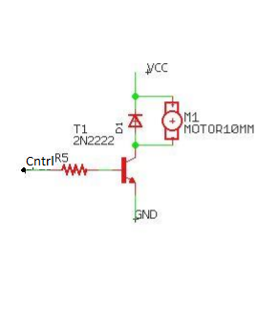
The motor choice to be part of our project must undergo some testing and documented results before including it as an indicator. The motor will vibrate enough to bring the user attention to charge the battery for example. At this level of our research towards the realization of the Vital Monitoring Wrist Strap we are not sure if the noise introduced by adding a motor will affect the normal operation. Now almost every wearable device can produce vibration alerts, adding this feature faces some common problems that we will try to outline with the best electrical practice to overcome them. The circuit suggested for our Vital Monitoring Wrist Strap will be simple if we stay within the constraints of noise and space. Included in Figure 19 above is a circuit design for a motor.
Figure 19 - Circuit for Motor Design
The ROB-08449 offers a very minimal size with its 10mm diameter, it falls also within the range accepted in our design. There are other specifications relevant to our design that we choose to list in this research based on the product datasheet: the motor has an operating voltage between 2.3V and 3.6V, starting voltage at 2.0V, rated current at 60mA, and an operational temperature at 25±2°C. As for the schematic layout and after the testing permitted at this phase of our research, the BJT base pin need to maintain a fix voltage that is why we uses the R5 to yield the right voltage drop from 3.7V to 0.8V that put the R5 at value of 5KΩ.

3.17.7 Power Consumption:
Power design of the strap is a crucial element to the success of the watch. The Vital Monitoring Wrist Strap must be able to power many components simultaneously, while also having a long enough lifespan to satisfy the user. If this design is not properly designed, insufficient voltage could turn off components, overvoltage could damage components, and voltage fluctuations could cause bad performance of the device.
The Vital Monitoring Wrist Strap is a portable device, thus when the watch is not being charged a lithium battery will act as a supply. The battery being used is a 3.7V, 500mAh battery. This battery will be connected to a charging circuit, and a voltage regulation circuit. While a battery is charging, and discharging, the voltage will fluctuate. This is not acceptable as an input for a circuit, because components like the AFE have sensitive inputs that can be affected by these fluctuations. This creates a need for a voltage regulation circuit that can keep the secondary components supplied.
The voltage regulator that will be used is a boost regulator that has linear down regulation capability. This regulator will keep the output at 3.3V, which will work with every component in the watch. The maximum voltage that can be supplied by the battery or the charger when it is fully charged is 4.2V. This regulator will down regulate up to 5V, so it will keep the components properly supplied even when the battery is charging. This is important if the user would like to turn on the device while it is turned on. The voltage regulator claims an efficiency of up to 90%, which is an excellent efficiency for this project.
The motor will not be regulated by the voltage regulator because it will reduce losses that are introduced by the power supply. Instead, the motor circuit will be directly supplied by the battery and will not be a secondary power component. The motor is able to handle the full voltage of the battery; thus, it will not be necessary to regulate the voltage to the motor. Also, the difference in force output by the motor between 3.2 and 4.2V (operating voltage of the supply battery) is not noticeable to the user. The reason for choosing not to regulate the motor’s voltage is essentially to save power.
It can be seen in Figure 20 below, that the microcontroller, screen, analog to digital converter, AFE, temp sensor, Wi-Fi, and Bluetooth will all be receiving the 3.3V DC. Components were chosen strategically to have compatible input voltages, to minimize efforts on designing power supply circuit.
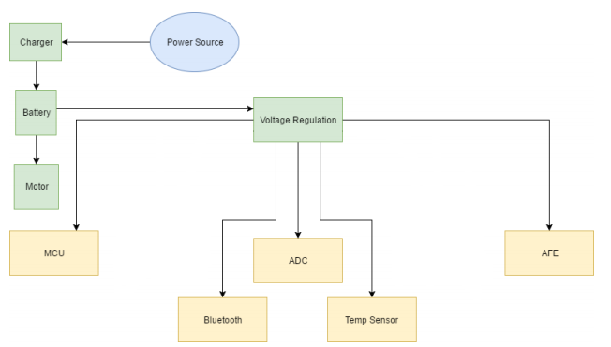
At this phase of our research a visionary layout is must to know how much current is being drawn to match the rating of the power supply. This type of data is based on each component datasheet, although the exact amount of current drawn can vary depending on the actual usage management.
Figure 20 - Power System Diagram

Table 20: Power draw of components
Components | Max Current Draw
Microcontroller | 200mA
Bluetooth | 50mA
ADC | 0.15mA
Sensor | 0.050mA
AFE | 50mA
Motor | 100mA
Estimated Total | 500mA

3.18 IDE/Setup

3.18.1 Arduino
For the Vital Monitoring Wrist Strap, the IDE selected will be a critical feature for successfully uploading software instructions to the microcontroller (ESP8266). Arduino, a very common and user-friendly IDE supports many microcontrollers for beginners and is complex enough for advanced users to implement advanced code. Arduino is cross-platform meaning that the code can be modified on Windows, Mac OS, and Linux operating systems. Along with being cross-platform, it is completely open source which makes finding solutions to problems a bit easier if someone else has a similar problem. No special licenses or permits are required to use Arduino as it is completely free. As mentioned before, the ESP8266 has a large Arduino community along with a great amount of documentation for troubleshooting the ESP8266. The choice of Arduino is very clear versus other IDEs that are supported such as NodeMC, esptool.py, esptool-ck, esp-open-sdk, and embedXcode.

3.18.2 Uploading Code
Whenever you purchase a chip from a popular electronics store like Mouser.com or Digikey.com, the memory in the chips arrive completely empty meaning there is no built-in IDE pre-installed on the chip. For some manufacturers, like ATMEGA, you can use their IDE(Atmel Studio) to directly upload code the board without having to install a boot loader onto the microcontroller. In the case of ESP8266 chip, a bootloader is not necessary to flash onto it. However, a certain device called a USB to serial TTL UART module is necessary for communicating instructions from a PC. The USB-A end plugs into your PC and the remaining pins are connected to pins of the ESP8266 which will be shown in the tutorial below. In the following text below, a short tutorial is made to make the process more understandable to the reader.

1) Download and install the Arduino IDE

2) Within Arduino, navigate to File Preferences (Figure 21)

Figure 21 - Preferences in Arduino
3) Within the settings tab, there will be a text box associated with Additional Boards Manager URLs. Copy/Paste the following link and hit OK. (Figure 22)
http://arduino.esp8266.com/stable/package_esp8266com_index.json

Note: This step allows you to extract the supported libraries from the ESP8266 community to allow you to easily use them in any ESP8266 project.
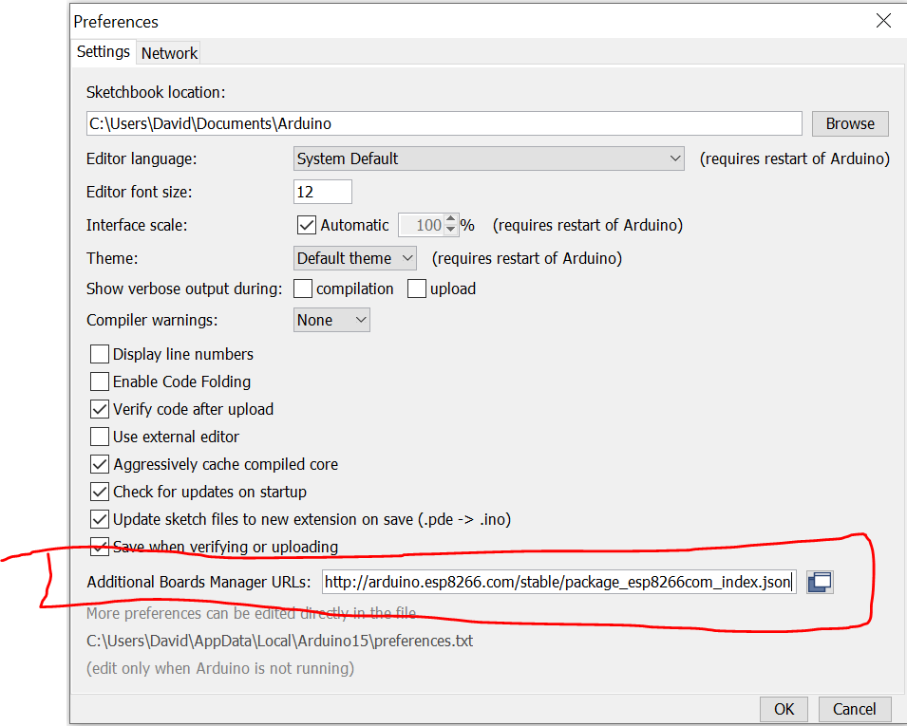
Figure 22 - Additional Boards Manager Setting in Arduino

4) Navigate to Tools Board: Boards Manager (Figure 23)

Figure 23 - Board Manager in Arduino

5) Select the esp8266 by ESP8266 Community and select the latest version to install.
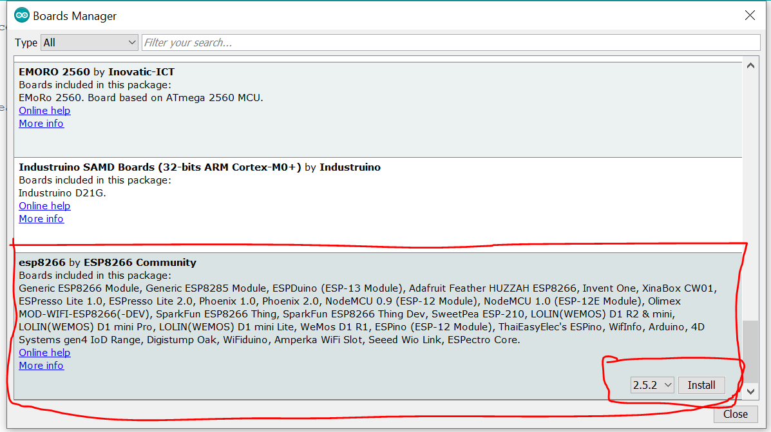
Figure 24 - Arduino ESP8266 Community Version Installation
6) Wait for installation to finish.
7) Restart Arduino
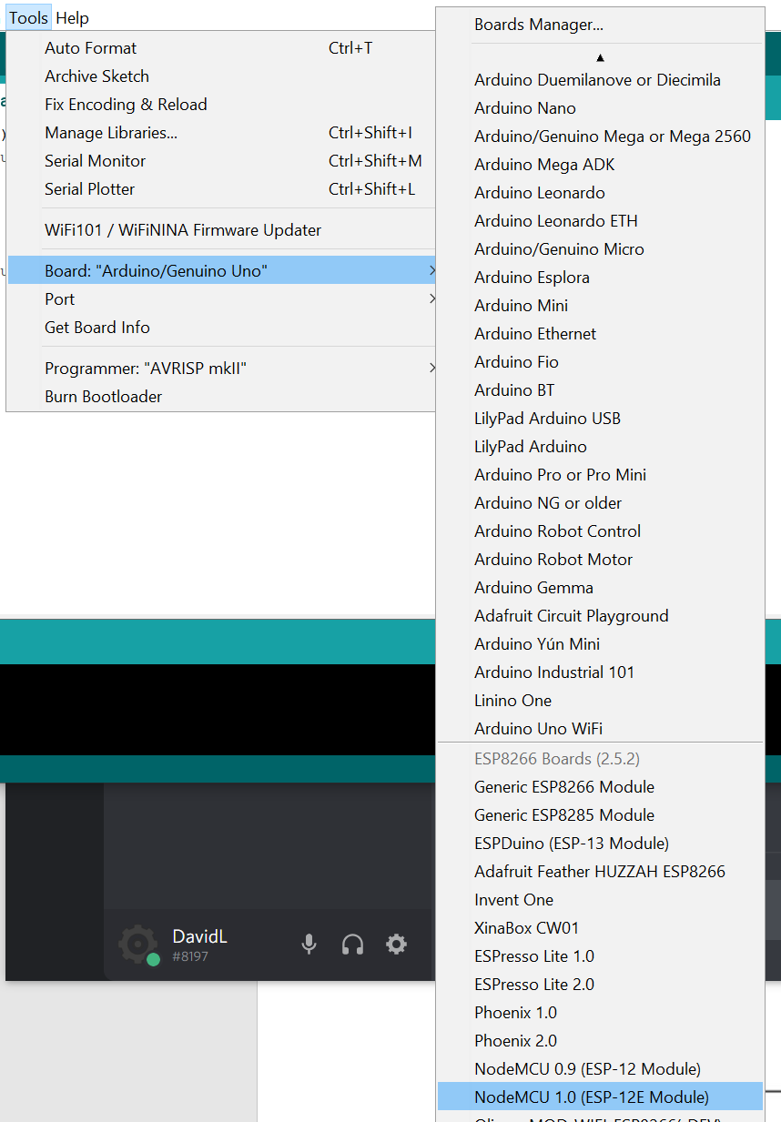
8) In Tools Board: Select NodeMCU 1.0 (ESP-12E modules)
Figure 25 - NODEMCU 1.0 (ESP-12E Module)

At this point, the IDE software should be setup if all steps were followed directly. The next part involves correctly wiring up the pins to the ESP8266 to the USB to serial TTL UART module to flash information appropriately. It’s critical that the ESP8266 is properly powered by a 3.3V source that can supply the appropriate amount of current to the chip, otherwise damage to the chip can occur. In Figure 26 below, it depicts the wire up of the ESP8266 for proper communication and power delivery.

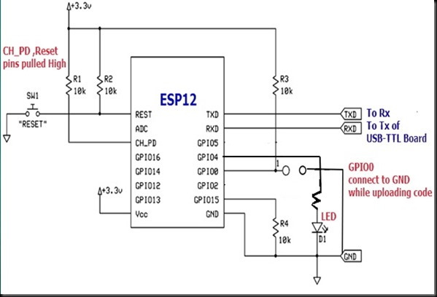
Figure 26 - Wire Up of ESP8266

Table 21: ESP8266 Pins
From | To
REST | SW1 to GND
CH_PD | R1 to +3.3V
Vcc | +3.3V
TXD | RX of TTL UART board
RXD | TX of TTL UART board
GPIO4 | D1 to GND
GPIO0 | Switch to GND (When uploading)
GPIO15 | R4 to GND
GND | GND

Note: D1 (LED) is added in as a testing feature and is not required for any other ESP8266 projects. When testing the sketch, verify that the proper pins are called out in the correct mode (OUTPUT), and that the GPIO is properly selected.

9) After hooking up the electrical circuit, in the Arduino IDE, verify that the following settings are correctly selected by looking at Table 22 above. Note: The COM port may need to change depending on which USB port the USB to TTL UART module is connected to. (Figure 27)

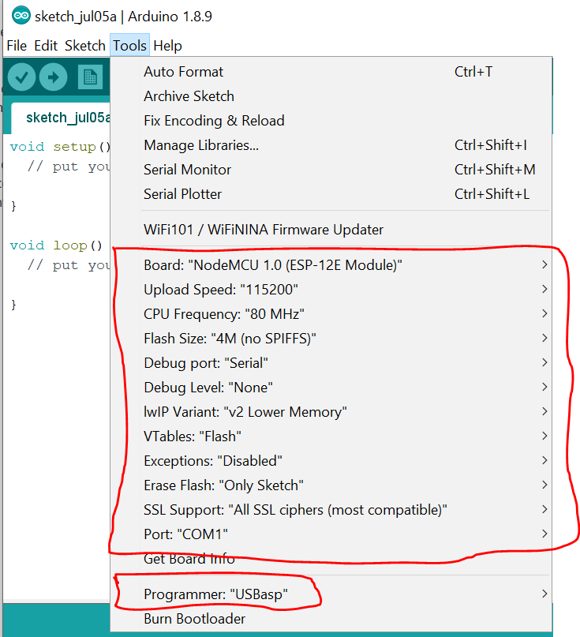
Figure 27 - Settings Verification in Arduino
The final step in the setup of the ESP8266, is simply uploading test code that will demonstrate basic functionality. As mentioned before, the LED connected to GPIO4 is there to demonstrate this concept, similar to a ‘hello world’ print statement. A critical step when uploading code is to ensure that the ESP8266 is in programming mode by correctly grounding the GPIO0 pin when uploading code. It is best practice to include a tactile pushbutton switch to hold down to properly ground the line in combination with a pull-up/pull-down resistor. Typically, uploading code takes approximately 1 minute to fully upload. A useful way of knowing when the board is done uploading is to pay close attention to the console window in the bottom of the Arduino IDE. The way the library is coded, it lets the user know the certain percentage of completion for successful upload of the code. When the upload reaches 100%, the user can now release the tactile switch allow the ESP8266 to come out of programming mode. If properly uploaded, the LED should begin to start flashing given that the code is correct along with circuitry setup. For example, code to use for a sample sketch, refer to the Arduino website or navigate through examples provided within the ESP8266 library located in Arduino directory. If using other sample code, verify that the correct GPIO pins are properly accounted for. If code refuses to upload repeat this tutorial and verify all connections and settings are correct.

3.19 PCB Design
When finishing an electrical design through many hours of troubleshooting and breadboarding, the final step is clean up the design through creating a Printed Circuit Board (PCB). Considering a final PCB is required for senior design, it would be helpful to know common tricks and guidelines before attempting to submit final files to a manufacturer to reduce time and cost. Some key features that are specified in the engineering requirements is that the PCB shall be less than 4x3 inches as well as being a double-sided PCB. Allowing the physical size of the PCB to be fixed to 4x3 inches allows the Vital Monitoring Wrist Strap to acquire a small footprint on the patient’s wrist. Requiring the PCB to be double-sided allows for the vital sensor to be placed directly flat onto the patient’s skin. The engineering team has decided to allow the least number of components and solder joints to be in contact with the patient’s skin to prevent grime and sweat from unintentionally shorting components together. This allows for the Vital Monitoring Wrist Strap to prevent harm to the patient as well as decreasing the risk of components being damaged or shorted.

Placement of the components on the PCB is considered a science as well as an art in the electrical community. Typically for most beginners that attempt a PCB design, the components will typically not be organized in any specific way that makes sense, electrically or design wise. A recommendation from Altium is to place all of the surface mount (SMT) components on the same side of your board and all through-hole (TH) components on the top side of your board to minimize the number of assembly steps. It is also a very good practice to place components in a manner that the shortest traces on the PCB will be etched in. In other words, if two resistors are in series to each other, then it would be wise to place as the resistors close as possible to avoid wasted copper along with not causing losses in digital or analog signals that require accuracy.

When the printed circuit board is being prepped for soldering, some component may not solder correctly or evenly compared to other components. This causes an uncertainty in correct solder joints which could lead to device malfunction or shorts within the circuit. [41]

In the case of the Vital Monitoring Wrist Strap, the placement of the components will be mimic these guidelines in the most efficient way possible. As of now, the engineering team has chosen a microcontroller integrated circuit, a battery monitoring integrated circuit, and a vital sensor. In theory the placement of the components on the board should not cause a huge concern.

Another important design task when developing a PCB is placing the power, ground, and signal traces. It is a recommendation to place the power and ground planes internally within the PCB while at the same time being symmetrical and centered. Placing these planes in this manner, will strengthen the board and prevent the board from bending. When powering integrated circuits, it is common to utilize common rails for each supply. Typically, for power rails and ground rails you will want to make the traces solid and wide enough, but also avoid daisy-chaining power lines.

When connecting signal traces, it is important and obvious that the traces match up to what the planned wiring schematic is. In Altium Designer, specifically, you would start with that wiring schematic and as you place signals, it verifies that the correct signal is properly placed along with giving tips on how to trace the wires. If a component placement forces a horizontal trace routing on one side of the board, then always place traces vertically on the opposite side. [41]

As mentioned before, wide traces are typically common in power and ground rails. The same goes for different configurations that require more current. For low analog and digital signals, it is recommended to provide a 0.010” width. If the signal requires more 0.3 amps, it should be wider to accommodate the supply. There are plenty of trace width calculators online that provide easy and clear access to widths for a trace. Follow the IPC-2152 standard when determining current-carrying capacity in PCB design if confusion arises. [41]

In the case of the Vital Monitoring Wrist Strap, considering our components are powered by a 3.3V regulator and does not consume a large amount of current, small traces can be made. However, calculations have been done to properly establish the research that has been acquired.

3.19.1 PCB Current Ratings
By utilizing the IPC-2221 standard for traces for PCB design, a free online calculator has been made to easily calculate the appropriate line trace widths that are needed for a printed circuit board [42]. The most power consuming IC in the project will most likely be the WiFi microcontroller, the ESP8266. According to the datasheet, the maximum current that will be seen when transferring packets is around 290mA+ of current. [28] To be design the traces carefully, a value of 300mA has been selected to be inserted into the trace width calculator.

For internal layers, it is recommended to give at least 2.92mm for those traces. For Imperial conversion to inches, it equals approximately 0.115 inches of trace width for the PCB.

For other signal traces that are present in the printed circuit board, like GPIO signals, I2C signals, and other small signals, we can stick to the standard limit of 0.010’ width

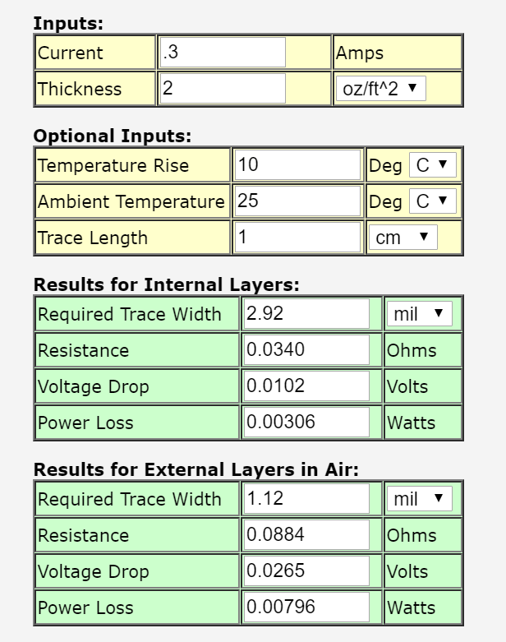
Figure 28 - PCB Trace Width Calculation

3.19.2 PCB Software (Altium Designer)
The choice of PCB software that has been chosen for use in the Vital Monitoring Wrist strap will be Altium. Altium is becoming the go-to choice for professional use within the electronics industry along with being relatively versatile in the features that it offers. While being not the easiest PCB software to start with as students, using Altium will be very beneficial to include on a resume in the future. Some of the benefits of using Altium Designer are listed in Table 23. [40]

Table 22: Altium features
Altium Features
An enormous number of shortcuts to efficiently edit and modify the PCB
Superior manufacturing and output file generation with many configurable settings
Import/Export addons for use in different format generation
Offline design system where license information is not needed
Net names automatically appear on the pads of the PCB
ECO check/process between changes which documents, and highlights changes when moving between schematic and PCB editor
Creating design constraints
Filtering through different components in the large library
3D visualization is superior versus any other PCB software
Simplified project tree with easy drag and drop capability
Copy room formats for several copy/paste PCB layouts.

3.20 Data Logging Server
As part of the functionality of the vital wrist monitoring strap, it is necessary that the patients’ vitals are collected and stored in some type of data logging server. The vitals must be stored in a data logging server in order to be accessible and transferable to the application during each vital reading. In order for comparisons to be made between the set standards for each of the vitals so that emergency notifications can be generated, it is important that the vitals is stored in a database which can be accessed by the mobile application to make these comparisons and display the information and notifications. Furthermore, a reach goal feature that will hopefully be implemented in the application are graphical representations of each of the vitals over time. This will allow caregivers to look for trends in the vitals that could potentially indicate developing medical issues. It will be a great source of information to show to doctors during visits, permitting them to keep track of the patient’s status over the course of time. Having the ability to look at trends in patients’ health history could assist in better diagnosis of issues. The data logging server is an integral component of the vital wrist monitoring strap development. Choosing an adequate data logging server to utilize for the project is a major part. There are currently two different data logging servers that are being considered to incorporate into the development of the strap. In this section, these servers will be explained including all of their services and features.

3.20.1 Amazon Web Services
Amazon Web Services (AWS) began in 2006 when Amazon began to offer services in information technology infrastructure to businesses. The web services that Amazon currently offer has come to be known as cloud computing. Cloud computing utilizes the internet to host remote servers instead of personal computers or local servers in order to collect and manage data [47]. With the birth of cloud computing, the expenses associated with the infrastructure have become low cost. Moreover, it has become more accessible. Servers can be setup in minutes no longer requiring weeks even months in order to set up the local servers. This not only lessens the amount of time for set up, but it also makes the servers more assessible since it is in the cloud. Companies across the world in over one hundred and ninety countries utilize Amazon Web Services. There is a plethora of services that are offered through AWS [48].

The services offered by Amazon Web Services vary from mobile application development to internet of things to even machine learning. It can be considered a toolbox for developers. They are a variety of each type of service that depends on what developers need from the service. Each of these services range from being free to being of medium cost and higher-end cost for businesses. For databases, there are several different options available in the services that vary based on the type of database, the language associated with it, etc. Additionally, there are other services assist with managing previously existing databases and integrating databases as well.

For the vital wrist monitoring strap, we will be collecting a variety of vitals repeatedly so it is important that the database can hold numerous fields for the different vitals and hold a ton of information for each of them over the course of time. The database will need to have the ability store information for a long period of time. Being expansive and long lasting are two key components necessary for the database in this project. Amazon Web Services offers multiple databases to work with.

Currently, Amazon Web Services divides and explain each of the databases they offer through the best application of each of the databases. There are several different distinct applications that are available. There are both relational and non-relational databases offered. Relational databases are collections of information and data that have pre-defined relationships between them [49]. According to Amazon Web Services, the relational databases that they offer are best utilized in traditional applications, applications for e-commerce, Enterprise Resource Planning (ERP) applications, and applications that focus on Customer Relationship Management. Services such as Amazon Redshift, Amazon RDF and Amazon Aurora are available relational databases. These databases are SQL and MySQL language based. Another type of database available are key-value databases. Key-value databases are great for internet-scale applications and applications that are centered on shopping and bidding. It allows for pairs of key values to be extracted from large quantities of data in the database. Amazon DynamoDB is the primary key-value database offered by Amazon Web Services. For web application developers that use the MERN or MEAN stack, the typical database that is utilized is through MongoDB. Through Amazon DocumentDB, AWS offers a compatible database with MongoDB. Amazon DocumentDB is a document database that can store the structured data in the form of documents, making the data accessible and readable through a document. Typically, document databases are most fit for mobile applications, and managing content. Other available databases include: In-memory, graph and ledger databases. In-memory databases such as Amazon ElastiCache for Redis and Amazon ElastiCache for Memcached are great for real-time data access such as for caching and gaming. The data in these databases store the information directly in memory, decreasing the latency time to microseconds. With graph databases such as Amazon Neptune, datasets can be connected and queried quickly and easily for applications such as social networking and fraud detection. Amazon Neptune is offered by Amazon Web Services to create graphs using datasets. For applications such as those with registrations and banking transactions, ledger databases are available including Amazon Quantum Ledger Database which was developed to maintain secured records of transactions [50]. As evident, there are a variety of databases available on Amazon Web Services that have distinct applications.

The final database offered by Amazon Web Services are Time series databases. According to Amazon, Time series databases are utilized to collect data and comprehend large quantities of data that change over the course of time. Time series databases are typically utilized in internet-of-things applications and industrial telemetry. Based on the goals of the application for the vital wrist monitoring strap, it seems like the time series database is the best option in order to collect the data continuously and depict the data in graphs which show the trends in the patient’s vitals. This would allow for all of the patient’s vitals during a specified amount of time to be illustrated for each of the vitals so that it is more apparent how the patient’s health is doing. The offered database by Amazon Web Services that utilizes time series is the Amazon Timestream.

Amazon Timestream is scalable and quick. It can store and analyze trillions of pieces of data per day at one tenth of the cost of a relational database. The development of Amazon Timestream was driven by the development of information technology (IT) systems and Internet of Things (IoT) devices, just to name a few. The data in these databases typically change over the course of time and are fast growing. The data that are considered time-series have specific characteristics that define it. For instance, time-series data is sorted in the order of arrival. New data is added to the end of the existing data. The queries that are conducted on the time-series data are always done over the course of a certain time interval. In addition to the described qualities of timestream databases, it is serverless as well. This would, of course, save time with set-up and managing servers for the database. Moreover, Amazon Timestream has built-in features that permit for quick analysis of the data collected [50]. Based on the necessities of the vital monitoring wrist strap and its mobile application, time series databases seem like the most fitting for collecting, maintaining and analyzing the data from the vitals. Amazon Timestream has several functions and qualities that meet the determined criteria of the vitals wrist monitoring strap purpose; although, this is subject to change during the development of the application and strap as there could be other options that are better fitting such as the next data logging server that will be described.

3.20.2 Adafruit IO
Connecting from the microcontroller to the internet in order to store all of the vitals in an easy and quick manner is important for the vital wrist monitoring strap, with Adafruit IO and its capabilities to communicate with microcontrollers over the internet in an easy manner, this could be possible. Adafruit IO is a platform that was created with a focus on data, providing the abilities to interact, respond to and display the data through the platform. With the necessity to keep vitals of patients secured since it is a violation of privacy and the HIPAA law, it is important that all of the data is stored in a secured database. The Adafruit IO platform by default keeps all data private and secured. It provides many of the basic necessities of the vitals wrist monitoring strap in an easy-to-use and quick functioning application.

Like Amazon Web Services, Adafruit IO is a cloud service that is ran and managed by Adafruit so there is no need to set up servers and manage them locally. This is a major plus as it decreases the cost and set-up time associated with storing and working with the data. While the main functionalities of Adafruit IO is to store and allow for retrieval of data, there are several other functions that assist within the application. The system has the ability to read sensors. This is a major component for the vitals wrist monitoring strap as all of the data comes from several different sensors on the strap. In addition to collecting the data from a multitude of sensors at a time, it also provides the capability to visualize the different datasets at the same time. It is a goal for the accompanying mobile application of the vital wrist monitoring strap that it will illustrate the vitals changing for heart rate, temperature, etc. over the course of time while also providing the most current reading of each vital in an easy-to-read layout. The abilities of Adafruit IO would could assist in making this possible. Furthermore, Adafruit IO can connect directly to devices beyond just the sensors. Using the internet, it has the ability to connect directly to the components to devices controlling components such as motors. Moreover, it can also connect to existing web services such as social networking sites.

There are several different components and characteristics of Adafruit IO that developers can utilize in order to work more effectively with their database and data they are collecting. For instance, Adafruit IO offers triggers which allows developers to control their data and also respond to them. This is a helpful feature for the implementation of emergency notifications from the database perspective.

Adafruit IO is directly compatible with Arduino and CircuitPython boards. It is equipped with libraries to assist with connecting the boards to the online environment and to conduct certain functionalities. Those boards are just two of the countless products and devices that Adafruit can be utilized with. There are numerous languages that Adafruit supports including Python, Ruby, Node.js and Go. Libraries can assist with working with these languages on the platform. The platform is actually built on Node.js and Ruby on Rails. Given that it is a database, APIs are required to work with the database and for communication. There is documentation for both REST API and MQTT API provided by Adafruit to work with these on the Adafruit databases.
Lots of documentation is available for Adafruit IO usage with devices which makes the connection between devices and the server easier establish and use.

For the vital wrist monitoring strap, current options for connecting the device to the data logging server that are being researched are WiFi and Bluetooth. Adafruit IO offers three different interfaces that can be utilized to connect the device to its server. These interfaces include WiFi, Ethernet and Cellular. WiFi is available almost everywhere making it an easy protocol to utilize for connection. Adafruit IO supports ESP8266, ESP82, WINC1500 and WICED WiFi chips. It even offers hardware to assist with WiFi connection, AirLift. AirLift is an ESP32 chip that can be added to microcontrollers to added WiFi connection so that data can be transferred from the device to the Adafruit IO site. Beyond Wifi, it also supports connection through Ethernet which can be achieved through connecting the device using the standardized connector, the RJ-45. With the mass usage of cell phones, it is no surprise that Adafruit can also utilize cellular connectivity. The Adafruit FONA is a module that effectively connects projects to cellular networks, utilizing the powerful cell towers around. These different methods of connection make Adafruit applicable to a variety of projects.

Having adequate storage for the vitals collected by the vital wrist monitoring strap is an extremely important consideration. Adafruit IO offers two options for data collection. A free option which provides thirty data points of collection per minute along with thirty days of data storage. Moreover, ten feeds are available along with five dashboards. On the other hand, the other option is IO Plus which offers the sixty data points of collection per minute along with sixty days of storage. Through IO Plus, there are also unlimited feeds and dashboards [51]. These options are both viable options by Adafruit depending on how many different vitals will need to be collected and the rate at which they will be collected.

The Adafruit site has two main components when logging data: Feeds and Dashboards. On each individuals Adafruit IO account there is the core, their feeds. Feeds are what holds the data that was collected and data about the data that was collected (meta-data) such as the data and time the data was collected. There are different feeds for the different data collected. There are also dashboards which assist in analyzing and visualizing the data collected. Through the dashboards, the data can be logged, charted or put into graphs for easier examination [51]. This is a very useful functionality as it would assist in visualizing the data on the mobile application for the caregivers. The Adafruit IO platform is centered on these two components when logging and retrieving data by developers.

Adafruit IO provides a cloud-based platform that is easy-to-use and can be connected in a variety of ways to different pieces of hardware. There are several differences and similarities between Amazon Web Services and Adafruit, each of which provide adequate services which meet the requirements of the vital wrist monitoring strap.

3.21 Medical Overview
The main drive behind the vital wrist monitoring strap was the implementation of heart rate monitoring. When we proposed this idea, it was centered on providing constant heart rate readings which would allow caregivers to ensure that the patient was alive once a heart rate was being read and provided on the application. Of course, this idea was extended to other vitals being provided through the strap, but it is still focused primarily on heart rate monitoring as its central purpose. There are a plethora of cardiovascular issues that exists and through heart rate monitoring there is a lot that can be told.

There are a multitude of cardiovascular issues that exists. The overarching area which encompasses all cardiovascular issues is labeled as cardiovascular disease. Cardiovascular disease is defined as any condition in which blood vessels in the heart narrow or are blocked leading to issues such as angina (chest pains), stroke or heart attack. There are several heart diseases that are specified as blood vessel diseases. These blood vessel diseases include congenital heart defects, arrhythmias (heart rhythm issues) and coronary artery disease [21].

Heart rate is directly associated with one cardiovascular issue, heart arrhythmias. Heart arrhythmias are abnormal heartbeats. There are two variations of abnormal heartbeats, tachycardia and bradycardia. Tachycardia is an arrhythmia in which the heartrate is exceedingly high causing the heart to race [21]. There are three different variations of tachycardia that are identified and defined. These types include: atrial (supraventricular) tachycardia, sinus tachycardia and ventricular tachycardia. Atrial or Supraventricular Tachycardia (SVT) is a form of abnormally fast heart that begins in the upper chambers of the heart in which the electrical signals there fire abnormally causing interference with other impulses being generated by the heart’s natural pacemaker, the sinoatrial node. Due to this, the chambers of the heart are unable to completely fill between contractions. Sinus tachycardia is slightly less extreme than SVT. With sinus tachycardia, there is a natural increase the normal heart rate that is caused by the sinoatrial node firing electrical signals at a faster rate than it normal would. The heart continues to beat in a proper manner through despite this. Ventricular tachycardia is much more similar to atrial tachycardia. Patients that have ventricular tachycardia have a faster heart rate that begins in the lower chambers of the heart. Just like supraventricular tachycardia, the electrical signals in the lower chambers of the heart fire abnormally interfering with the electrical impulses from the sinoatrial node resulting in a faster heart rate and also the heart not being able to completely fill its chambers between contractions severing blood flow to the rest of the body. Ventricular tachycardia is much more serious than the other two types of tachycardia as it can be life-threatening [22].

Bradycardia, as mentioned prior, is when heart rate is overly slow. Unlike tachycardia, there are not multiple types of the issue. Although, there are several potential causes of bradycardia. The heart’s natural pacemaker, the sinoatrial node, can also play a role in the development of bradycardia if there are issues with it. Additionally, if electrical impulses are unable to pass from the atria to the ventricles properly due to issues in the conduction pathway, bradycardia can develop. It can also be a result of other issues of the body like hypothyroidism, general damage from a heart attack or heart disease, etc. [23]. There is a lot that can be attributed to the development of arrhythmias which are one of the less serious heart issues that exists. On a more complicated and popular note, another cardiovascular issue that exists are myocardial infractions otherwise known as heart attacks.

Oxygen is a very important component in the survival and functioning of the heart. A heart attack results when adequate oxygen to the heart is severed. Blood is what transfers oxygen to the heart. When blood flow is reduced or completely cutoff, the amount of oxygen that is brought to the heart is also cutoff or reduced. Blood flow is severed to the heart due to the narrowing of the coronary arteries through a process known as atherosclerosis. The narrowing of the coronary arteries are causes by a series of substances such as fat and cholesterol building up within the arteries. These substances are known as plaque. Plaque buildup in the arteries occurs very slowly. Despite this, when enough plaque builds up, plaque can break causing a blood clot to form around it within the artery. This will constrict the space within the artery resulting in a loss of blood flow through the artery to the heart muscles and therefore a lack of oxygen to the muscles known as ischemia. Ischemia results in the death of the heart muscles which ultimately leads to a myocardial infraction occurring. The process of atherosclerosis and the death of heart muscle which lead to heart attacks.

As seen in the image above, several layers of different substances must build up to form the plaque in the arteries. The formation of a blood clot around plaque can sever the entire blood flow to that artery causing the muscle it is supplying oxygen to die completely resulting in a myocardial infraction. Myocardial infractions and arrhythmias are only two of a plethora of cardiovascular issues that exists. They are two of the more major and common issues that are known and have ties with heart rate that will allow us to evaluate the cardiovascular issues based on the vitals that we will collect through the vitals wrist monitoring strap.

3.21.1 Heart Rate Ranges and Emergency Indicators
Heart rate as mentioned before is the central vital that is the driving force for the vital wrist monitoring strap. While there is no direct correlation between heart rate and any critical medical issues, analysis of heart rate can indicate potential cardiovascular issues especially in emergency situations. With different ages and disorders comes different normal heart rate ranges. Heart rate also can change significantly during certain normal activities. In these cases, it is not considered an emergency or any indication that a cardiovascular issue is occurring. It is known that during sleep, heart rate decreases significantly in individuals. Moreover, during physical activity, individuals can experience a spike in their heart rate. Individuals that exercise and are more physically fit typically have a normal resting heart rate that is lower than a general resting heart rate. During the development of the vital wrist monitoring strap, these factors will definitely need to be taken into consideration as a heart rate in the 50s can indicate a cardiovascular issue for one individual while it could just be normal for another. Moreover, the heart rate vitals can not only be indicative of emergency cardiovascular issues but also long-term issues. If caregivers notice sudden changes in heart rate that are being sustained over the course of a long period of time, it may indicate an incurring issue that needs to be treated immediately to prevent further development. There is much that can be said from heart rates, but it is important that the vital is understood in the light of the individual.

Table 24 (below) provides some general information about heart rates and what they signify or indicate. The information presented is for a general adult, age 18 years and older. Information not only about the heart rates are presented below but also the cardiovascular issues that they are potentially associated with. General heart rates and alterations in heart rate based on certain activities is also presented. All rate and range values are provided in beats per minute (bpm).

Table 23: Heart Rate Indicators
Description | Rate/Range | Indication
Normal Resting Heart Rate | 60-100 bpm(9) | Does not indicate anything specifically. This information is suited for a normal healthy adult.
Normal Resting Heart Rate for Athlete | 40-60 bpm(9) | Does not indicate specifically. This information is indicative of an athlete so any assumptions about their heart health should be made in the light of this approximate range.
Arrhythmia: Tachycardia | > 100 bpm(6) | Having a consistent heart rate that is greater than 100 bpm can indicate an underlying development of one of the three forms of tachycardia developing.
Arrhythmia: Bradycardia | < 60 bpm(7) | Having a consistent heart rate that is less than 60 bpm can indicate an underlying development of bradycardia, a form of heart arrhythmia.

In order to provide the most accurate notifications based on the status of the patient and their normal heart rate levels, it will be important to take into consideration their normal resting heart rates as well as their minimum and maximum heart rates based on their fitness level, conditions and specifically age group. As stated prior, age plays a major part in resting heart rate range. It varies significantly based on ages. There are minimum and maximum ranges that are typical of each age group. These ranges are defined as target ranges. For an individual, it is recommended that during moderately intense activities, their heart rate sits at between fifty and seventy percent of their maximum heart rate while during vigorous activities, they should have a heart rate around seventy to eighty-five percent of their maximum heart rate [25]. If they lie at any extremities from these ranges, it is possible that they could have an impending cardiovascular problem. Table 25 provides information about the target heart ranges for different ages:

Table 24: Target Heart Rate Zones based on Age [25]
Age | Target HR Zone 50-85% | Average Maximum Heart Rate, 100%
20 years | 100-170 beats per minute (bpm) | 200 bpm
30 years | 95-162 bpm | 190 bpm
35 years | 93-157 bpm | 185 bpm
40 years | 90-153 bpm | 180 bpm
45 years | 88-149 bpm | 175 bpm
50 years | 85-145 bpm | 170 bpm
55 years | 83-140 bpm | 165 bpm
60 years | 80-136 bpm | 160 bpm
65 years | 78-132 bpm | 155 bpm
70 years | 75-128 bpm | 150 bpm

As part of accuracy development in the vital wrist monitoring strap, it will be important that these ranges will be considered when comparing vital readings before providing an emergency notification to caregivers. Of course, individuals in these ages can have starkly different heart rate ranges due to specific issues. We will require that an initial resting heart rate is provided by the patient to the application as a basis for comparison for the patient. In certain instances, it may be necessary to provide emergency notifications based on these upper levels of these levels as more of a warning than an emergency signal. The vital wrist monitoring strap not only serves as an emergency notification system but also preventative system as it will allow caregivers to take into consideration vitals over a long period of time to find trends that are variable from what is typical of the patient such as those which indicate one of the forms of heart arrhythmia. These are only a few of the indicators of heart rate, much more can be told which is not explained in this section as there are a plethora of cardiovascular diseases and also other health issues that can be indicated by heart rate.

3.21.2 Temperature Indicators
Temperature is another easily accessible vital that can tell much about the health of a patient. Any variation from normal body temperature can indicate issues with the patient whether critical or minor. Normal body temperature is on average 98.6$℉$ (37$℃$) with the range being from 97$℉$ (36.1$℃$) to 99$℉$(37.2$℃$) [10]. Much like heart rate in which below or above a certain threshold indicates a potential problem, temperature also has indictor zones as such. When an individual has any indication of the cold or flu, one of the first vitals that doctors take is temperature as a major piece of information to make their diagnosis. Temperature sensing is a potential vital to be implemented into the vital monitoring wrist strap for this reason. Caregivers will be able to evaluate the temperature of their patients in order to make sound decisions of if a potential health issue is occurring and if the patient needs to seek medical care. Temperature is a simple vital that will assist in increase patient health. There is much that can be told by a simple temperature reading.

Over the course of a day, body temperature changes. This depends on many different factors such as the temperature of the environment the individual is and the activity they are doing. Despite this, temperature does not change starkly without a more critical reason than daily alterations. For instance, fever is one example of a health issue indicated by temperature. Fever is actually an abnormally high body temperature. Typically, any value above the normal upper range of body temperature is considered a fever. It is more specifically defined that any temperature beyond 100.4$℉$ (38$℃$) is considered a fever that is potentially caused by an illness or infection [10]. General colds and infections are accompanied by fevers therefore through tracking this vital, it will allow caregivers to see whether the patient is potentially developing one of these issues and if they are, keep an eye on the temperature of the individual during treatment.

More serious long-term medical issues can also be indicated by temperature. Autoimmune disorders such as thyroid disorders could potentially be indicated by temperature. Hypothyroidism is one of the forms of thyroid disorder in which your thyroid is not as active as it should be due to the body’s immune system attacking itself and making antibodies against the thyroid gland [27]. Individuals with hypothyroidism are typically bothered by cold temperatures and if the disorder is left untreated, they typically experience low body temperatures [27]. Through the vital wrist monitoring strap, if an individual is displaying temperature vials that are lower than the standardized body temperature values and they are consistent, it could indicate to their caregiver that they could potentially be developing the thyroid disorder. This is also true for the other form of the thyroid disorder, hyperthyroidism. Hyperthyroidism is the opposite of hypothyroidism. It is caused by an overactive thyroid gland [20]. Due to this, it has the opposite effect on patients. Individuals with hyperthyroidism typically are disrupted by hot temperature and sweat more than usual. They experience higher body temperatures [20]. Thyroid issues are one of many issues that can potentially be indicated and discovered by constant temperature readings as it will be implemented in the vital wrist monitoring strap.

While it is rare that temperature could indicate a major emergency situation, there are odd instances in which major fluctuations in temperature can be a major issue occurring and immediate action would need to be taken. The vital wrist monitoring strap will take into consideration these situations including the ones discussed in this section in order to implement temperature sensing both for emergency and preventative purposes.

3.21.3 Oxygen Saturation Level Indicators
Oxygen is a vital element in the body and it is important that it is regulated in order to ensure that it is adequately distributed to organs for proper functioning. Moreover, it is important that it is regulated to prevent extreme levels that can poison individuals. There are several disorders that are associated with oxygen saturation levels specifically related to the levels themselves. Furthermore, there are other health issues that can be indicated by oxygen saturation levels. These levels can be obtained using pulse oximetry. One of the potential sensing capabilities that may be added to the vital wrist monitoring strap is a pulse oximeter to conduct these vital measurements. It is a potential vital that will allow much greater understanding of the overall health of the patient by its caregiver.

Oxygen saturation is defined as the level in which hemoglobin, the oxygen binding molecule in blood, is saturated with oxygen [21]. On a normal scale, typically the arterial oxygen level is between the values of seventy-five to one hundred millimeters of mercury. This is correlated to a pulse oximeter reading of between ninety-five and one hundred percent. Values outside of these ranges are considered slightly abnormal. Any value below sixty millimeters of mercury or under ninety percent by pulse oximetry is considered too low and therefore indicates the need for supplemental oxygen [22]. There are disorders directly related by these levels. For instance, hypoxemia is a disorder in which oxygen levels in your blood, particularly blood located in your arteries are below the normal levels indicated prior. Patients with hypoxemia typically have circulation issues or breathing issues that do not allow them to get adequate oxygen to their arteries [22]. Through oxygen saturation sensing in the vital wrist monitoring strap, caregivers will have the ability to track these levels and look for trends that could possibly point in the direction of disorders like hypoxemia in order to bring it the attention of the medical doctors for the patients.

Oxygen saturation levels can also indicate other potential health issues not directly related to its value. It can assist with the evaluation of symptoms and for diagnosis. Pneumonia is one medical issue that relies on oxygen saturation levels as part of diagnosis. Pneumonia is an infection in which the air sacs (alveoli) of the lungs become inflamed. It makes it very hard for oxygen that is breathe in to get into your bloodstream which in turn causes lower oxygen saturation levels. The infection is accompanied by several symptoms which seem much like the regular flu. With adequate sensing of oxygen saturation levels in conjunction with these symptoms, pneumonia can be distinguished from the flu and cold by caregivers so that immediate and proper medical attention can be given to patients before it worsens [23]. Much like pneumonia, there are more long-term medical issues that are also caused by inflamed lungs. Chronic obstructive pulmonary disease or COPD is a medical condition in which the air sacs of lungs become damaged (emphysema) and the lunch airways become narrower and inflamed (chronic bronchitis). As a side effect of COPD, oxygen levels decrease in the bloodstream while carbon dioxide levels increase. In patients with COPD, oxygen saturation levels below eighty-eight percent indicate the need for supplemental oxygen [16]. The vital wrist monitoring watch will allow patients with conditions like COPD to keep track of their levels as an indication of whether they need alterations in their treatment.

Oxygen saturation levels are tightly associated with various pulmonary conditions and can serve as a method of evaluating the conditions and their possible development.

3.22 Application Development Tools and Languages
For software developers, there is an overabundance of mobile application development tools on the market. While application development from pure scratch is available, using a software development kit (SDK) allows application development to be much easier and more effective. Each individual platform has specific development tools that all developers to utilize the functionalities of their operating systems while developing. Although, with the increase of both iOS and Android users, developers have been looking for development tools which allow them to create applications that are functional on both types of devices. There are several software development kits that are available now which allow for cross-platform development, saving both time and money for developers that seek to develop applications for both platforms. In this section of the paper, three different software development tools will be discussed. These tools will be considered during the mobile application development for the application that will accompany the vital wrist monitoring strap.

3.22.1 Flutter
Flutter is a new mobile application software development toolkit created by Google. It is open-source and allows for the development of both Android applications and iOS applications through a single codebase. The main purpose behind Flutter is the ability for software developers to create applications that can run on different platforms with little to no differences between them. It is one of the major development environments for applications currently.

When developing applications using Flutter, software developers use the language Dart. Dart is much similar to other languages such as Java and Javascript which are also used for application development on other platforms. As evident by the language similarities, Flutter utilizes object-oriented programming that is slightly altered. Flutter is centered on an object model labeled “the widget” to develop user interfaces. The widget has several definitions of what it can be as defined by Flutter. These definitions of the widget include: (1) an element related to style like font, (2) a structural element such as a menu, (3) a layout aspect like padding. The widget follows the properties of object-oriented programming as when put together with other widgets, it inherits properties from its parent widget. This is due to the fact that Flutter utilizes a hierarchy in which widgets are nested within one another. The Flutter framework itself is organized in a hierarchy of layers which build upon each other. These layers from top to bottom include: the Framework, the Engine and the Embedder. Despite the specific language that Flutter utilizes, it allows for easy learning especially for individuals that have prior coding experience particularly with object-oriented programming. Alongside being object-oriented based, it also utilizes a framework that is very similar to React and has a 2D rendering engine. With the development tools it offers and its ready-made widgets, it seems to make application development much easier.

As stated prior, Flutter allows for cross-platform mobile application development for both iOS and Android through using a single codebase. This is a major pro of application development since there are both large volumes of Android and iOS users. In addition to this, there are several other benefits of using this development environment. For instance, Flutter offers hot reload in which experimentation with the application can be done quickly and efficiently during development. It allows for code to be changed and reloaded while the application is running, cutting large amounts of time as it does not require restarting of the application for alterations to be visible on it. Moreover, during development, if the application crashes, it allows developers to fix the crash and continue debugging from right where the application left off after crashing [25]. These abilities that the Flutter software development kit provide allow for easier and quicker application development, assisting developers like our group that have short deadlines.

The software development kit works alongside a multitude of other technologies for development. For instance, Flutter development can be done in Android studio and it could be connected to a database that is ran through Firebase [25]. There are several capabilities by Flutter that allow for applications with much technological integration. For largescale applications, this is an important feature. Flutter provides a plethora of functions and capabilities for cross-platform development through a nascent development environment.

3.22.2 Ionic
Ionic Framework is another software development kit that allows developers to create cross-platform applications that can function on iOS, Android, Web and Desktop through an open-sourced environment. It utilizes web development technology such as CSS, HTML and Javascript for the development. The main goal behind Ionic is to enhance user interface interaction with the application.

There are a series of tools that are included within Ionic such as Javascript and CSS which are already compiled for the application. Moreover, it comes with JS Framework and Sass files all to enhance the application development experience for the developer. Additionally, it has the ability to work in node.js as node can be utilized to start an Ionic project. Ionic primarily focuses on the front-end of application projects and can therefore be added to other projects which take care of the rest of the application. It has the ability to be added to projects created through Trigger.io, PhoneGap and Cordova. This is done simply through referencing the Ionic files from the web root of the application. Ionic provides lots of potential for further technology integration as it is compatible with several development technologies.

Currently, there are two different versions of Ionic that are available to use for development: Ionic 1 and Ionic 2. The first version of Ionic, Ionic 1, focuses on providing the tools to build native (hybrid) mobile applications rather than mobile websites. On the other hand, Ionic 2 focuses on providing the tools to building native (hybrid) applications using Cordova while adding the ability for Electron and Progressive Web Apps. Ionic 1 supports older versions on iOS and Android than Ionic 2.

While Ionic provides major development tools that will assist software developers in creating mobile applications in a quicker manner, there are some drawbacks to the kit. For instance, currently, AngularJS is required for Ionic to work at its maximum potential. Without AngularJS, some of the interactions for the user interface will be severed meaning that a more basic user interface will be created if only CSS is utilized [26]. For developers that have not worked with AngularJS, this will be another language and tool to learn during the application development. Ionic requires learning more than just the environment itself since it relies on many other external technologies, this is slightly more difficult than using an environment as Flutter. Despite this, it provides adequate tools to assist with application development in a Javascript, web-based environment.

3.22.3 Android Studio
Highly popularized, Android provides access to software developers to its official Integrated Development Environment (IDE) to allow for Android development. Unlike the other software development kits discussed prior in this section, Android Studio does not allow for cross-platform mobile application development. All of the development conducted within Android studio are solely for Android applications. The idea for Android studio was based on IntelliJ IDEA. Much like IntelliJ, it provides lots of developer tools along with a code editor. In addition, it has a multitude of features which distinguishes it.

Language plays a major role in software development and the decisions made by the developers on what development tools should they should utilize usually stems from what languages they already know in order to easy development through not having to learn a new language if it is not necessary. Android Studio assists with this as it allows for development in several different languages including Java, C++, Go (with extensions) and now Kotlin. There are a variety of extensions that are available to enable application development using different languages. Besides greater programming language options, Android studio has several other features that assist in the development process. Similar to Flutter, Android Studio has instant run which permits changes to be pushed directly to the application without having to build an entirely new Android file, APK. It also comes with an emulator and lint tools which catch issues in performance, version compatibility and usability. All of these features provided by Android studio assist in effortless Android app development.

When using Android Studio development, applications can be created for all Android devices. Moreover, it can be combined with other technologies such as the Google Cloud Platform for greater technology integration. The applications and extensions that Android Studio can work with effectively has been increasing with each version of the IDE. Currently, up to version 3.2 is available of Android Studio. One major pro of Android Studio on this note is that it supports a variety of version control systems such as GitHub, CVS and Google Source Repositories [26]. For sharing code and also collaborative software application development, which most of it is, it is important that the newest version is accessible at all times and that no code is overwritten by other changes.

In order for Android Studio to build your applications, it utilizes Gradle through a plug-in. While Gradle typically works from the command line, it is actually integrated within Android Studio and works directly within it. All build files for Android Studio applications are generated by Gradle and they employ Groovy syntax. With this build system, it is possible to create different versions of an application within one project [26].

Android Studio is a popularized integrated development environment that allows for mobile application development solely for Android devices. This is the downside of not using a cross-platform development tool. Although, with the large population of Android users, being able to create an application through an easy-to-use and developer -friendly environment is a plus. Having several different languages to utilize unlike the other software development kits discussed is a major pro of Android Studio and its array of debugging tools assist with making the development process much easier. Android Studio much like the other tools discussed in this section has its fortes and failings but acts as an outstanding app development tool in industry.

4.0 Design Constraints and Standards

4.1 Constraints
Throughout the project development, there were several constraints to take into consideration when designing the vital monitoring watch. Many of these constraints were highlighted by the Accreditation Board for Engineering and Technology (ABET). Others of these constraints were due to the timeline of the project as restricted by the semester schedules that were provided. As engineers, it is extremely important to consider the constraints of a project in order to create a product that is functional, and safe for the user and the environment. Additionally, a multitude of constraints in terms of cost, tools, monetary values, etc. must be considered to adequately create a device that is within the available funds and items. A constraint is defined as a “limitation or restriction” [25]. There are several types of constraints that all play significant roles in product development. In this section, various constraints will be discussed in the light of the development of the vital monitoring wrist watch.

4.1.1 Medical Knowledge Constraints
A major component of the vital monitoring wrist strap is an application in which a caregiver can view the vitals of the patient who is wearing the watch. Vitals are considered private medical information of the patient which should not be shared without the consent of the patient. This is stated by HIPAA. HIPAA or the Health Insurance Portability and Accountability Act was implemented by the U.S. Department of Health and Human Services through the Privacy Rule [26]. As per the Privacy Rule and HIPAA, any medical information that can be utilized to identify an individual is considered protected and should only be disclosed under the circumstances as permitted by the Privacy Rule or if the individual whose information should be disclosed, signs a written form of consent.

There are a variety of parties that are covered by the Privacy Rule, particularly any health care providers that transmit health information in an electronic form. Despite not being a health care provider, our team will continue to follow the components of the Privacy Rule as stated for such parties in order for all personal information about the wristband users to be kept private through its transmission from the wristband to the application. The information that will be kept private as per HIPAA and the Privacy Rule include any “individually identifiable health information” [26]. Identifiable health information includes anything related to the individual’s past, present and future conditions. Additionally, it relates to their payment for health care, provision of care and demographical data that can be utilized to identify them as an individual overall such as name, birthday, address, Social Security number, etc.

Due to the restrictions as placed by HIPAA and the Privacy Rule, prior to wristband and application set up, the patient will be required to provide a written form of approval for their caregiver to utilize the application to view their real-time vitals and receive emergency notifications about their health status. Without this, a caregiver will not be able to access patients’ information nor will their vitals be read and stored on our database system as collection of their vitals should also be kept private. This will ensure compliance with the Privacy Rule and HIPAA. Patient privacy protection is a major consideration for the overall implementation and goals of the device.

4.1.2 Health and Safety Constraints
Development of the vital monitoring wrist strap focuses on providing a useful and safe watch that can be worn daily throughout most daily functions without harming the user. All components utilized in the strap will be considered in all aspects before implementation into the strap to ensure that it will not cause harm to any of the patients. One design aspect that has already been considered for further implementation is the protection of skin contact from the sensors that will be reading the vitals of the patients. To ensure that none of the electrical sensors will have any contact with skin which can cause serious issues due to sweat and other bodily secretions, a type of thin tempered glass or plastic much like those found in other fitness bands will be placed behind the sensors so no sensor to skin contact occurs. This will allow for the continuous readings of the vitals by the sensors without having any direct contact to the patients so that no electrical components will have exposure to any substances that can cause shorts, electrical failures, etc. that can harm the patient while wearing the strap. This is especially vital with certain types of sensors such as oximeters which utilize infrared light for the readings [27]. No direct light should be on the patient’s skin. Moreover, all housing for the electrical components and the strap itself will consist of wearable materials that will limit irritation for the user. These are important and central constraints for the development of the vital monitoring wrist strap as the strap is geared to providing medical assistance and improve the health of patients. Therefore, it should not cause any danger or harm health-wise to the patient.

4.1.3 Economic Constraints
For this senior design project, no sponsor will be paying for all expenses associated with developing the vital monitoring wrist strap. As a result, the teammates will be splitting all costs in order to effectively cover the monetary amounts necessary to produce the final project and also any costs involved during development and prototyping. Since each of the members of the team are college students with minimal funds for a large scale project which could cost thousands, even millions of dollars, we have limited the scope of the project in order for it to be feasible to pay for. All components that will be utilized in the wrist strap will be researched in order to purchase parts at the lowest cost possible. Currently, it is expected that costs will remain under a thousand dollars with each student contributing approximately a hundred dollars or so. The current estimated cost based on a budget analysis and parts cost is slightly over four-hundred dollars.

Due to the monetary constraints, some of the components that will be utilized will not be the best parts that are on the market. In order to use the most accurate sensors available, it would require greater prices. As a result, it has been decided that the some parts such as the sensors will have to sever accuracy in order to it to be affordable. Additionally, the type of material that will be used for 3D printing the housing for the electrical components of the strap will not be of the best material due to pricing but it will provide enough durability and function for the strap.

Other parts of the project development will need to be of low costs such as PCB development. We will be looking for companies that a print PCB for a cost effective price. Moreover, all tools such as software for the application development and the design tools to develop the PCB design will be found, hopefully, in a low cost to no cost version. We hope to develop a vital wrist monitoring strap that will be cost effective for the general public as well.

4.1.4 Environmental Constraints
The basis of this project does not produce direct environmental consequences nor does it have many ties with the environment which would restrict the development of the vital wrist monitoring strap. Of course, the parts that will be utilized will be environmentally friendly and seek to produce no harm. In terms of part specifics, the main component that will be restricted by potential environmental issues is the housing for electrical components of the strap.

As part of the housing for the electrical components of the vital wrist monitoring watch, a 3D printed casing will be developed. There are a plethora of available materials especially plastics which can be utilized for the housing but due to the possible effects that these materials can have on the environment, we will be researching and utilizing the material that is most environmentally friendly. Despite the possible benefits of using certain materials like ABS, there are more eco-friendly materials that can suffice instead. Materials like ABS use non-renewable resources such as petroleum to produce the material [20]. In turn, we will try to veer away from materials as such as they are environmentally unfriendly.

Additionally, the vital wrist monitoring watch seeks to be wearable by any patient no matter their location. The strap should be developed so that it is resistant to any type of weather or environmental conditions. As a result, all materials will need to be durable to withstand any conditions such as extreme heat, rain or snow.

4.1.5 Social Constraints
The vital wrist monitoring strap is geared toward elder patients that require caregivers but has the potential to be utilized at all ages from babies to teens to adults. Beyond just elder patients, individuals of all ages can suffer from various health issues which can be monitored by the vital wrist monitoring strap. Parents can also potentially utilize this device to keep a watchful eye on their children if they suffer with any health issues as well.

As a device that is geared toward health and safety, our hopes is to create a basic device that is accessible to all individuals with no monetary boundaries associated with it so that all individuals can reap the benefits of the device. Additionally, the vital wrist monitoring strap should be easy-to-use for all patients and the accompanying application should display the required information in a manner that is understandable and easy to read. We hope to create a device that has little potential for user error.

Given that the information being collected and transferred by the device are vitals which as mentioned prior is considered confidential information, we must ensure that the information is not transferred through any open means and cannot be accessible on any social platforms in which other individuals can see personal information. Much security would need to be taken into account.

During development of the vital wrist monitoring watch, we will take into consideration the mentioned social constraints with much thought to produce a well-rounded, accessible and cost-effective device for all ages. We hope of developing a device that can help achieve greater health and safety for all individuals that utilize the watch and contribute to the growing technology development for the medical profession.

4.1.6 Ethical Constraints
The main priority of the vital wrist monitoring strap is to provide a new mode of safety and health monitoring. We seek to create a device that will do this to the fullest potential without causing any additional harm. The parts for the device, particularly the electrical components, were chosen and assembled in a manner that would allow for accurate readings while causing no harm to the user. For example, a protective glass will be placed under the sensors so that no skin contact will occur with the patient. Additionally, the housing for the strap will protect the user from the electrical components so they have no exposure and no potential of getting harmed. All of the parts chosen for this project where researched and selected on a basis of safety in addition to all of the other requirements of the project description.

On a different standpoint, the sensors on the strap will be collecting confidential patient vital readings which should only be accessed by caregivers who were given permission by the patient to receive and read their data. This ties in with the access to medical knowledge. It is unethical for the patients’ information to be accessible by any external sources besides the developers of the device and also the caregivers. It is extremely important that us developers have precautions and carefully transfer their information from the sensors to the database and application in a secure form. No one should have access to the application with the patient’s information unless a written form of consent is given. Additionally, the database should be secured, despite being web-based.

As the goal of our device is to provide increase health and safety, the driving force behind our project is to not cause any harm in any form to the users. These ethical constraints mentioned are of great importance to us and something we are taking into high consideration during planning and project implementation.

4.1.7 Manufacturability Constraints
A variety of sensing is needed for the implementation of the vital wrist monitoring strap. Our group has conducted in-depth research about the sensors that can be utilized. Some of the more accurate sensors are cost higher when they are not bought in bulk. Moreover, they tend to sell out quickly. We have chosen to obtain sensors that are available quite readily just in case we need additional ones during our prototyping and development stages. Beyond the sensing, the materials for the 3D printing of the housing will be done with materials that are easily accessible to us and are also cost effective. The 3D printing of the housing has much room for error since it is the first time 3D printing for multiple of the group members. Having available material for the printing is very important during the prototyping stage of the strap development to compare the best housing for the electrical components of the strap.

We have also chosen to utilize a basic Velcro strap for the vital wrist monitoring strap. This is easily accessible and something that does not require custom fit. We hope to create a device that is long lasting and applicable to all ages and therefore would like to utilize products that can easily be replaced if something goes wrong with it or it breaks in order to increase the lifetime of the device. We will be manufacturing the vital wrist monitoring strap with common materials that re cost effective and readily available at all times. Of course, with the advancing field, newer sensors may be available in the future but we will try to utilize the more advance ones currently available during our development.

4.1.8 Sustainability Constraints
With the constant monitoring of a patient’s vitals it is important that the device can withstand any conditions that the patient is in and still provide accurate readings. A major concern of the device is the battery life of it and whether it can provide enough power for constant monitoring. Due to this, the rate at which the device takes vitals may have to be altered in order to expand the battery life. Moreover, in order for the device to be operable and useable for a long period of time, the battery should be replaceable or rechargeable. The hopes is that the device is a longstanding device that can be used by individuals for many months or even years. It should be extremely durable.

Since individuals will be wearing the device throughout the day, it should have the ability to withstand daily “wear and tear.” This includes being composed of materials that protect the electrical components and also a strap that will reassure support of the device on the wrist. We will try to minimize any breakage of the device components including the housing of the device. The sensors will be very active in order to get periodic readings and need to be durable as well in order to be utilized for a long period of time. During development, to expend the operation of the sensors, when not being used for readings, it may be turned off or put into sleep mode. This would increase both the life span of the sensor and also of the battery. Sustainability is an important issue when creating a product as the vital wrist monitoring strap.

4.1.9 Time Constraints
Unlike major engineering companies which typically have a long time span to produce a fully functioning product that is marketable, this project is restricted to two semesters worth of worktime total, approximately seven months maximum. The planning and design stage of this project development is limited to about three months. During this stage, all development tools and components for the final design must be identified in order to minimize the alterations that would need to occur at the last minute during actual product development. Within this design and planning stage, options for each component must be explored to the fullest extent possible and chosen. With limited time to do this, making rational decisions for the components will have to be done in a quick manner and with much certainty. For the actual physical development stage of this project, only four months are actually designated during the second semester of the senior design course for it. Due to this, in order to have adequate time to ensure that a large scale project as such will be deliverable by the required date, development should start at an earlier time than designated.

In terms of the actualities of the project, the features that can be implemented on the vital wrist monitoring strap is limited due to the time constraints. Certain features would require extensive amount of time to implement on the strap such as blood pressure readings and has therefore become reach goals instead of the primary features that we will focus on for implementation. If warranted more time or if we finish the primary features implementations early, we will be able at add on additional features as such. Because of limited timing, the vital wrist monitoring watch has to center on more minimal features until all is complete.

Time is one of the largest constraints to accompany this project. If provided much more time, a different, larger scale project could have been developed instead with much greater features and support for the vital wrist monitoring strap.

4.1.10 Testing Constraints
A major component in any type of engineering development in testing. For this project, there are two different devices or rather components that need to be tested individually and in conjunction with each other. As a result of this, it is important that the testing stage of the project should be conducted early and should also be conducted in a manner in which smaller portions of the project are tested individually using unit testing during the course of development to ensure that individual parts work properly before they are combined together.

The wrist strap itself which contains all of the associated hardware for the project will need to be tested extensively during the prototyping and development stages of the project. This is necessary as the wrist strap itself will be collecting all of the vitals through the sensors on the strap and it is extremely important that all components are working adequately and properly to ensure that the device is providing the most accurate information about the patient’s vitals. Without testing, it could cause serious discrepancies of whether the strap is working properly. Since vitals will be obtained by the sensors, in order to test accuracy, the vitals obtained by the sensors will have to be compared to numbers obtained through primitive medical techniques utilized to get such vitals without technology (i.e. using a stethoscope and counting beats for heartrate). Hardware testing is a vital portion of development and should be done periodically.

The software portion of the project requires extensive testing as well. Since it will be displaying all of the information to the caregivers on the app, it is important that the most accurate information is provided to the caregivers. Additionally, as stated prior, this vital wrist monitoring strap is geared toward safety so it is important that no missed emergency notifications occur by the application. To ensure this, extensive testing of the application needs to occur. The application has great dependence on the hardware to obtain the vitals to display but during the course of development, information can be manually inputted into our database to test the application functionalities. Moreover, the database functionality would need to be tested as well to ensure that all information is being inputted into the database from the strap and can be accessed properly from the application to display.

Testing is a vital step in the development of the vital wrist monitoring strap. It is required periodically throughout the development of the strap and application for progressing through the stages since many components depend on each other for ultimate functionality. Testing must be implemented in our development plan at all stages.

4.1.11 Presentation Constraints
With presentations before the official ending of the semester, it will be vital that all components are put together and a fully functioning product can be displayed with all identified components and functions prior to the end of the Senior Design 2 semester. During the course of the presentation, every individual in our group should be able to explain the project and the components in which they worked on in a very in-depth manner. Additionally, it is important that all of our team members are verse enough in the project to answer any questions delivered by our panel. Furthermore, presentations also include the senior design project showcase in which we should be able to provide a description of our project in a manner that any individual can understand the project itself and its development without having an engineering background. Proper presentation should be followed during the course of final presentations of the project.

4.2 Standards and Certificates
In order to ensure that the most valuable, safe and accurate pieces of hardware and software is developed, utilized, and disposed of in the most proper manner, a plethora of standards have been developed by several organizations and societies. These standards seek to provide information about how to produce quality hardware and software by both humans and machinery. Moreover, it also discusses how to maintain hardware and software. In an everchanging society and technology environment, this is especially important since new criteria and needs are being developed and added frequently. When technology phases out, it is important that the old technology, both hardware and software, is disposed of properly, to mitigate consequences. There are several components involved in the hardware and software design process that have not been mentioned prior. These components are more specific to certain pieces of hardware and software that will be discussed in this section.

Standards also include certificates. Certificates, which are similar to standards, provide fundamental information about practicing certain engineering practices. For instance, wireless communication which will be further discussed in this section. These certificates are much like standards as they are typically globally accepted and developed by several societies and organizations.

There are several organizations that work in conjunction with each other to develop the standards and certificates that will be discussed. The most popular organization that typically creates hardware and software standards is the Institute of Electrical and Electronics Engineers or IEEE. IEEE works alongside other societies such as the International Organization for Standardization (ISO) to deliver engineering standards for companies and developers to utilize and follow during their development of technology.

It is extremely important as developers and producers for standards to be followed and utilized to its fullest extent. Standards and certificates provide useful information in an in-depth manner that not only provides descriptions of what is necessary or not necessary to include but also the processes which should be followed in order to implement the standards in the developmental and maintenance processes for technology. Standards and certificates typically provide the minimum knowledge and requirements that should be implemented in the technology developed.

For the vital wrist monitoring strap, there are several certificates and standards that need to be taken into consideration and followed during the developmental process. Most of the standards and certificates focus on the hardware component of the wrist monitoring strap project. There are also standards that will be necessary in order for the hardware to effectively communicate with the software, the mobile application. Wireless is a very important component of the vital wrist monitoring strap and there are several certificates and standards that need to be incorporated in production. To effectively produce a mobile application, several software engineering standards will also need to be integrated.

It will be ensured that the vital wrist monitoring strap production and maintenance will follow the information provided by the series of standards and certificates that will be discussed in order to provide an adequate and approved form of technology that will be safe and useful to users through a long period of time.

4.2.1 Wireless Communication Standards
When communicating between electrical devices, a set of standards are always chosen to keep communication methods consistent. In the case of the Vital Monitoring Wrist Strap, which will be utilizing the ESP8266, the ESP8266 contains wireless standards that are convenient for communicating with common household routers and devices. Specifically, the ESP8266 utilizes the IEEE 802.11b/g/n standard to communicate between itself and a receiving device such as a router.

The IEEE 802.11 is a set of guidelines when incorporating Wi-Fi into a device. The IEEE 802.11 standard was originally established in 1997 namely IEEE802.11-1997 which has now become obsolete. The most up-to-date amendments to the IEEE 802.11 standard that the ESP8266 can utilize are named 802.11b, 802.11g, and 802.11n. IEEE 802.11b was the first Wi-Fi standard to be widely adopted by manufacturers. Ultimately, when 802.11b was released many Wi-Fi hotspots were set up in offices, hotels, and airports considering the laptops were outfitted with Wi-Fi transceivers. Listed in Table 26 below is the summary of 802.11b Wi-Fi standard specifications. [42]

Table 25 – 802.11b
Summary of 802.11b Wi-Fi Standard Specification
Parameter | Value
Date of standard approval | July 1999
Maximum data rate (Mbps) | 11
Typical data rate (Mbps) | 5
Typical range indoors (Metres) | ~30
Modulation | CCK (DSSS)
RF Band (GHz) | 2.4
Channel Width (MHz) | 20

Considering the value of the data rate that was given in the table above, it does not always achieve that data transmission rate even in perfect radio conditions. If the signal falls or interference occurs, then the system will utilize a lower transmission rate with more error correction to accommodate the change.
The IEEE 802.11a was another revision of the IEEE 802.11 standard, however it was mainly focused on the 5 GHz band where IEEE 802.11b is focused on the 2.4 GHz band. Refer to Table 27 below. [42]
Table 26 – 802.11a
Summary of 802.11a Wi-Fi Standard Specification
Parameter | Value
Maximum data rate (Mbps) | 54
Typical data rate (Mbps) | 25
Typical range indoors (Metres) | ~30
Modulation | OFDM
RF Band (GHz) | 5
Channel Width (MHz) | 20

The IEEE 802.11g was the next main Wi-Fi standard to surpass versions 802.11a and 802.11b in terms of performance and speed for the 2.4GHz band. Refer to Table 28 below. [42]
Table 27 – 802.11g
Summary of 802.11g Wi-Fi Standard Specification
Parameter | Value
Maximum data rate (Mbps) | 54
Modulation | CCK, DSSS, or OFDM
RF Band (GHz) | 2.4
Channel Width (MHz) | 20

Following forward for next couple years, the next revision of the IEEE 802.11n solidified Wi-Fi with more increased speeds and performance. Notably, 802.11n was the first 802.11 standard that provided backward compatibility switching between Legacy (802.11a, b, and g), Mixed (802.11 a, b, and n) and Greenfield(802.11n). For use in the Vital Monitoring Wrist Strap, it may be useful to utilize this backwards compatibility for use in many different environments where old routers utilize older standards. Since data is usually transmitted in high bursts, the 802.11n standard utilizes power-saving methods to ensure the device remains idle or running at reduced clock frequency. Included with the 802.11n standard is the ability to increase the bandwidth in the configuration at the cost of losing channels. Another improvement on the 802.11n standard is the introduction of beam-forming technology for the antennas. Essentially, beam forming focuses the radio signals along the path of the receiving antenna to improve the range and stability of the connection. 802.11n supports any number of antennas between one and four. [42] Refer to Table 29 below for IEEE 802.11n standard specifications. [42]
Table 28 – 802.11n
Summary of 802.11n Wi-Fi Standard Specification
Parameter | Value
Maximum data rate (Mbps) | 600
Modulation | CCK, DSSS, or OFDM
RF Band (GHz) | 2.4 or 5
Channel Width (MHz) | 20, or 40
Number of spatial streams | 1, 2, 3, or 4

4.2.2 Wireless Certificates
Included with ESP8266 is the Japanese TELEC certification which verifies that in the Japanese market, importers and manufacturer must verify that their radio equipment conforms to technical standards and regulation imposed by Japanese Radio Law.[43] There are two types of TELEC certifications, TELEC test certification and TELEC type certification. The TELEC test certification process tests every device submitted and provides a certificate specifically for each individual unit once proven it has passed testing. [43] The TELEC type certification verifies conformity by evaluating the manufactures documents and methods for manufacturing the product. Testing and evaluations will be conducted on a test sample for that device. [43] Refer to Table 30 below for basic guidelines of submission

Table 29 – TELEC Certification Submission Basic Guidelines
Terminal equipment operating manual outline | Materials explaining the name, purpose, configuration functions and an outline of the specifications of the terminal equipment.
Exterior view diagram | Diagrams showing the exterior view, structure and dimensions of the terminal equipment
Operating manual | Materials explaining how to handle or operate the terminal equipment.
Terminal equipment | If testing is done by TELEC; Jigs and fixtures, etc. that are required when testing.
Another certificate included in the ESP8266, is the SRRC certificate that is issued by the State Radio Monitoring and Testing Center. This certificate is relevant to any products that contain a radio transmitter in any form. Some parameters that the SRRC certifies are the frequency, frequency band, transmitting power, frequency tolerance, occupied bandwidth, parameters of frequency spectrum (i.e. out-of-band emissions). Products that are required to conform to SRRC certificates are cellphones (GSM or CMDA), wireless devices, and devices that utilize WLAN, Bluetooth, ZigbeeWiMAX, and RFID. For each country, the government reviews the frequencies for the product, so the manufacturer most conform to those regulations as well. List in Table 31 below is the basic information for an SRRC certification. [44]

Table 30 – SRRC Certification Basic Guidelines
Validity | 5 years
Lead Time | 10 to 12 weeks
Local tests required | Yes
Local representative | No
Approval Label required | Yes

4.2.3 Hardware Standards/Protocols
When communicating between electrical devices, a set of standards are always chosen to keep communication methods consistent. In the case of the Vital Monitoring Wrist Strap, which will be utilizing the ESP8266, the ESP8266 contains hardware standards that are convenient for communicating with between itself and other sensors. Specifically, the ESP8266 utilizes the SPI, UART, I2C, I2S, IR, PWM, GPIO, and SDIO standards to communicate between itself and other sensors.

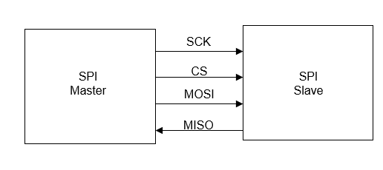
SPI is a synchronous serial communication method to interface between a master device and a slave device. Typically, SPI is used for short distance communication such as on PCB board. SPI consists of 4 ports shown in Figure 29 below, SCK, CS, MOSI, and MISO. SCK represents the Master Clock signal which is what determines what clock frequency that the sensors will update accordingly too. CS is chip-select which activates the SPI interface. An important note is that if the CS is kept at high, the SPI slave will not communicate with SCK or MOSI(Master Out Slave In). The two different communication lines MOSI and MISO are responsible for communicating information between the Master device and Slave device. When CS is kept low, data can be transferred from the Master device to the slave device. When programming sensor communication between each other, it is very important to allot a certain amount of time for the CS to switch states from high to low to prevent incorrect data from being passed.
Figure 29 - SPI Interface
SPI bus systems are also supported when multiple slave devices are incorporated into the design. For the Vital Monitoring Wrist Strap, multiple sensors are going to be attached to gain as many vital readings as possible. If the ICs chosen are an SPI interface then, a configuration depicted in Figure 30 below is what will be incorporated. [45]

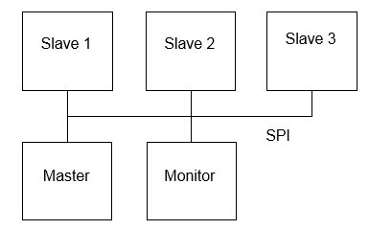

Figure 30 - SPI Bus

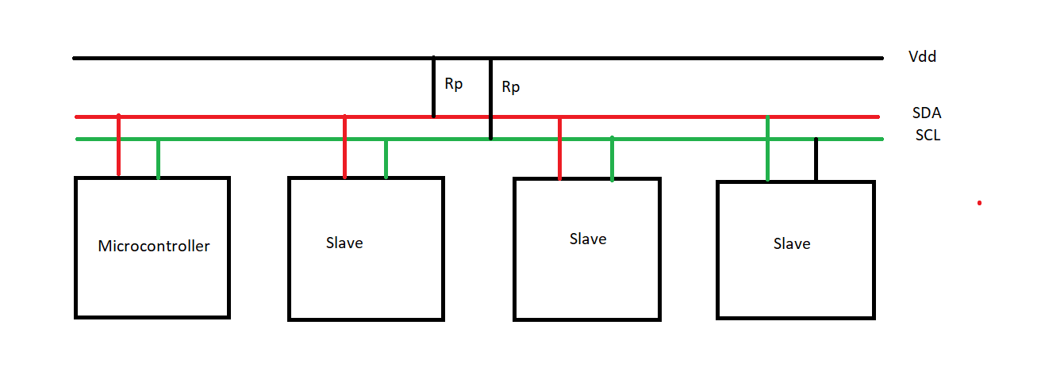
Another very common serial protocol is I2C, which utilizes 2 wires to communicate between a microcontroller and a slave device. Unique addresses must be obtained from NXP (formly Philips semiconductors) for slave devices. The SCL (Serial clock) is responsible for setting the clock frequency of the master and slave devices. SDA (serial data) is the line that communicates data between master and slave devices. Initial I2C specification have defined a maximum clock frequency of 100kHz until Fast mode was released which increased the clock frequency to 400 kHz. More advancements have been made to the speeds such as High-speed mode which goes up 3.4 MHz and Ultra-fast mode which goes up to 5 MHz. Figure 31 below depicts the simple wire setup of an I2C setup. [46]
Figure 31 - I2C Interface

4.2.4 Software Development Standards
Similar to hardware development, software development also has set standards that are defined by the Institute of Electrical and Electronics Engineers (IEEE) and other standard committees. As of 2017, there is an updated software engineering standard by the International Organization for Standardization (ISO), International Electrotechnical Commission (IEC) and IEEE. This standard is IEEE 12207, a systems and software engineering standard focused on the software life cycle processes. This standard provides a framework for obtaining and maintaining software systems.
ISO/IEC/IEEE 12207 focuses on providing information and criteria about the processes that are necessary to acquire a software product, system or service. It is stated that acquisition of software products is typically done through stakeholders who focus on providing software which would adequately satisfy all of the defined requirements of customers. In addition to acquisition, the standard also focuses on development of the products and services, operating them and maintaining them. These are vital criteria in order to produce satisfactory software that can meet requirements and withstand alterations over the course of time. It is also important that when software is no longer being utilized that it is disposed of properly. This standard also covers the proper instruction for disposing software products and systems and ending software services. Within this standard, it is important to understand that software is also defined as the firmware which involve the software as well [52]. This standard can be applied to software development solely on in conjunction with another software engineering standard, ISO/IEC/IEEE 15288.

All of the software that will be utilized for the mobile application and for communicating with the hardware will be written by group members or be code utilized from open-source areas. This means that these will be human-made systems. ISO/IEC/IEEE 15288 is centered on human-made software systems such as that which will be created for this project, making it a very applicable standard in conjunction with ISO/IEC/IEEE 12207 for the software development for the vital wrist monitoring strap. The ISO/IEC/IEEE 15288 standard provides a framework for the life cycle of software systems that are developed by humans with an engineering perspective. The most current form of the standard is from 2015 and it defines methods to control and improve the systems proceeding development. Like ISO/IEC/IEEE 12207, the focus of this standard is also customer satisfaction. Even human software processes should meet requirements initially during creation and after when alterations and new requirements need to be made or added to the existing software product or service [53]. This standard is an extension of the prior standard mentioned as it furthers the criteria for systems that are made by humans and are configured with other elements such as hardware and data, relating much to the software that will be created for the vitals wrist monitoring strap.

During software development, it is important that standards are followed in order to produce the most reliable and satisfactory products. With a high drive for customer satisfaction and safety, it is important that all of the software developed during the development of the vital wrist monitoring strap product follows the standards described. Maintenance is particularly important for this product to create a long-lasting medical device and the described methods in each of these standards will be analyzed and applied extensively for these products.

5.0 Project Design

5.1 Hardware Design
The hardware schematic is included in Figure 32 below. This schematic includes the connections necessary to communicate and control different features of the device. To start with, in the top corner of the schematic, is the USB to UART device which is required to appropriately upload code to the ESP controller. Special attention is required to appropriately flash and or upload code to the ESP controller. To upload code, the switch (S1) must be help down to set the microcontroller into programming mode to allow for code to be uploaded. When the code is successfully uploaded, the tactile button can be released to allow the intended functionality of the device. If flashing new data is desired, than the second switch (S2) should be held down to properly allow the data to flashed.

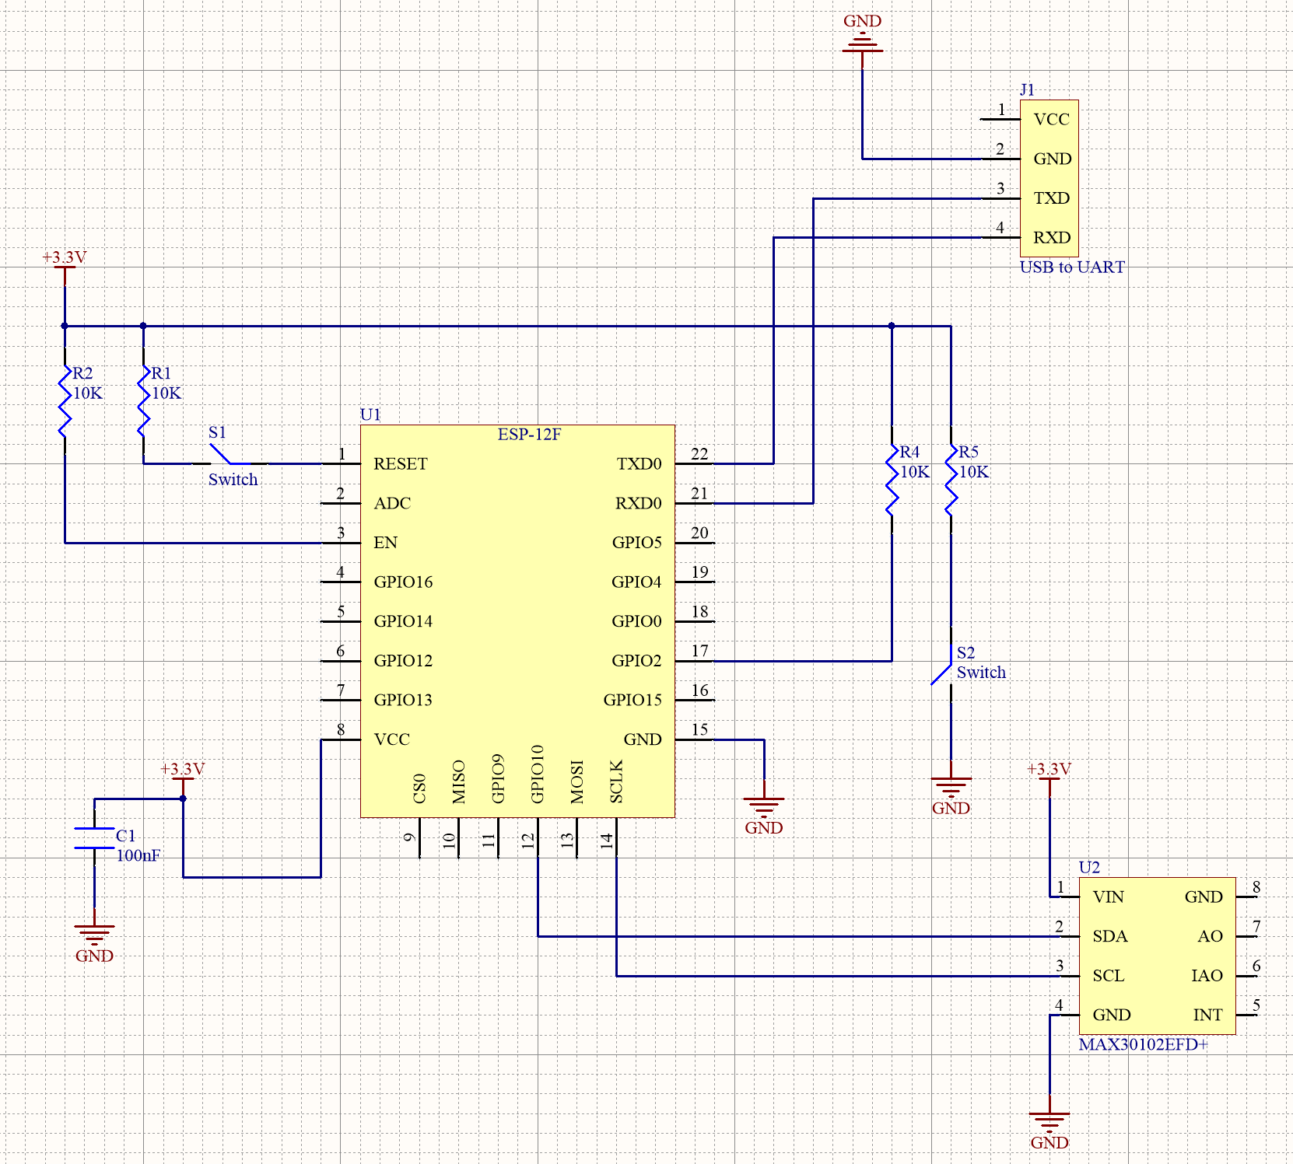
Figure 32 - Microcontroller Schematic
Located at the bottom right corner of Figure 33 above, is the MAX30102 Vital sensor chip. The connections are rather simple, as the serial clock connects to the clock of the ESP and the data line as well. Notice how there are no pullup resistors included on the lines of the I2C lines. This is because the pull-up resistors are already included on the breakout board of the MAX30102.

The power schematic is located in Figure 33 below. Starting from the top left, we are going to utilize typical a 5V, 1A wall charger due to their convenience and availability in a typical household. Essentially, the Micro-USB connector jack on the V.M.W.S will plug directly into a male micro-usb plug. The MCP73833T chip is responsible for controlling charging and the indicator lights for battery states: low battery, charging, charged. The next stage is where the Li-Po battery is connected to be the main source of power for device. Located next to the batteries are two 10uF capacitors to smooth out the voltage delivery. Finally, the MAX77640 chip is responsible for delivering 3.3V power to whole device. Essentially it is the DC-to-DC converter which will take the voltage level of the battery and step it down to 3.3V Included, with MAX77640 are other ports namely, SBB0, SBB1, which output different voltage outputs in the case the engineering team expands the number of vital sensors included on the board which require different voltage levels.
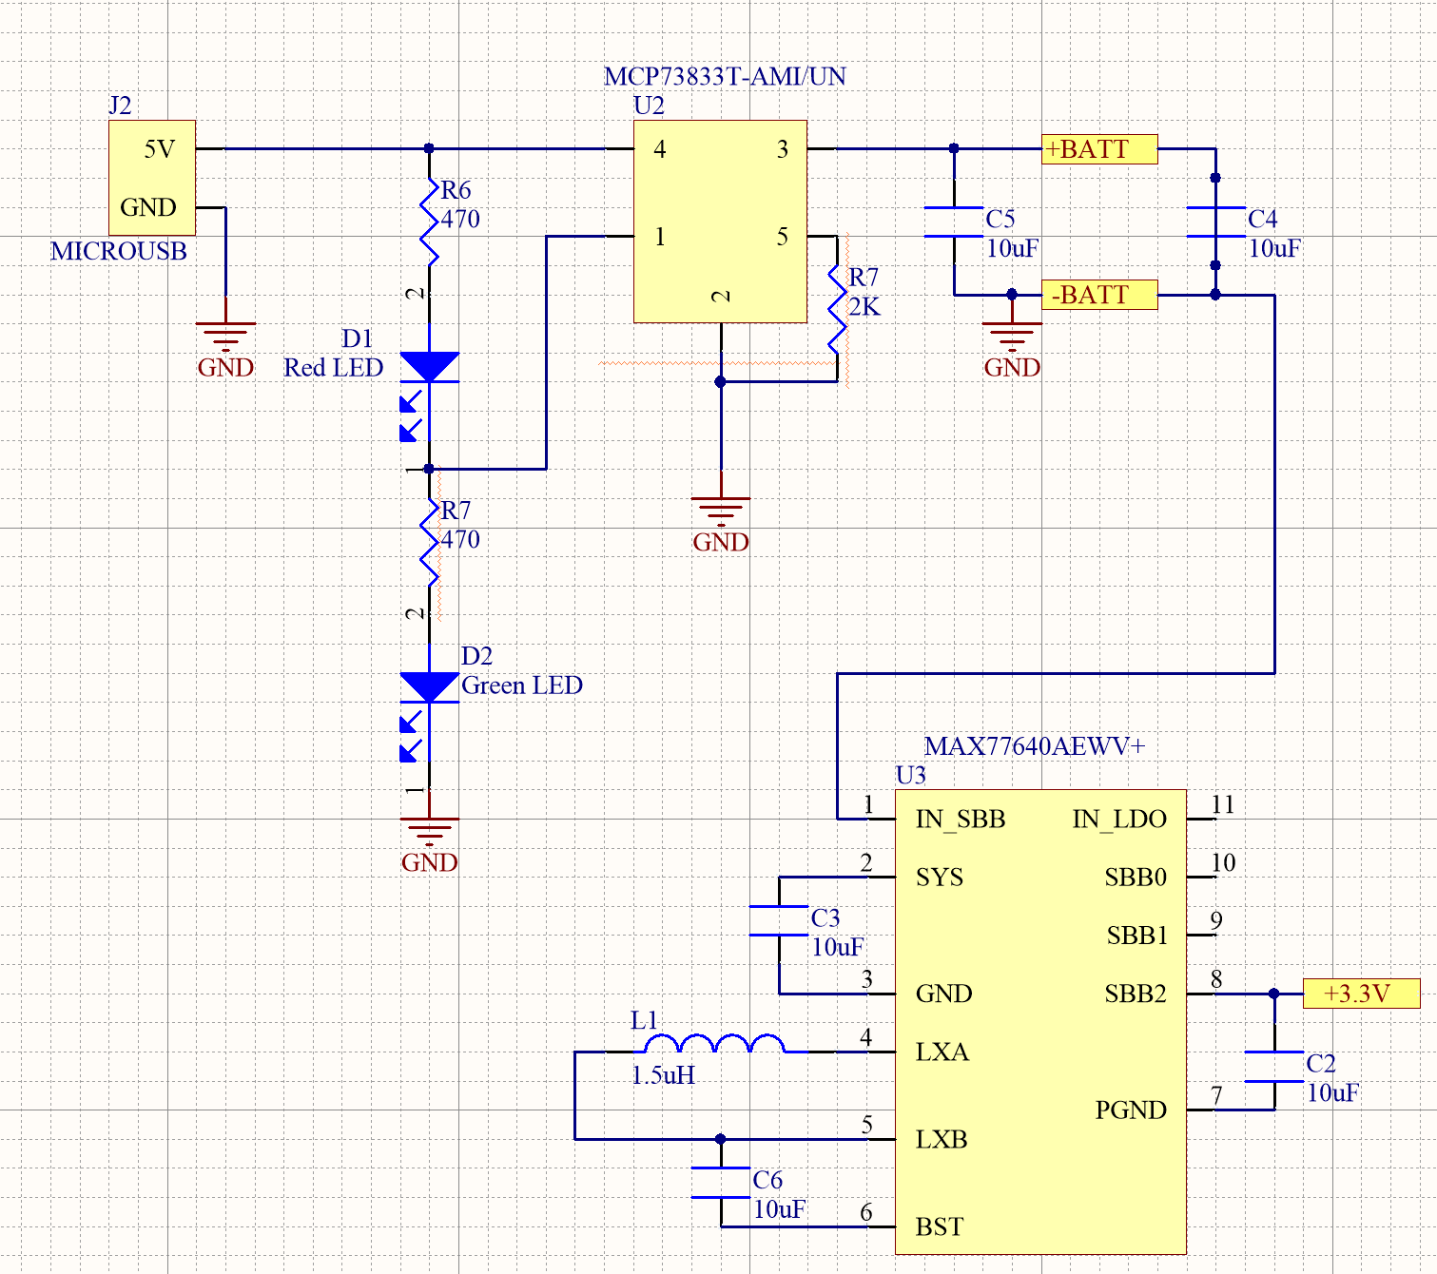
Figure 33 - Power Circuitry Schematic

5.2 Software Design
A major component of the Vital Wrist Monitoring Strap is the accompanying mobile application which displays the patient’s vitals to the caregiver. There are several capabilities that are required for the mobile application. The software needs to ensure that the security is the top priority beyond the general functionality of the application in order to ensure all of the patient’s vitals are private and visible only by the authorized caregiver with the application. There are specifics of the software that will specified in this section such as the graphical user interfaces for each of the pages in the application and the various functionalities of the application.

The mobile application will be developed using one of the application tools discussed earlier. Currently, the intention is to develop an application that will work both on iOS and Android for greater user outreach. This will require the usage of either Flutter or Ionic in order to develop for both mobile operating systems. With Android having an easier developmental system through the Android Studio development environment, developing only an Android application is an alternative to developing a mobile application for both systems.

In order to display the vital information collected by the physical vital wrist monitoring strap, it will need to have the capability to connect and retrieve information from the database in which the vitals are being stored. The intention is to utilize Amazon Web Services as the database storage service. It will be required that the mobile application can access all of the information stored in the database and can analyze and sort the data in order to portray it to the caregiver in both numerical forms as well as graphs. In addition to having the ability to retrieve information from the database, it should also have the ability to add information about the patient and caregiver to the database. For instance, it will be a feature of the mobile application that the caregiver will have to log into a private and individualized account for the patient whose vitals they are tracking. It will be necessary that this information entered in by the caregiver into the mobile application initially to be stored into the database for later usages for accessing their accounts. Moreover, it will be important to obtain certain pieces of information about the patient in order to enhance the patient experience with the vital wrist monitoring strap. These pieces of information will need to be stored in the database to be utilized for comparisons. It will be very important that the software of the mobile application work seamlessly with the database.

In addition to working with the operating systems to run the application, it will also be necessary that the software of the application is designed to access and work with the notification systems of the user’s phone. This is instrumental for the emergency notifications to be generated by the mobile application. The application will relay the emergency notifications after comparing vital values with defined, standardized values that will be defined in the code for the comparisons.

There are several components of the software design such as its pairing with the database through Amazon Web Services which acts as an intermediary between the mobile application and the microcontroller. Also, it must have an easy-to-use user interface that can be utilized not only by caregivers but patients as well. It will be important that the application is operating system friendly in order for the application to be available to a wide range of users and can adequately send the emergency notifications on the device’s environment. There will also be some software involved in the configuration of the microcontroller to collect the vitals and transfer them to the database system.

5.2 Software Logic Diagram
Figure 34 below provides a general outline of the logic that will be conducted by the backend of the mobile application particularly with the vitals emergency notification system. Beyond just displaying the vitals to the caregiver, an algorithm and several functions will have to be written in order to simulate comparisons between the vitals read and obtained from the database and standardized values to generate emergency notifications properly. This logic process will occur on a minute-by-minute basis as the vitals are read and transferred.

Figure 34 - Software Logic Diagram

5.3 Amazon Web Services
Amazon Web Services through its online cloud interface is largely accessible. For the purpose of the vital wrist monitoring strap system, it will be a major component in the software design as it will be connecting with both the microcontroller and the mobile application for the storage and the retrieving of the patients’ vitals. There is a plethora of databases that exist on Amazon Web Services. The database will need to be configured on Amazon Web Services in order to meet the requirements of both the microcontroller storage and the mobile application.

The database on Amazon Web Services will need to store patient and caregiver information for the account and match the account to the corresponding patient’s vitals. In turn, it will be necessary that the database is relational in one aspect. Furthermore, since the database will be storing information on a time basis and it is necessary that the mobile application has access to the vitals changing over time to display the graphical representation of the data, it is also necessary that the database also functions somewhat like a time series database. Both relational and time series databases are available on Amazon Web Services. One or the other will need to be modified in order to satisfy the criteria of being both time based and relational.

On Amazon Web Services, there are several types of relational databases that are available. For ease, if the basic database being utilized is a relational database one which utilizes MySQL will be utilized such as Amazon Aurora or Amazon RDS. MySQL is openly available and easy to use since it is one of the most popular open source databases. The relational databases on Amazon Web Services that utilized MySQL are typically preconfigured which will assist in setting up the database. The MySQL language can used to program the configuration of the database and make modifications as well. Part of the database configuration is the defining of primary and foreign keys. A primary key is a unique attribute that is utilized for the identification. In the case of the database for the vital wrist monitoring strap, the defined primary key will most likely be an account ID which would allow for the identification of individual caregiver account which corresponds to the information of a single patient. Moreover, in order to tie in the account with the specified vitals, it will be necessary to have a foreign key as well in the database. A foreign key is a characteristic in another table in the database which links the tables together within a single database. For the purpose of this project, a possible foreign key would be patient ID which links the patient’s vitals to the proper account stored in an users table. Defining of the different attributes and keys in the database is necessary for the full functionality of the database.

Some of the already defined attributes that will need to be included in the database configuration will be at least two tables, one for the user accounts and the other for the actual storage of the vitals. Each of the vitals will have its own column in the database table along with a time column in order to include a time and date stamp of the vitals. There will be other attributes that will need to be included in the configuration of the database based on the overall functionality of the vital wrist monitoring strap and how the individual components such as the mobile application and the microcontroller works with it. Individual attributes for the users table which specify information about the caregiver and patient will also need to be included such as a column for the username, password, patient name, patient resting heart rate, etc. will need to be defined.

AWS provides the basis of the database that will be utilized for the project. Configuration of the database through software will be necessary in order to meet the requirements of the project.

The current intended design of the relational database is as follows in Figure 35 below. Shown is the Entity Relationship Diagram (ERD) which includes two tables, Users table and Vitals table, in a one-to-many relationship. Each of the tables contain attributes or the information that will be inputted and stored in each table of the database. It is noticed that the ERD also designates the primary key (PK) and foreign key (FK) for the database. The UserID is the primary key which will be the unique attribute which individualizes each entry into the Users table. It will also act as the foreign key in the Vitals table to link the both tables. The PatientID is designated as the primary key in the Vitals table.
Figure 35 - Entity Relationship Diagram Representing Database Structure

5.4 Software Design – Data Structures and Functions
The transmission and maintenance of the vitals is significant in the software design. The intention is to consolidate and transmit all of the vitals on a minute-by-minute basis from the microcontroller to the database. In a similar manner, in order for easy access of all of the vitals by the code for the mobile application, when the vitals data is extracted from the database, it will be inserted into a two-dimensional integer array of one row and five columns to store the data. This data structure is shown in Figure 36 below. The data will be able to be extracted from this array for use through utilizing the indexing. For instance vitals[0][2] corresponds to the oxygen reading stored in the array.
Figure 36 -Array data structure to store vitals
There will be a plethora of necessary constants and variables to store the data and calculations in the code written for the mobile application. Below in Figure 37 are the proposed constants and variables for the software with the explanation of their usage. The skeleton of the code provided is intended to display the object-oriented approach to the software development through the Java language which is one of the main programming languages in Android application development.

Figure 37 - Proposed Constants and Variables for Mobile Application Code
The program for the mobile application will be broken up into several functions in order to accomplish the individual tasks of the application. Below in Figure 38 are the function headers for the intended functions as well as explanations of what each function will accomplish.

Figure 38 - Proposed Functions for the Mobile Application

5.5 Application Overview
The accompanying mobile application for the vital wrist monitoring strap will have several functionalities and displays. Like any general account-based mobile application, the mobile app will have a secured login page that will allow caregivers to login to the specific account of the patient’s vitals they are tracking. This will ensure that the vitals are kept confidential in order to adhere to all privacy rules. The general outline of the graphical user interface for the login page is shown in Figure 38 below. When a new patient obtains a new vital wrist monitoring strap, it will be required that the caregiver registers, creating new account to which the strap will be paired to. This will allow the caregiver to have access to only the vitals paired to that registered account. For confidentiality and ease, only one vital wrist monitoring strap will be allowed to be paired to one individual account on the mobile application at a time. Although, users will be able to log in to other separate accounts if they are caregivers to multiple patients using the vital wrist monitoring strap. The outline of the registration page of the application is also shown in Figure 38 below as well. Additional features can and will be added to the login and register parts of the application in order to make it more secure such as asking a security question. Registration may also need to include a portion to specifically pair the patient’s vital wrist monitoring strap to this account at the time of registration or a special key which matches the specific vital wrist monitoring strap that the patient has.
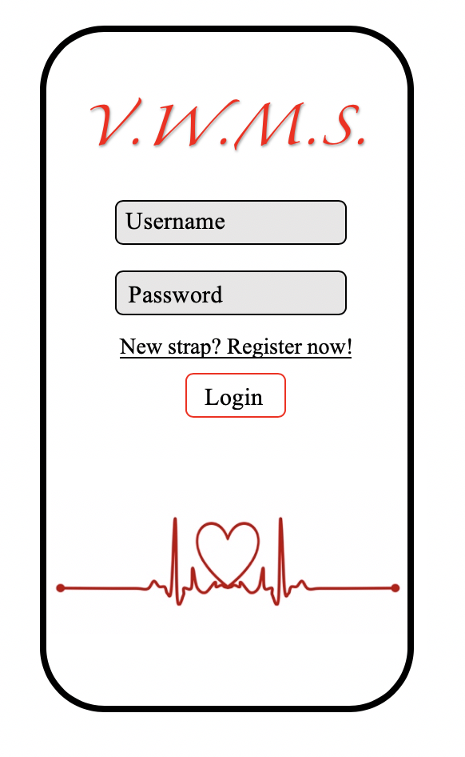
Figure 39 - Login and Register Screens of Mobile Applications
In addition to registering and pairing the vital wrist monitoring strap proceeding registration, it will be necessary to obtain some information about the patient including their name for identification, their birthday and resting heart rate. The outline for the patient info page on the mobile application is shown below in Figure 40. Collection of the patient’s birthday is necessary to calculate their age in order to compare their vital values to the standardized values for their age group. Moreover, resting heart rate will allow for an additional comparison so that the vitals are being compared for emergency notifications in a range that is unique to the patient as well. On Figure 40, there is a button with a question mark symbol. It is intended that when that button is pressed, it will provide information to the caregiver on how to properly obtain the patient’s resting heart rate such as in what condition they should be, how they should count the beats and how it needs to be calculated in order to be correctly inputted into the mobile application for use. Additional information may need to be added to this screen in order to produce the most accurate vital readings and emergency notifications for the caregivers and patients.
Figure 40 - Patient Information Page of Mobile Application
The most important part of the application is the displaying of the vitals. It is intended that both current readings and past readings will be available to the caregivers. This will allow them to have access to long-term vital readings to show to medical professionals about the status of the patient. Shown in Figure 41 is the planned outline for the displaying the vitals both currently and overtime. The outline on the left of Figure 41 shows how the collected information overtime will be displayed, in graphs. There will be graphs on a time scale for each of the vitals. It may be possible that the graphs will display the average vital reading per day and each day point will be able to be clicked on to provide more specific information about the vitals. To the right of Figure 41 is a draft of how the minute by minute readings will be displayed to the caregiver. As seen, it will be provided in a list format in order for it to be easy to read by the caregiver. All of the different vitals that will be taken will be provided in this manner to the caregiver.
Figure 41 - Screens with Display the Vitals on the Mobile Application
Alongside vital readings being provided to the caregivers through the mobile application that will be created, the next major component of the application is the emergency notifications. Emergency notifications will be generated by comparing the vitals to defined standardized ranges based on the patient’s age. Furthermore, if it is heart rate, it will also compare the vital to the patient’s resting heart rate. If out of range, the application will generate a notification which will appear immediately on the caregiver’s device whether or not he or she is currently on the application. Of course, it is necessary that notifications from the vital wrist monitoring strap application are enabled. These emergency notifications will display the name of the application in order for the caregiver to realize that it is coming from the application and that it can potentially be an emergency. Shown in Figure 42 is an example of a notification that will be generated and displayed to the caregiver. The following emergency notification is a generalized version of the notification. It is intended that the notification will not just say “Vital out of range!” but instead will state the actual vital that is out of range such as heart rate or temperature.

Figure 42 - Emergency Indicator
The application is intended to be developed with the specified components. The actual graphical user interface could be altered depending on additional requirements and uses of the application. Also, depending on the developed style for the application.

The goal is to produce an application that will work on both Android and iOS devices in order to be applicable to all devices ensuring that the vital wrist monitoring strap can provide safety to a wide range of users. The application will be published in both of the stores, once developed, to be assessible to all caregivers and users.

In order to work properly, the mobile application will be connected to the database in order to store and obtain information. The information collected by the mobile application for the login, and about the patient will be stored in a database. Moreover, for the vitals to be displayed from the readings by the sensors, the application will have to retrieve the data from the database. The mobile application will heavily rely on the database and the information inputted into it in order for it to function properly. The application will not be directly connected to the device.

Overall, the mobile application to accompany the vital wrist monitoring strap will provide basic information about the patient’s vitals in a secure manner to caregivers and in a manner that will allow caregivers to read and analyze the data with ease. The emergency notification will be a necessary part of the implementation to fulfill the goals of the vital wrist monitoring strap. Through the application, information about the patient will be able to be obtained and also displayed. It will not only be a useful application for the caregiver but also for the medical professionals for the patients as well.

There will be several functionalities between different entities in the Vital Wrist Monitoring Strap system that will work in conjunction with each other in order to accomplish the overall task of the system. Figure 43 is the Use Case Diagram for the V.W.M.S. Shown are the different functions that will be necessary and accomplished by the wireless communication system and mobile application in order to transfer information from the sensors to the database and to the caregiver.

Figure 43 - Use Case Diagram for V.W.M.S

6.0 Testing
When deciding how to test the different features of the Vital Monitoring Wrist Strap, approaches must be made to ensure full product delivery at the end of Senior Design II. Critical pieces of hardware such as the power delivery and sensor communication are entitled to a high priority to ensure proper device functionality. Just as important as hardware is, the software implementation of a database and Android Application require efficient testing to ensure the caretaker receives correct information as well as no bugs or glitches.

6.1 Battery Monitoring for Wearable Devices
The smart wearable electronics is a new trend in the consumer electronics industry. The power requirements of a smart wearable device put a lot of constraints and requirements for the battery’s performance.

The smart wearable devices require ultra-low power consumption and the size of the device is very compact. Hence, the form factor of the required battery should be very compact as well. Lithium ion batteries are very commonly used in such applications because of their smaller size.

In addition to other requirements, one of the main requirements of the wearable devices is an efficient battery management system. The smart wearable devices usually have a graphical interface such as an LCD screen. Hence it is required by the user to be able to monitor the battery status. The battery management system of the wearable device must be able to indicate the remaining power, indication of charging when plugged into a power source, alert notification when the battery charge is below the critical level, and option for power saving mode. In addition to the software features, the hardware of the battery management system should have a voltage and current protection circuit. The main hardware components of a battery management system for a smart wearable device are listed as following [59]

- Lithium ion battery cell
- Short circuit current protection
- Over voltage protection
- Thermal break down protection
- Input buck converter with LDO output
- Output boost converter
- Fuel gauging circuitry
- Battery charger circuitry
- Micro USB slot

6.1.1 Battery management circuitry
The battery management circuitry of a smart wearable device includes following electronic components [59]:

- Battery charger IC
- Micro USB charging port
- Lithium Ion battery cell
- Voltage/current protection IC
- Battery fuel gauge sensor IC
- Output boost converter system

Lithium ion battery cell is used for powering up the device when no external power source is connected. The cell has a high-power density and very compact form factor due to which it is suitable for wearable applications.

The charger IC is used for charging the Li-ion battery. The charger IC can also be configured for fast-charging mode. The input power to the charger IC is provided through a micro USB interface. The charger IC contains a buck converter for voltage regulation. The power-up button and the manual-reset button can also be interfaced with the charger IC pins.

The protection IC saves the battery and the circuitry from over-voltage or over-current. This IC also monitors over-charging of the battery and helps in preserving power.
The fuel gauge IC is a microcontroller-based peripheral that provides fuel gauging for Lithium ion batteries. The device requires minimum configuration and firmware programming effort on user’s part. This IC provides functions such as remaining battery capacity, state of charge and battery voltage. The IC uses impedance tracking algorithm for accurate gauging of the battery. The fuel gauge IC also incorporates a temperature sensor for monitoring the battery temperature.
The output stage of the battery management system employs a boost converter designed for high voltage compact applications. The module contains a power switch, input/output isolation switch, and a power diode. The boost converter is capable of providing 28V at its output. The size of the passive components is decreased significantly by using a higher switching frequency of the power switch. Typically, 1 MHz switching frequency is used. The IC also provides short-circuit protection, over-voltage protection and thermal shutdown.
The DC-DC input buck converter is used to step down the DC voltage from the charger. It contains a power switch, power diode and control signal circuitry. The converter outputs voltage up to 3.3V.

6.2 Microcontroller and Sensor Testing
In order to successfully test if the components we ordered are probably working, it would be useful to test sensors with established libraries for an Arduino UNO. The Arduino UNO by far has the most support from the community in terms of troubleshooting and library support. For the MAX30102 sensor, a library has already been built to test all of the features that are included on the board, such as the heart rate sensor, oxygen sensor, and temperature of the individual using it. A small prototype has been made using the Arduino Uno to test the basic functionalities of the MAX30102 chip which can be eventually ported over to a ESP8266.

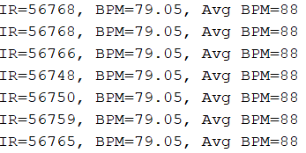
As the team receives parts, like the ESP8266, the library that was written for the UNO will have to be redone, to match the internal registers and callouts for the ESP8266. A benefit of having the ESP8266 over the Arduino, at least in the case of the ESP12E, is that we can fully utilize the amount of memory required to obtain 32-bit accuracy. Included in the library for the Arduino UNO, it cuts the accuracy to only 16-bits due to memory issues with the ATMEGA328P chip. This will allow for faster and more accurate measurements for Vital Monitoring Wrist Strap.
Figure 44 - Serial Output of MAX30102 Sensor
As mentioned before, an Arduino UNO has been utilized to begin testing communication between a controller and the sensor. In Figure 44 above, it shows the heart rate output of the MAX30102 chip.

When trying to find the best reading of the pulse, it was somewhat difficult to get accurate readings, as a decent amount of pressure and stability must be applied to the wrist. Since humans can not accurately apply constant pressure or stability, it is recommended to have a strap of some kind to securely place the sensor on the wrist. Currently, the best position for the MAX30102 to be placed near the radial pulse of the patient’s wrist for the most accurate readings as depicted in Figure 45 below.

When seeing how the accuracy of the sensor data is, it is useful to compare the readings to other available sensors on the market. For example, we utilized a Fossil Smartwatch that contains another heart rate chip and compared the results. In Figure 46 below, the heart rate symbol in red, depicts the results.

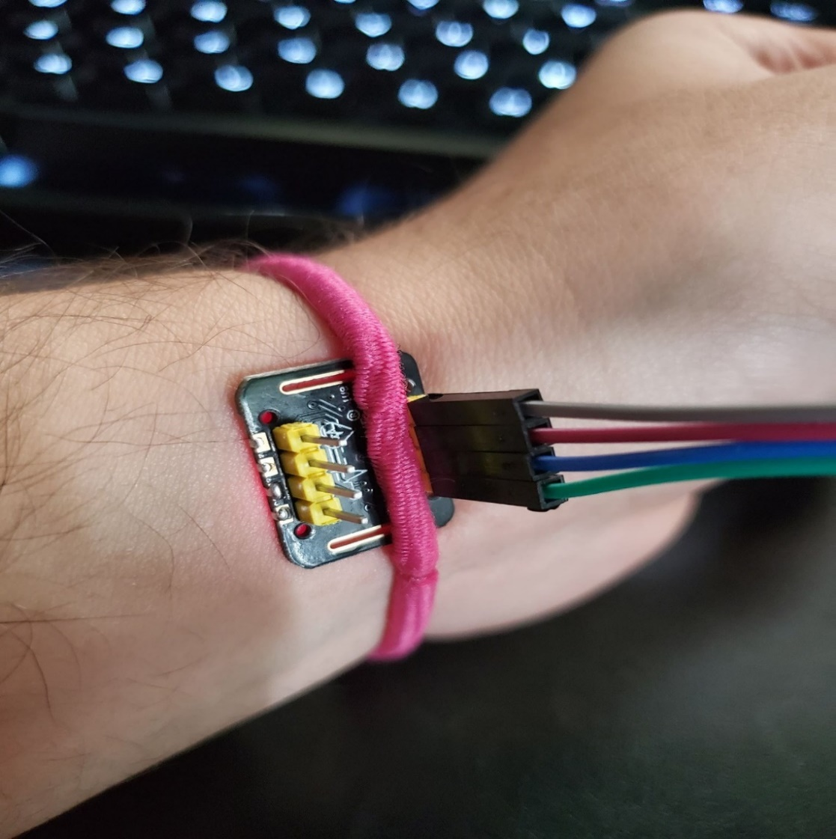
When comparing Figure 45 and Figure 46, you can see that the readings are relatively close which provides greater proof the MAX30102 chip will properly work when ported over to ESP8266.
Figure 45 - Sensor Placement on Radial Pulse Area

Figure 46 - Fossil Smartwatch Pulse Reading
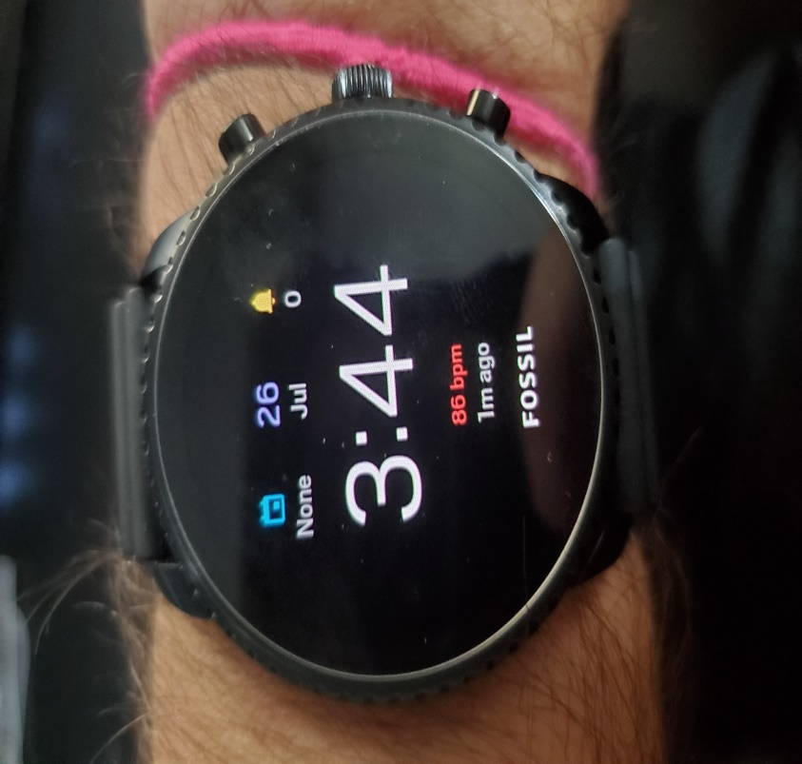
One problem that the engineering team is faced with is that the readings are somewhat skewed with the movement of the patient. For example, if the patient is using his or her hands than the readings can be spiked up all the way to extreme numbers that are a bit ridiculous. More troubleshooting and prototyping will have to done to overcome these issues to prevent having misleading values and warnings. Perhaps we could utilize a movement system such as an accelerometer to void measurements when movement is detected while measuring vital signs.

6.2.1 Amazon Web Services
The microcontroller will work hand-in-hand with the database on Amazon Web Services as all of the vital readings conducted by the sensors on the microcontroller will be transmitted to Amazon Web Services for storage. It will be vital that extensive testing of the microcontroller communication to the database on Amazon Web Services is conducted. Both individualized testing and testing when the microcontroller is fully integrated will be necessary. The microcontroller is the main communicator with the database on Amazon Web Services requiring extensive testing to ensure the reliability of the vital wrist monitoring strap.

The main functionality and communication between the microcontroller and Amazon Web Services will be to transfer and store the vitals on a minute-by-minute basis. During transferring of the numerous vitals, there is much opportunity for values to be miscommunicated or mixed up such that the wrong vitals will be stored in the wrong vital category in the database. As part of testing, it will be important that the vitals which are read by the sensors are ensured to be stored adequately in the database. Testing of this will include obtaining the sensor readings individually then reading the database entries for the new vitals and ensuring that the values correspond to what is being read through the sensor. Especially since the microcontroller will be taking vitals repeatedly for a long period of time and the data needs to be stored for a long period of time for the application, it will be important to test that the database can withstand holding such a large amount of information. Long term testing over a week or so should be conducted to ensure that the large quantities of vital readings are adequately being stored in the database so they will be accessible for later uses by the mobile application.

Unit testing will be vital during development of the vital wrist monitoring strap when considering the microcontroller and the database through Amazon Web Services. As described prior, it will need to be guaranteed that the vitals are properly being transferred to the database online. Testing for this will be done on an individual basis. Each individual sensor on the microcontroller should allowed to be obtained vitals solely, without the other sensors conducting readings as well. The vitals should then be transferred to the database and the readings should be compared for accuracy. This process should be conducted for each sensor by itself before they are all integrated together and allowed to run at the same time.

Proceeding of the individual communication of the sensors to Amazon Web Service’s database. It will also be required to conduct integration testing as described before. When all sensors are running at the same time on the microcontroller, testing must be conducted which checks to make sure vitals are not getting misinterpreted and traded between the different vitals when being stored in the database. This is extremely important before proceeding with the final development stage of the vital wrist monitoring strap.

It should be noted that the sensors on the vital wrist monitoring strap will not directly communicate with the database and Amazon Web Services on its own. It will depend on the microcontroller which will do the deciphering of the vital readings before transmitting it to the database. The microcontroller acts as the intermediary in the communication between the sensors and the database. Amazon Web Services has built in services and there are also specific libraries for the programming of the microcontroller that will assist in setting up the communication between them.

6.3 Android Application Communication
The mobile Android application will be instrumental in the functioning of the entire vital wrist monitoring strap system. It is important that the android application functions adequately and can seamlessly converse with the database on Amazon Web Services (AWS). The application will communicate directly with the database to transmit and receive data to and from the web services. The application will have no direct communication with the smart device that constitutes the vital wrist monitoring strap. In order to ensure that the Android application is communicating properly with the database, it will have to be tested extensively. In order for an application to be written to communicate with a database such as the relational databases that will be utilized for the application, several Application Program Interfaces (APIs) will need to be developed. These application program interfaces which will constitute the backend of the mobile application functionality will need to be tested extensively. Testing of communication of the application to the database can be done through utilizing the Advanced Rest Client (ARC). Through the Advanced Rest Client, retrieval of data from the database and writing of data to the database from the application can be done through Json packages. The process of testing the backend functionality of the android application occurs prior to integration of the entire application. Provided information about a specific patient’s caregiver’s account, the Json package should be able to retrieve the patient vitals as they are stored in the database. I will be important to test that the application can satisfactorily retrieve the information from the database on a repetitive minute by minute basis in order to simulate the actual functionality of the vital wrist monitoring strap and mobile application system.

During the actual implementation of the full scale Android mobile application, testing of the Android communication to Amazon Web Services and the database that will be hosted on there will be necessary as well to ensure that the frontend of the application does not interfere with transmittance and receiving of the information. This will be through inputting information into the mobile application and checking the database to ensure that it was added to the database properly. Vice-versa should also be conducted to make sure that the information being displayed on the application is correct as well.

Amazon Web Services provides an easy-to-use environment that allows for easy connection between the mobile application and the database especially if the database being utilized is a relational database. The site provides tools that will also assist in testing the application’s communication with the database as well. Since there is no other medium in which the android application must communicate with, it is important that the application can communicate effectively with Amazon Web Services in order to have information to provide to the caregivers through the application.

Beyond just the utilization of software testing to ensure the communication between the Android application and the database is working properly, physical testing of the application’s communication must occur especially since caregivers will be in remote locations away from the patient wearing the vital wrist monitoring strap. Physical tests through testing the actual functionality of the application and its communication with AWS with real patients and caregivers is necessary to ensure proper communication as realistic conditions can provide information about how the application connects to the database. The database acts as an intermediary between the vital wrist monitoring strap and the Android application.

6.5.2 Software Tests
Beyond the testing of the hardware, it is instrumental that the software is tested also to ensure that the entire system for the vital wrist monitoring strap is working properly. The software involved in the project not only includes the software for the mobile application but also for the microcontroller’s functionalities and connection with the database through transferring the vitals read by the sensors. A series of testing of the software will be necessary throughout the entire developmental period to ensure that each part of the software is working properly individually and when integrated.

Part of the software tests that will need to be conducted will be through the process of unit testing. Unit testing consists of testing each individual part of software as it is developed. Some of the software utilized in this project will be dependent on other parts of the project and therefore cannot be subjected to unit testing. It will be important that the mobile application is subjected to unit testing during development. Each development of the application will require testing to ensure that the application is working on a basic level. This constitutes checking that input boxes are getting and retrieving information properly and that buttons are functioning properly such that when they are pressed, they will redirect to the proper pages, store information on command, etc.

Integration testing will be fundamental in testing of the software and the overall development of the project. Specifically, it will be important when connecting the microcontroller and the mobile application to the database. In order to ensure that the information is being transferred from the microcontroller’s sensors to the database, the database will need to be observed. The validity of the sensors and the transferring of the information should be check by physically conducting the medical techniques in order to obtain the vitals. For instance, to check the validity of the heart rate sensor and to ensure that the correct information is being transferred, the pulse of the individual wearing the vital wrist monitoring strap can be measured and compared to the reading that is being provided in the database. In terms of testing the mobile applications connectiveness with the database, Application Programming Interface (API) testing will need to be conducted. This will ensure that the application is sending and retrieving information properly. To do this, the Advanced Rest Client (ARC) can be used to conduct the sending and retrieving of the information before the full-blown mobile application is connected to the database. Testing each individual API solely is considered a form of unit-testing but leads to integration testing after it is ensured that all individual components are working properly. Testing of the APIs developed through the Advanced Rest Client entails creating Json objects which transfers information to and from the database. Both integration testing and unit testing will work in conjunction with each other for this project.

In addition to unit testing and integration testing, it is also necessary to conduct end-to-end testing on the entire project, not just the software. It is vital that the software components are connected to the hardware in order to adequately test the project. End-to-end testing consists of testing the entire project to make sure that every component is working in conjunction with each other. The purpose of end-to-end testing is to ensure that the product is finalized and ready to be produced. Software testing for this form of testing will consist of making sure that the mobile application is adequately displaying all of the information from the sensors and transferring the information collected from the application to the database.

7.0 Administrative Content
The administrative section covers all of judiciary decisions and actions that the engineering team has discussed in detail. This includes budget, cost, and the planned timeline of events to reach required deadlines of submission. The schedule is subject to change based upon hardware/software related issues.

7.1 Budget and Cost
The cost of the Vital Monitoring Wrist Strap is listed in Table 32 below. This cost and budget are subject to change throughout the process of the design, as parts will most likely be swapped out. The team will be financed individually as the final cost of the project will be split between the four group members.
Table 31: Project Costs
Item (Quantity) | Cost
Housing (1) | $25.00
Oximeter/Heart Rate Sensor (1) | $8.00
Temperature Sensor (1) | $5.00
Microcontroller | $8.00
PCB and Mounting | $50.00
Power Supply | $5.00
Switching Voltage Regulator 3.3V (1) | $8.00
Wires and Components | $50.00
Documentation Printing | $50.00
Rechargeable Battery | $50.00
Total | $259.00
Cost Per Member | $64.75

7.2 Project Timeline
Table 32: Senior Design I - Timeline
Week (Date) | Task
Week 3 (5/27/2019) | Divide and Conquer 1.0 Submission
Week 4 (6/7/2019) | Divide and Conquer 2.0 Submission
Week 5 (6/14/2019) | Table of Contents Submission
Week 5 (6/14/2019) | Pages and Topics assigned to each member
Week 6 (6/22/2019) | 5 Pages due for each member
Week 7 (6/29/2019) | 10 Pages due for each member
Week 8 (7/6/2019) | 15 Pages due for each member– 50% Submission
Week 9 (7/13/2019) | 20 Pages due for each member
Week 10 (7/20/2019) | 25 Pages due for each member – 75% Submission due
Week 11 (7/28/2019) | 30 Pages due for each member – Final Group Review
Week 11 (8/2/2019) | 100% Page Submission
Week 13 (8/11/2019) | Group Meeting to discuss project progress

Table 33: Senior Design II - Timeline
Week (Date) |  | Task
Week 1 (8/25/2019) |  | Group Meeting to discuss duties and responsibilities
Week 3 (9/8/2019) |  | Group Meeting to discuss project progress
Week 4 (9/15/2019) |  | Group Meeting to discuss project progress
Week 5 (9/22/2019) |  | Hardware Design Complete (Start PCB), Software Design Complete
Week 6 (9/29/2019) |  | Software and Hardware Communication Testing
Week 7 (10/6/2019) |  | Group Meeting to discuss project progress
Week 8 (10/13/2019) |  | Group Meeting to discuss project progress – PCB Complete
Week 9 (10/20/2019) |  | Critical Design Complete
Week 10 (10/27/2019) |  | Clean-up (Harness)
Week 11 (11/3/2019) |  | Verification of Requirements
Week 12 (11/10/2019) |  | Group Meeting to discuss project progress
Week 13 (11/17/2019) |  | Presentations

8.0 Conclusion

With the infringing of technology on the world of medicine, the importance of new technological developments for the medical field is exponentially growing. The proposed Vital Wrist Monitoring Strap (V.W.M.S.) seeks to contribute to the biomedical technology evolution. As stated, the driving force behind the V.W.M.S. is patient health safety. There are no stopping emergencies but with the Vital Wrist Monitoring Strap, they can be mitigated. Our goal is to enhance the patient-caregiver relationship through continuous monitoring of patient’s vitals through the device and mobile application system. Caregivers would no longer need to be within close proximity of patients in order to keep a watchful eye on them. Moreover, with the designed system, long-term presentation of vital information on the mobile application can assist health professionals also in better understanding patient’s health between office visits.

The design of the Vital Wrist Monitoring Strap described in this document is centered on a physical strap which exploits several sensors in order to obtain temperature, heart rate, oxygen saturation, etc. Through wireless communication, vital readings will be transferred to a cloud- based database which will be portrayed to the caregiver through a mobile application. The proposed implementation of emergency notifications will heighten the tracking of patient safety, a distinctive feature of the V.W.M.S.

The development of the Vital Wrist Monitoring Strap will be focused on following the design described in this document including the standards and constraints explained. Modifications will be necessary throughout the production period depending on the process. The ultimate goal is to produce a fully functional, cost effective instrument and application that can be utilized by any patient to ensure their safety and enrich their health.

References
[1] “Coin Cell / Button Cell Battery Guide.” Batteries.com, www.batteries.com/pages/coin-cell-button-cell-battery-guide#https://www.batteries.com/pages/coin-cell-button-cell-battery-guide%23%20.
[2] “BU-103: Global Battery Markets.” Global Battery Markets Information – Battery University, 11 Apr. 2016, batteryuniversity.com/learn/article/global_battery_markets.
[3] “BU-107: Comparison Table of Secondary Batteries.” Secondary (Rechargeable) Batteries – Battery University, 1 Apr. 2019, batteryuniversity.com/learn/article/secondary_batteries.
[4] “Lithium-Based Batteries Information.” Lithium-Based Batteries Information – Battery University, 1 June 2018, batteryuniversity.com/learn/article/lithium_based_batteries.
[5] “Lithium-Based Batteries Information.” Lithium-Based Batteries Information – Battery University, 28 Feb. 2019, batteryuniversity.com/index.php/learn/article/lithium_based_batteries/1.
[6] “BU-203: Nickel-Based Batteries.” Nickel-Based Batteries Information – Battery University, 28 Feb. 2019, batteryuniversity.com/learn/article/nickel_based_batteries.
[7] “What The Heck Is a NiCd Battery?” BatteryStuff.com: We Have The Stuff, www.batterystuff.com/kb/articles/battery-articles/what-the-heck-is-a-nicd-battery.html.
[8] J. Am. Chem. “The Li-Ion Rechargeable Battery: A Perspective.” The Li-Ion Rechargeable Battery: A Perspective | Journal of the American Chemical Society, 7 Jan. 2013, pubs.acs.org/doi/10.1021/ja3091438.
[9] “Constraint,” Dictionary.com. [Online]. Available: https://www.dictionary.com/browse/constraint. [Accessed: 21-Jun-2019].
[10] HHS Office of the Secretary,Office for Civil Rights and Ocr, “Summary of the HIPAA Privacy Rule,” HHS.gov, 26-Jul-2013. [Online]. Available: https://www.hhs.gov/hipaa/for-professionals/privacy/laws-regulations/index.html.[Accessed: 21-Jun-2019].
[11] “How pulse oximeters work explained simply,” How Equipment Works. [Online]. Available: https://www.howequipmentworks.com/pulse_oximeter/. [Accessed: 23 -Jun-2019].
[12] “Eco-friendly 3D filament guide - what are the possibilities and innovations,” Aniwaa. [Online]. Available: https://www.aniwaa.com/eco-friendly-3d-filament/. [Accessed: 23-Jun-2019].
[13] “Heart disease,” Mayo Clinic, 22-Mar-2018. [Online]. Available: https://www.mayoclinic.org/diseases-conditions/heart-disease/symptoms-causes/syc-20353118. [Accessed: 25-Jun-2019].
[14] “Tachycardia: Fast Heart Rate,” www.heart.org. [Online]. Available: https://www.heart.org/en/health-topics/arrhythmia/about-arrhythmia/tachycardia--fast-heart-rate. [Accessed: 25-Jun-2019].
[15] “Bradycardia: Slow Heart Rate,” www.heart.org. [Online]. Available: https://www.heart.org/en/health-topics/arrhythmia/about-arrhythmia/bradycardia--slow-heart-rate. [Accessed: 25-Jun-2019].
[16] “About Heart Attacks,” www.heart.org. [Online]. Available: https://www.heart.org/en/health-topics/heart-attack/about-heart-attacks.[Accessed: 27-Jun-2019].
[17] “Know Your Target Heart Rates for Exercise, Losing Weight and Health,” www.heart.org.[Online]. Available: https://www.heart.org/en/healthy-living/fitness/fitness-basics/target-heart-rates. [Accessed: 03-Jul-2019].
[18] “Body temperature norms: MedlinePlus Medical Encyclopedia,” MedlinePlus. [Online].Available: https://medlineplus.gov/ency/article/001982.htm. [Accessed: 03-Jul-2019].
[19] “Hypothyroidism,” Johns Hopkins Medicine. [Online]. Available: https://www.hopkinsmedicine.org/health/conditions-and-diseases/hypothyroidism.[Accessed: 03-Jul-2019].
[20] “Hyperthyroidism,” Johns Hopkins Medicine. [Online]. Available: https://www.hopkinsmedicine.org/health/conditions-and-diseases/hyperthyroidism.[Accessed: 03-Jul-2019].
[21] D. Leader, “The Importance of O2 Sats With COPD,” Verywell Health, 10-May-2019. [Online]. Available: https://www.verywellhealth.com/oxygen-saturation-914796.[Accessed: 03-Jul-2019].
[22] “Hypoxemia (low blood oxygen),” Mayo Clinic, 01-Dec-2018. [Online]. Available: https://www.mayoclinic.org/symptoms/hypoxemia/basics/definition/sym-20050930.[Accessed: 03-Jul-2019].
[23] “Learn About Pneumonia,” American Lung Association. [Online]. Available: https://www.lung.org/lung-health-and-diseases/lung-disease-lookup/pneumonia/learn-about-pneumonia.html. [Accessed: 03-Jul-2019].
[24] UpToDate. [Online]. Available: https://www.uptodate.com/contents/chronic-obstructive-pulmonary-disease-copd-including-emphysema-beyond-the-basics. [Accessed: 03-Jul-2019].
[25] “Technical Overview,” Flutter by Google. [Online]. Available: https://flutter.dev/docs/resources/technical-overview#layer-cakes-are-delicious.[Accessed: 03-Jul-2019].
[26] Drifty, “Overview,” Ionic Framework. [Online]. Available: https://ionicframework.com/docs/v1/overview/#download. [Accessed: 03-Jul-2019].
[27] “Meet Android Studio: Android Developers,” Android Developers. [Online]. Available: https://developer.android.com/studio/intro. [Accessed: 03-Jul-2019].
[28] Espressif Systems. (2015). ESP8266EX Datasheet. [online] Available at: https://www.mouser.com/datasheet/2/306/0a-esp8266_datasheet_en_v4.4- 1095238.pdf [Accessed 7 Jul. 2019].
[29] Microchip.com. (2018). ATmega328 - 8-bit AVR Microcontrollers. [online]Available at: https://www.microchip.com/wwwproducts/en/ATmega328 [Accessed 7 Jul. 2019].
[30] www.microchip.com. (2008). MRF24J40MA Data Sheet. [online] Available at: http://ww1.microchip.com/downloads/en/DeviceDoc/70329b.pdf [Accessed 7Jul. 2019].
[31] Pew Research Center: Internet, Science & Tech. (2019). Demographics of Internet and Home Broadband Usage in the United States. [online] Available at: https://www.pewinternet.org/fact-sheet/internet-broadband/ [Accessed 7 Jul. 2019].
[32] En.wikipedia.org. (2019). IEEE 802.11. [online] Available at: https://en.wikipedia.org/wiki/IEEE_802.11 [Accessed 7 Jul. 2019].
[33] Aislelabs. (2015). The Hitchhikers Guide to iBeacon Hardware: A Comprehensive Report by Aislelabs (2015) - Aislelabs. [online] Available at: https://www.aislelabs.com/reports/beacon-guide/ [Accessed 7 Jul. 2019].
[34] Rfwireless-world.com. (n.d.). Advantages of Zigbee | Disadvantages of Zigbee. [online] Available at: https://www.rfwireless-world.com/Terminology/Advantages-and-Disadvantages-of-zigbee.html [Accessed 7 Jul. 2019].
[35] alselectro. (2016). ESP8266 – Upload code from Arduino IDE – No Arduino Board Required. [online] Available at: https://alselectro.wordpress.com/2016/11/07/esp8266-upload-code-from-arduino-ide-no-arduino-board-required/ [Accessed 7 Jul. 2019].
[36] Redon, Monica, et al. “Strategies for Choosing the Appropriate Microcontroller When Developing Ultra Low Power Systems.” Strategies for Choosing the Appropriate Microcontroller When Developing Ultra Low Power Systems | Analog Devices, www.analog.com/en/analog-dialogue/articles/strategies-for-choosing-the-appropriate-microcontroller-when-developing-ultra-low-power-systems.html.
[37] “Maxim Integrated - Analog, Linear, & Mixed-Signal Devices.” Maxim Integrated -Analog, Linear, & Mixed-Signal Devices, www.maximintegrated.com/en.html.
[38] “Coin Cell / Button Cell Battery Guide.” Batteries.com, www.batteries.com/pages/coin-cell-button-cell-battery-guide#https://www.batteries.com/pages/coin-cell-button-cell-battery-guide%23%20.
[39] “TPS65720 (ACTIVE) 2-Channel Power Management IC (PMIC) with Battery Charger, One Step-Down Converter and One LDO.” TPS65720 2-Channel Power Management IC (PMIC) with Battery Charger, One Step-Down Converter and One LDO | TI.com, www.ti.com/product/TPS65720?keyMatch=tps65720&tisearch=Search-EN-Everything.
[40] Sfcircuits.com. (n.d.). The Ultimate PCB Design Software Comparison | SFCircuits. [online] Available at: https://www.sfcircuits.com/pcb-school/pcb-design-software-comparison-guide#altium-overview [Accessed 12 Jul. 2019].
[41] D. Marrackchi, “Top 5 PCB Design Guidelines Every PCB Designer Needs to Know,” Altium Resources, 30-Nov-2016. [Online]. Available: https://resources.altium.com/pcb-design-blog/top-pcb-design-guidelines-every-pcb-designer-needs-to-know. [Accessed: 12-Jul-2019].
[42] E. Notes, “IEEE 802.11b,” Electronics Notes. [Online]. Available: https://www.electronics-notes.com/articles/connectivity/wifi-ieee-802-11/802-11b.php. [Accessed: 16-Jul-2019].
[43] “Japan TELEC Certification Service,” G&M Compliance, Inc.[Online]. Available: https://www.gmcompliance.com/japan-telec-certification-service/. [Accessed: 19-Jul-2019].
[44] “SRRC Certification for a market launch in China - CETECOM™,” CETECOM. [Online]. Available: https://www.cetecom.com/en/certification/market-approval-for-china/srrc-certification/. [Accessed: 20-Jul-2019].
[45] “Overview of SafeSPI -,” SPI. [Online]. Available: https://safespi.org/overview/. [Accessed: 20-Jul-2019].
[46] “I2C Info – I2C Bus, Interface and Protocol,” I2C Info – I2C Bus, Interface and Protocol. [Online]. Available: https://i2c.info/. [Accessed: 20-Jul-2019].
[47] “What is Cloud Computing? - Definition from Techopedia,” Techopedia.com. [Online]. Available: https://www.techopedia.com/definition/2/cloud-computing [Accessed: 09-Jul-2019].
[48] “About AWS,” Amazon. [Online]. Available: https://aws.amazon.com/about-aws/. [Accessed: 11-Jul-2019].
[49] “What is a Relational Database? – Amazon Web Services (AWS),” Amazon. [Online]. Available: https://aws.amazon.com/relational-database/. [Accessed: 11-Jul-2019].
[50] “AWS Databases,” Amazon. [Online]. Available: https://aws.amazon.com/products/databases/?nc2=h_m1. [Accessed: 13-Jul-2019].
[51] “Welcome to Adafruit IO,” Adafruit Learning System. [Online]. Available: https://learn.adafruit.com/welcome-to-adafruit-io/overview. [Accessed: 14-Jul-2019].
[52] “12207-2017 - ISO/IEC/IEEE International Standard - Systems and software engineering--Software life cycle processes,” IEEE. [Online]. Available: https://standards.ieee.org/standard/12207-2017.html. [Accessed: 17-Jul-2019].
[53] “ISO/IEC/IEEE 15288:2015,” ISO, 21-May-2015. [Online]. Available: https://www.iso.org/standard/63711.html. [Accessed: 17-Jul-2019].
[54] (2019, June) vernier.com. [Online]. https://www.vernier.com/manuals/bps-bta/
[55] Honeywell. (2009, March) sensorstecnics.net. [Online]. https://www.sensorstecnics.net/media/productes/pdf/Serie_ASDXL_DO.pdf
[56] (2017, March) batteryuniversity.com. [Online]. https://batteryuniversity.com/learn/archive/whats_the_best_battery
[57] (2019, June) mpoweruk.com. [Online]. https://www.mpoweruk.com/leadacid.htm
[58] Kristoffer Bonheur. (2018, July) profolus.com. [Online]. https://www.profolus.com/topics/alkaline-battery-advantages-and-disadvantages/
[59] Texas Instruments. (2019, March) ti.com. [Online]. http://www.ti.com/lit/ug/tidub09/tidub09.pdf
[60] Texas Instruments. (2019, July) www.ti.com. [Online]. http://www.ti.com/general/docs/lit/getliterature.tsp?baseLiteratureNumber=tidub0 9&fileType=pdf
[61] Steve Ohr. (2018, March) www.powerelectronicsnews.com. [Online]. https://www.powerelectronicsnews.com/technology/power-management-for- wearables-make-friends-with-your-battery
[62] electronics-notes. (2019, May) www.electronics-notes.com. [Online]. https://www.electronics-notes.com/articles/equipment-items-gadgets/wireless- battery-charging/qi-wireless-charging-standard.php
[63] Mouser. (2019, June) www.mouser.com. [Online] http://www.mouser.com/pdfdocs/PublicRelations_TechArticle_ExtendingBatLife Wearables_2015Final.PDF
[64] Xuebing Han, Jianqiu Li, Minggao Ouyang Languang Lu. (2012, November) researchgate. [Online]. https://www.researchgate.net/publication/257225400_A_review_on_the_key_issu es_for_lithium-ion_battery_management_in_electric_vehicles

APPENDIX
